OLOMOWEWE RASHIDA OMOWUNMI

17/ENG04/057

ELECTRICAL ELECTRONICS ENGINEERING

ENGINEERING MATHEMATICS II ***ASSIGNMENT (V)***

1. ***Mathematical Modelling:***

This is the process of setting up the model , solving it mathematically and interpreting the result in physical or other terms.

1. ***Method of obtaining models for engineering systems:***

* Exponential Growth, Exponential Decay
* Hormone Level

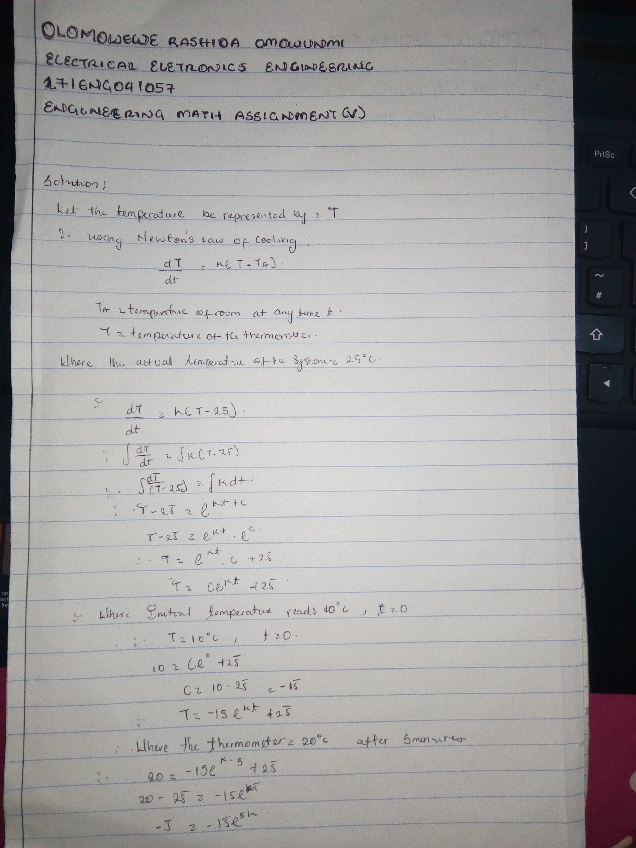

***3)***

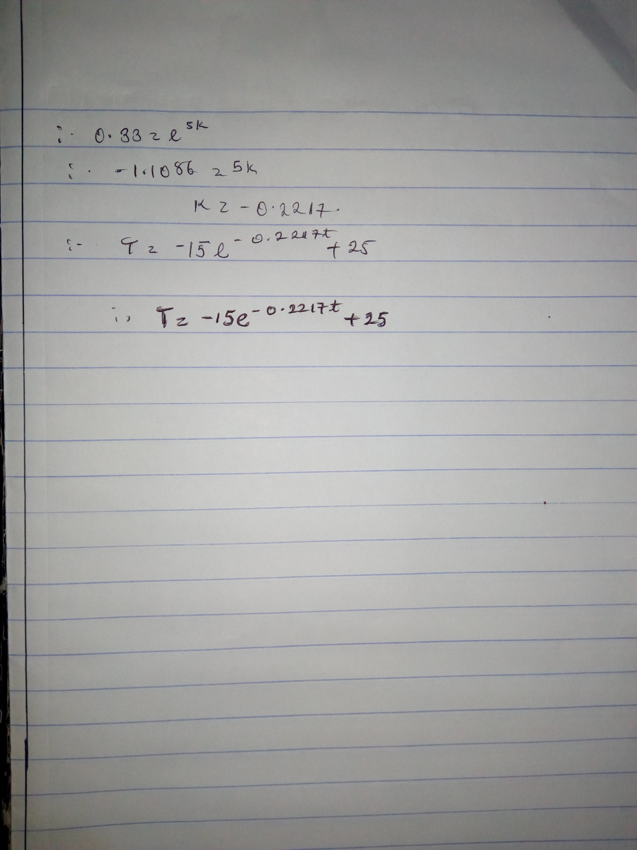

4 ) ***USING MICROSOFT EXCEL:***

|  |  |  |  |  |  |  |  |  |  |  |  |  |
| --- | --- | --- | --- | --- | --- | --- | --- | --- | --- | --- | --- | --- |
| t | T |  |  |  |  |  |  |  |  |  |  |  |
| 0 | 10 |  |  |  |  |  |  |  |  |  |  |  |
| 1 | 12.98266 |  |  |  |  |  |  |  |  |  |  |  |
| 2 | 15.37224 |  |  |  |  |  |  |  |  |  |  |  |
| 3 | 17.28667 |  |  |  |  |  |  |  |  |  |  |  |
| 4 | 18.82042 |  |  |  | | | | | | | | |
| 5 | 20.04919 |  |  |
| 6 | 21.03363 |  |  |
| 7 | 21.82232 |  |  |
| 8 | 22.45419 |  |  |
| 9 | 22.96041 |  |  |
| 10 | 23.36597 |  |  |
| 11 | 23.69089 |  |  |
| 12 | 23.9512 |  |  |
| 13 | 24.15974 |  |  |
| 14 | 24.32682 |  |  |
| 15 | 24.46068 |  |  |
| 16 | 24.56792 |  |  |
| 17 | 24.65384 |  |  |
| 18 | 24.72267 |  |  |
| 19 | 24.77782 |  |  |
| 20 | 24.822 |  |  |  |  |  |  |  |  |  |  |  |
| 21 | 24.85739 |  |  |  |  |  |  |  |  |  |  |  |
| 22 | 24.88575 |  |  |  |  |  |  |  |  |  |  |  |
| 23 | 24.90847 |  |  |  |  |  |  |  |  |  |  |  |
| 24 | 24.92667 |  |  |  |  |  |  |  |  |  |  |  |
| 25 | 24.94125 |  |  |  |  |  |  |  |  |  |  |  |
| 26 | 24.95293 |  |  |  |  |  |  |  |  |  |  |  |
| 27 | 24.96229 |  |  |  |  |  |  |  |  |  |  |  |
| 28 | 24.96979 |  |  |  |  |  |  |  |  |  |  |  |
| 29 | 24.9758 |  |  |  |  |  |  |  |  |  |  |  |
| 30 | 24.98061 |  |  |  |  |  |  |  |  |  |  |  |
| 31 | 24.98446 |  |  |  |  |  |  |  |  |  |  |  |
| 32 | 24.98755 |  |  |  |  |  |  |  |  |  |  |  |
| 33 | 24.99003 |  |  |  |  |  |  |  |  |  |  |  |
| 34 | 24.99201 |  |  |  |  |  |  |  |  |  |  |  |
| 35 | 24.9936 |  |  |  |  |  |  |  |  |  |  |  |
| 36 | 24.99487 |  |  |  |  |  |  |  |  |  |  |  |
| 37 | 24.99589 |  |  |  |  |  |  |  |  |  |  |  |
| 38 | 24.99671 |  |  |  |  |  |  |  |  |  |  |  |
| 39 | 24.99736 |  |  |  |  |  |  |  |  |  |  |  |
| 40 | 24.99789 |  |  |  |  |  |  |  |  |  |  |  |
| 41 | 24.99831 |  |  |  |  |  |  |  |  |  |  |  |
| 42 | 24.99864 |  |  |  |  |  |  |  |  |  |  |  |
| 43 | 24.99891 |  |  |  |  |  |  |  |  |  |  |  |
| 44 | 24.99913 |  |  |  |  |  |  |  |  |  |  |  |
| 45 | 24.9993 |  |  |  |  |  |  |  |  |  |  |  |
| 46 | 24.99944 |  |  |  |  |  |  |  |  |  |  |  |
| 47 | 24.99955 |  |  |  |  |  |  |  |  |  |  |  |
| 48 | 24.99964 |  |  |  |  |  |  |  |  |  |  |  |
| 49 | 24.99971 |  |  |  |  |  |  |  |  |  |  |  |
| 50 | 24.99977 |  |  |  |  |  |  |  |  |  |  |  |
| 51 | 24.99982 |  |  |  |  |  |  |  |  |  |  |  |
| 52 | 24.99985 |  |  |  |  |  |  |  |  |  |  |  |
| 53 | 24.99988 |  |  |  |  |  |  |  |  |  |  |  |
| 54 | 24.99991 |  |  |  |  |  |  |  |  |  |  |  |
| 55 | 24.99992 |  |  |  |  |  |  |  |  |  |  |  |
| 56 | 24.99994 |  |  |  |  |  |  |  |  |  |  |  |
| 57 | 24.99995 |  |  |  |  |  |  |  |  |  |  |  |
| 58 | 24.99996 |  |  |  |  |  |  |  |  |  |  |  |
| 59 | 24.99997 |  |  |  |  |  |  |  |  |  |  |  |
| 60 | 24.99997 |  |  |  |  |  |  |  |  |  |  |  |

5) ***USING MATLAB***

Code:

* commandwindow
* clear
* clc
* close all
* t =0:1:60
* T =-15*exp(-0.2217*t)+25
* plot(t,T)
* xlabel('time(seconds)')
* ylabel('temperature(c)')
* grid on
* grid minor

**output:**

t =

Columns 1 through 20

0 1 2 3 4 5 6 7 8 9 10 11 12 13 14 15 16 17 18 19

Columns 21 through 40

20 21 22 23 24 25 26 27 28 29 30 31 32 33 34 35 36 37 38 39

Columns 41 through 60

40 41 42 43 44 45 46 47 48 49 50 51 52 53 54 55 56 57 58 59

Column 61

60

T =

Columns 1 through 12

10.0000 12.9827 15.3722 17.2867 18.8204 20.0492 21.0336 21.8223 22.4542 22.9604 23.3660 23.6909

Columns 13 through 24

23.9512 24.1597 24.3268 24.4607 24.5679 24.6538 24.7227 24.7778 24.8220 24.8574 24.8857 24.9085

Columns 25 through 36

24.9267 24.9412 24.9529 24.9623 24.9698 24.9758 24.9806 24.9845 24.9876 24.9900 24.9920 24.9936

Columns 37 through 48

24.9949 24.9959 24.9967 24.9974 24.9979 24.9983 24.9986 24.9989 24.9991 24.9993 24.9994 24.9996

Columns 49 through 60

24.9996 24.9997 24.9998 24.9998 24.9999 24.9999 24.9999 24.9999 24.9999 25.0000 25.0000 25.0000

Column 61

25.0000

Graph:



6) The steady statetemperature of this system : The graph becomes straight at a time of 22 second and a temperature of 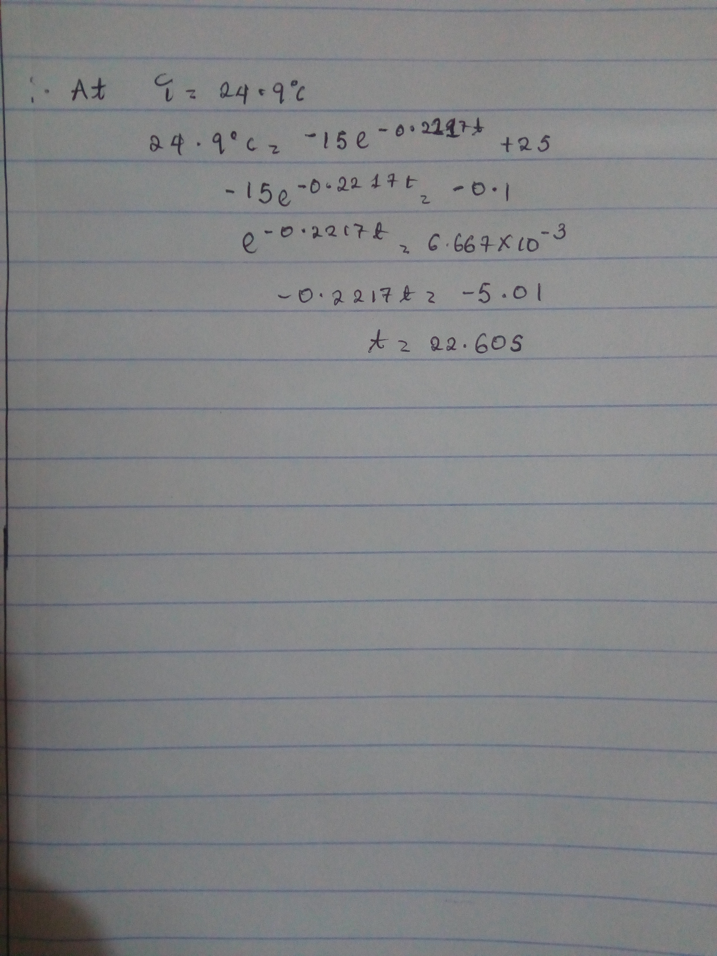25(celsius)

7)