Alawode chinonso iyanuoluwa
16/eng04/008
Elect/elect
Question 1 [20 Marks]
The model for the temperature distribution in a rod of length L = 6m is as given in Equation (1), $\frac{∂T(x,t)}{∂t}$ = $c\frac{∂^{2}T(x,t)}{∂x^{2}}$ ……………………………………….(1)
where
c = 2.2 cm² /hr …………………………………………(2)
with the conditions that the temperature ($℃$):
T(x, 0) = 3x²…………………………………………………………. (3)
T(0, t) = 0 …………………………………………………………………(4)
T(L,t) = 108 ……………………………………………………………….(5)
Using ∆t= 02 .0 hr and ∆x =3.0 cm, obtain the temperature profile of the system for 0 ≤ t ≤ 3 .0 hr
- manually, in tabular form, solving up to t =0 .02 hr and x = 6cm
SOLUTION
$\frac{∂T(x,t)}{∂t}$ = $c\frac{∂^{2}T(x,t)}{∂x^{2}}$
Simplifying the above equation using the forward difference method for first order and the central difference for the second order; gives:
$\frac{T_{i+1,J}-T_{i,j}}{∆t}$ = $c\frac{T_{i,j+1 - {2T}_{i,j}+T_{i,j-1}}}{(∆{x)}^{2}}$
T_{i+1,j} – T_{i,j} = $\frac{c∆t}{(∆{x)}^{2}}$ ( $T_{i,j+1 - {2T}_{i,j}+T_{i,j-1}}$)
Let r = = $\frac{c∆t}{(∆{x)}^{2}}$
T_{i+1,j} – T_{i,j} = r ( $T_{i,j+1 - {2T}_{i,j}+T_{i,j-1}}$)
T_{i+1,j} = r ( $T_{i,j+1 - {2T}_{i,j}+T_{i,j-1}}$) + T_{i,j}
T_{i+1,j} = r $T_{i,j+1+(1-2r) T_{i,j}+{rT}_{i,j-1}}$
The boundary conditions are:
T(0, t) = 0
T(L,t) = 108
And L = 6cm
T(x, 0) = 3x²
c = 2.2 cm² /hr
$∆t$ = 0.02 hr
$∆x$ = 0.3cm
r = $\frac{c∆t}{(∆{x)}^{2}}$ = $\frac{2.2*0.02}{{0.3}^{2}}$ = 0.4889
$nx$ = $\frac{x}{∆x}$ = $\frac{6}{0.3}$ = 20
$nt$ = $\frac{t}{∆t}$ = $\frac{0.3}{0.02}$ = 15

 | TIME t VALUES
Distance x values |  | i | 0 | 1
 | j |  | 0.00 | 0.02
 | 0 | 0.0 | 0 | 0
 | 1 | 0.3 | 0.27 | 0.534
 | 2 | 0.6 | 1.08 | 1.344
 | 3 | 0.9 | 2.43 | 2.694
 | 4 | 1.2 | 4.32 | 4.584
 | 5 | 1.5 | 6.75 | 7.014
 | 6 | 1.8 | 9.72 | 9.984
 | 7 | 2.1 | 13.23 | 13.494
 | 8 | 2.4 | 17.28 | 17.544
 | 9 | 2.7 | 21.87 | 22.134
 | 10 | 3.0 | 27.00 | 27.264
 | 11 | 3.3 | 32.67 | 32.934
 | 12 | 3.6 | 38.88 | 39.144
 | 13 | 3.9 | 45.63 | 45.894
 | 14 | 4.2 | 52.92 | 53.184
 | 15 | 4.5 | 60.75 | 61.014
 | 16 | 4.8 | 69.12 | 69.384
 | 17 | 5.1 | 78.03 | 78.294
 | 18 | 5.4 | 87.48 | 87.744
 | 19 | 5.7 | 97.47 | 97.734
 | 20 | 6.0 | 108.00 | 108

- with the aid of Microsoft Excel, in tabular and 3D graphical forms, and
SOLUTION
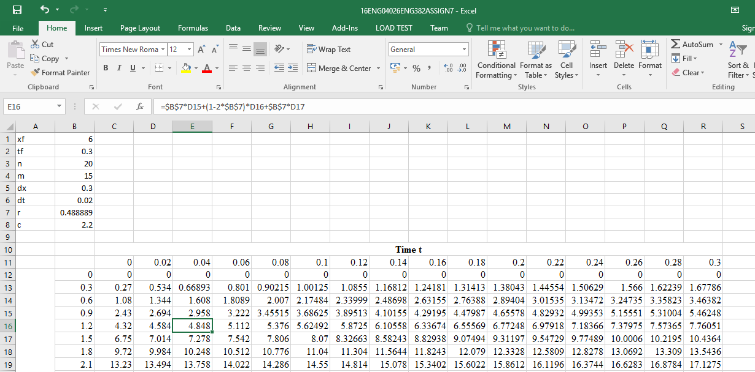

(c) with the aid of MATLAB, in tabular and 3D graphical forms.
SOLUTION

