Abdulazeez zubeidat
17/ENG03/001
CIVIL ENGINEERING
Assignment (vi)

MATLAB ASSIGNMENT
commandwindow
clear
clc
close all
t =0:0.5:50
T =-15*exp(-0.2197*t)+25
plot(t,T)
xlabel('time(seconds)')
ylabel('temperature(^oc)')
grid on
grid minor
t = 1×101
0 0.5000 1.0000 1.5000 2.0000 2.5000 3.0000 3.5000 4.0000 4.5000 5.0000 5.5000 6.0000 6.5000 7.0000 7.5000 8.0000 8.5000 9.0000 9.5000 10.0000 10.5000 11.0000 11.5000 12.0000 12.5000 13.0000 13.5000 14.0000 14.5000 15.0000 15.5000 16.0000 16.5000 17.0000 17.5000 18.0000 18.5000 19.0000 19.5000 20.0000 20.5000 21.0000 21.5000 22.0000 22.5000 23.0000 23.5000 24.0000 24.5000
T = 1×101
10.0000 11.5605 12.9586 14.2113 15.3337 16.3393 17.2402 18.0475 18.7708 19.4188 19.9994 20.5197 20.9858 21.4034 21.7775 22.1128 22.4131 22.6822 22.9234 23.1394 23.3330 23.5064 23.6618 23.8010 23.9257 24.0375 24.1376 24.2273 24.3077 24.3797 24.4443 24.5021 24.5539 24.6003 24.6419 24.6791 24.7125 24.7424 24.7692 24.7932 24.8147 24.8340 24.8513 24.8667 24.8806 24.8930 24.9042 24.9141 24.9231 24.9311
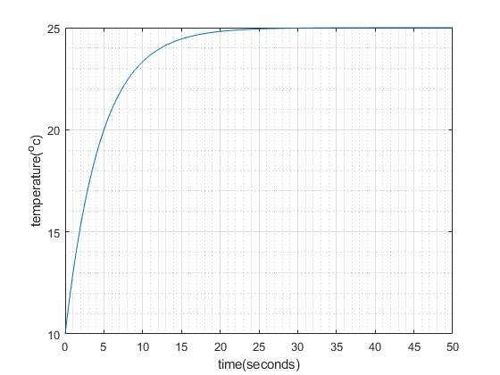

commandwindow
clear
clc
close all
t =0:0.5:50
T =-15*exp(-0.2197*t)+25
plot(t,T)
xlabel('time(seconds)')
ylabel('temperature(^oc)')
grid on
grid minor

