NAME: OLADIPO TOMI ISAAC
MATRIC NO: 17/ENG05/030
DEPARTMENT: MECHATRONICS ENGINEERING
ENGINEERING MATHS (ENG284) –ASSIGNMENT VI
MATLAB CODES
1-commandwindow
2-clear
3-clc
4-close all
5-t = 0:1:60
6-T = 25 - 15*exp(-0.22*t)
7-plot (t , T)
8-grid on
9-grid minor
10-xlabel ('Time(secs)')
11-ylabel ('Temperature(c)')

OUTPUT
t =

Columns 1 through 21

0 1 2 3 4 5 6 7 8 9 10 11 12 13 14 15 16 17 18 19 20

Columns 22 through 42

21 22 23 24 25 26 27 28 29 30 31 32 33 34 35 36 37 38 39 40 41

Columns 43 through 61

42 43 44 45 46 47 48 49 50 51 52 53 54 55 56 57 58 59 60

T =

Columns 1 through 12

10.0000 12.9622 15.3395 17.2472 18.7783 20.0069 20.9930 21.7843 22.4193 22.9290 23.3380 23.6662

Columns 13 through 24

23.9296 24.1410 24.3106 24.4468 24.5560 24.6437 24.7141 24.7705 24.8158 24.8522 24.8814 24.9048

Columns 25 through 36

24.9236 24.9387 24.9508 24.9605 24.9683 24.9746 24.9796 24.9836 24.9869 24.9895 24.9915 24.9932

Columns 37 through 48

24.9945 24.9956 24.9965 24.9972 24.9977 24.9982 24.9985 24.9988 24.9991 24.9992 24.9994 24.9995

Columns 49 through 60

24.9996 24.9997 24.9997 24.9998 24.9998 24.9999 24.9999 24.9999 24.9999 24.9999 25.0000 25.0000

Column 61

25.0000

GRAPHICAL REPRESENTATION
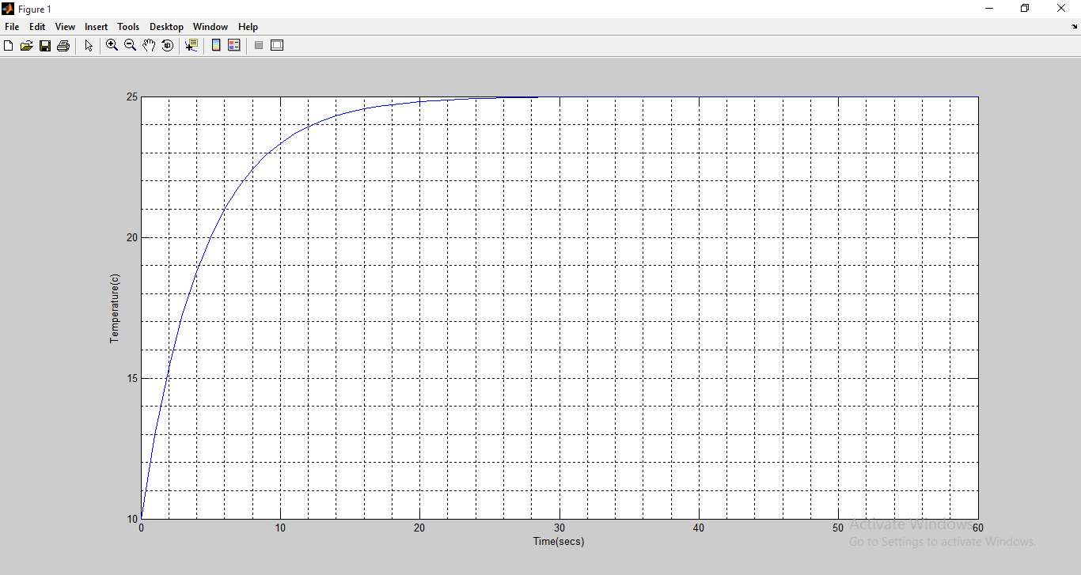

MICROSOFT EXCEL SPREADSHEET
t(sec) | T
0 | 10
1 | 12.96222
2 | 15.33945
3 | 17.24723
4 | 18.77826
5 | 20.00693
6 | 20.99297
7 | 21.78428
8 | 22.41933
9 | 22.92896
10 | 23.33795
11 | 23.66618
12 | 23.92958
13 | 24.14097
14 | 24.31061
15 | 24.44675
16 | 24.55601
17 | 24.64369
18 | 24.71405
19 | 24.77052
20 | 24.81584
21 | 24.85221
22 | 24.88139
23 | 24.90482
24 | 24.92361
25 | 24.9387
26 | 24.9508
27 | 24.96052
28 | 24.96832
29 | 24.97457
30 | 24.97959
31 | 24.98362
32 | 24.98686
33 | 24.98945
34 | 24.99154
35 | 24.99321
36 | 24.99455
37 | 24.99563
38 | 24.99649
39 | 24.99718
40 | 24.99774
41 | 24.99819
42 | 24.99854
43 | 24.99883
44 | 24.99906
45 | 24.99925
46 | 24.9994
47 | 24.99952
48 | 24.99961
49 | 24.99969
50 | 24.99975
51 | 24.9998
52 | 24.99984
53 | 24.99987
54 | 24.9999
55 | 24.99992
56 | 24.99993
57 | 24.99995
58 | 24.99996
59 | 24.99997
60 | 24.99997

GRAPHICAL REPRESENTATION OF THE MODEL

