NAME:IFESINACHI EZEUGWA
DEPT:CHEMICAL ENGINEERING
MATRIC NUMBER: 16/ENG01/008
ASSIGNMENT 7

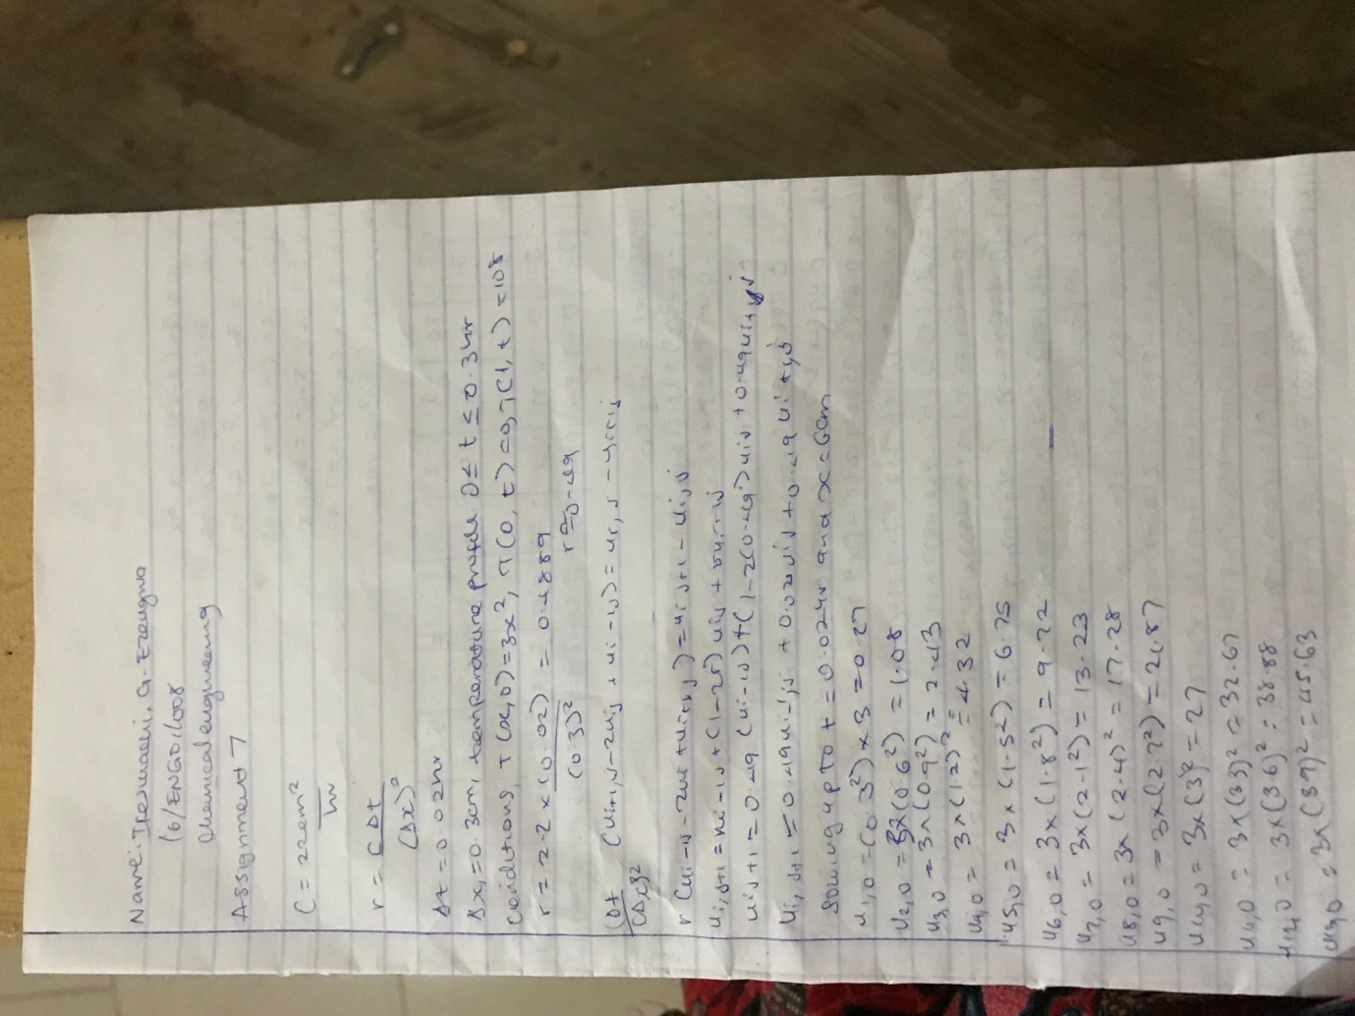

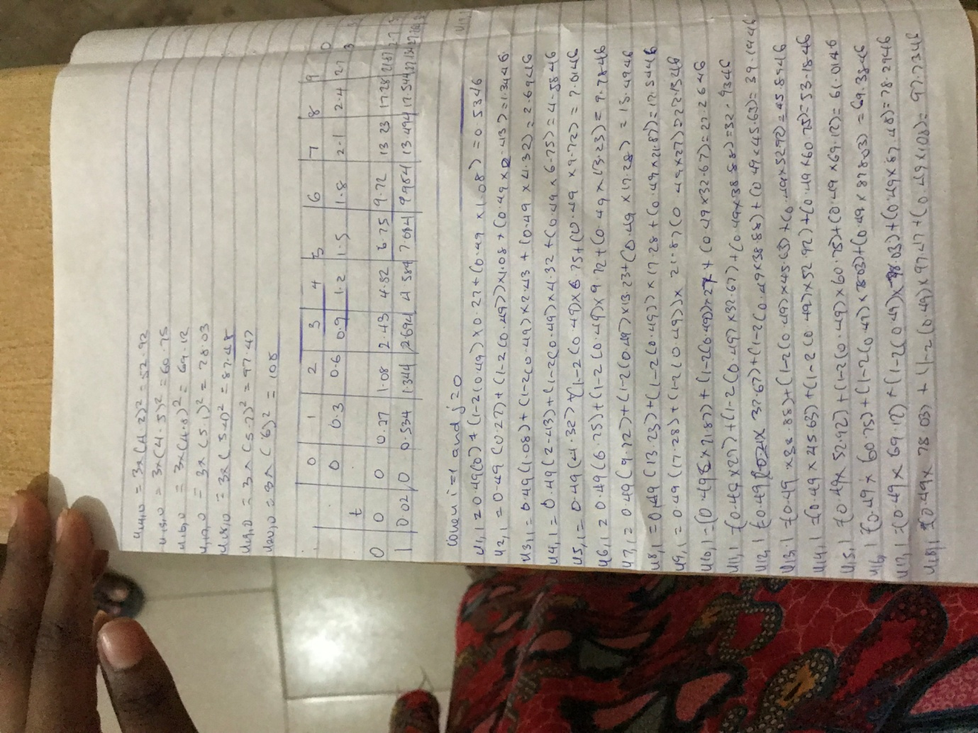
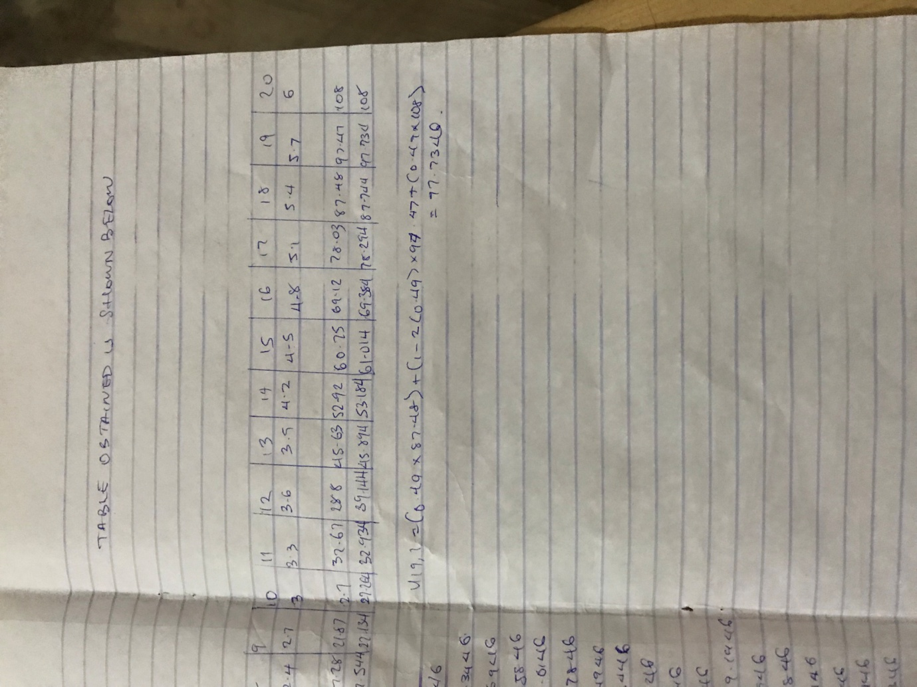

b. EXCEL
dx | 0.3
dt | 0.02
c | 2.2
r | 0.488889

 |  | T(0,t)=0
 |  | ui-1 | ui
i |  | 0 | 1 | 2 | 3 | 4 | 5 | 6 | 7
x |  | 0 | 0.3 | 0.6 | 0.9 | 1.2 | 1.5 | 1.8 | 2.1
t
0 | 0 | 0 | 0.27 | 1.08 | 2.43 | 4.32 | 6.75 | 9.72 | 13.23
1 | 0.02 | 0 | 0.534 | 1.344 | 2.694 | 4.584 | 7.014 | 9.984 | 13.494
2 | 0.04 | 0 | 0.668933 | 1.608 | 2.958 | 4.848 | 7.278 | 10.248 | 13.758
3 | 0.06 | 0 | 0.800999 | 1.808901 | 3.222 | 5.112 | 7.542 | 10.512 | 14.022
4 | 0.08 | 0 | 0.902151 | 2.006997 | 3.455151 | 5.376 | 7.806 | 10.776 | 14.286
5 | 0.1 | 0 | 1.001246 | 2.174837 | 3.686246 | 5.624918 | 8.07 | 11.04 | 14.55
6 | 0.12 | 0 | 1.085504 | 2.339993 | 3.89513 | 5.872496 | 8.326627 | 11.304 | 14.814
7 | 0.14 | 0 | 1.168119 | 2.486976 | 4.101553 | 6.105581 | 8.582434 | 11.5644 | 15.078
8 | 0.16 | 0 | 1.241813 | 2.63155 | 4.291952 | 6.33674 | 8.829376 | 11.82431 | 15.34024
9 | 0.18 | 0 | 1.314132 | 2.763875 | 4.479874 | 6.555688 | 9.074944 | 12.07902 | 15.6022
10 | 0.2 | 0 | 1.380431 | 2.894044 | 4.655783 | 6.772482 | 9.311966 | 12.3328 | 15.86119
11 | 0.22 | 0 | 1.445542 | 3.01535 | 4.829319 | 6.979177 | 9.547295 | 12.58094 | 16.11959
12 | 0.24 | 0 | 1.506294 | 3.134718 | 4.993532 | 7.18366 | 9.774886 | 12.82783 | 16.3744
13 | 0.26 | 0 | 1.566002 | 3.247353 | 5.155508 | 7.379752 | 10.00062 | 13.06916 | 16.62835
14 | 0.28 | 0 | 1.622395 | 3.358235 | 5.31004 | 7.573655 | 10.21948 | 13.30903 | 16.87844
15 | 0.3 | 0 | 1.677857 | 3.463818 | 5.46248 | 7.760514 | 10.43641 | 13.54363 | 17.12745

8 | 9 | 10 | 11 | 12 | 13 | 14
2.4 | 2.7 | 3 | 3.3 | 3.6 | 3.9 | 4.2
17.28 | 21.87 | 27 | 32.67 | 38.88 | 45.63 | 52.92
17.544 | 22.134 | 27.264 | 32.934 | 39.144 | 45.894 | 53.184
17.808 | 22.398 | 27.528 | 33.198 | 39.408 | 46.158 | 53.448
18.072 | 22.662 | 27.792 | 33.462 | 39.672 | 46.422 | 53.712
18.336 | 22.926 | 28.056 | 33.726 | 39.936 | 46.686 | 53.976
18.6 | 23.19 | 28.32 | 33.99 | 40.2 | 46.95 | 54.24
18.864 | 23.454 | 28.584 | 34.254 | 40.464 | 47.214 | 54.504
19.128 | 23.718 | 28.848 | 34.518 | 40.728 | 47.478 | 54.7644
19.392 | 23.982 | 29.112 | 34.782 | 40.992 | 47.74024 | 55.02431
19.65514 | 24.246 | 29.376 | 35.046 | 41.25514 | 48.0022 | 55.27902
19.91812 | 24.50958 | 29.64 | 35.30958 | 41.51812 | 48.26119 | 55.5328
20.17945 | 24.77307 | 29.90359 | 35.57307 | 41.77945 | 48.51959 | 55.78094
20.4404 | 25.03555 | 30.16708 | 35.83555 | 42.0404 | 48.7744 | 56.02783
20.6991 | 25.29778 | 30.42959 | 36.09778 | 42.2991 | 49.02835 | 56.26916
20.9572 | 25.55842 | 30.69182 | 36.35842 | 42.5572 | 49.27844 | 56.50903
21.21263 | 25.8186 | 30.95249 | 36.6186 | 42.81263 | 49.52745 | 56.74363

15 | 16 | 17 | 18 | 19 | 20
4.5 | 4.8 | 5.1 | 5.4 | 5.7 | 6
60.75 | 69.12 | 78.03 | 87.48 | 97.47 | 108
61.014 | 69.384 | 78.294 | 87.744 | 97.734 | 108
61.278 | 69.648 | 78.558 | 88.008 | 97.86893 | 108
61.542 | 69.912 | 78.822 | 88.2089 | 98.001 | 108
61.806 | 70.176 | 79.05515 | 88.407 | 98.10215 | 108
62.07 | 70.42492 | 79.28625 | 88.57484 | 98.20125 | 108
62.32663 | 70.6725 | 79.49513 | 88.73999 | 98.2855 | 108
62.58243 | 70.90558 | 79.70155 | 88.88698 | 98.36812 | 108
62.82938 | 71.13674 | 79.89195 | 89.03155 | 98.44181 | 108
63.07494 | 71.35569 | 80.07987 | 89.16388 | 98.51413 | 108
63.31197 | 71.57248 | 80.25578 | 89.29404 | 98.58043 | 108
63.54729 | 71.77918 | 80.42932 | 89.41535 | 98.64554 | 108
63.77489 | 71.98366 | 80.59353 | 89.53472 | 98.70629 | 108
64.00062 | 72.17975 | 80.75551 | 89.64735 | 98.766 | 108
64.21948 | 72.37365 | 80.91004 | 89.75823 | 98.82239 | 108
64.43641 | 72.56051 | 81.06248 | 89.86382 | 98.87786 | 108

c. MATLAB
commandwindow
clear
clc
close all
xf =6;
x0 =0;
t0 = 0;
tf = 0.3;
dx = 0.3;
dt = 0.02;
c = 2.2;
r = c*(dt/(dx^2));
t =[t0:dt:tf];
x =[x0:dx:xf]
n =(xf-x0)/dx
m=(tf-t0)/dt
T(1:m+1,1) = zeros(m+1,1);
T(1:m+1,n+1) = 108*(ones(m+1,1));
T(1,1:n+1) = 3*(x.^2);
for j= 1:m
for i= 2:n
T(j+1,i)=r*T(j,i+1)+(1-(2*r))*T(j,i)+r*T(j,i-1);
end
end
T
mesh(x,t,T)

