*Kayode muinat*

*adebukola*

*Chemical engineering*

*17/sci14/016*

*ENGINEERING MATHEMATICS II* ***ASSIGNMENT (V)***

***Mathematical Modelling:***

*This is the process of setting up the model , solving it mathematically and interpreting the result in physical or other terms.*

***Method of obtaining models for engineering systems:***

*Exponential Growth, Exponential Decay*

Hormone level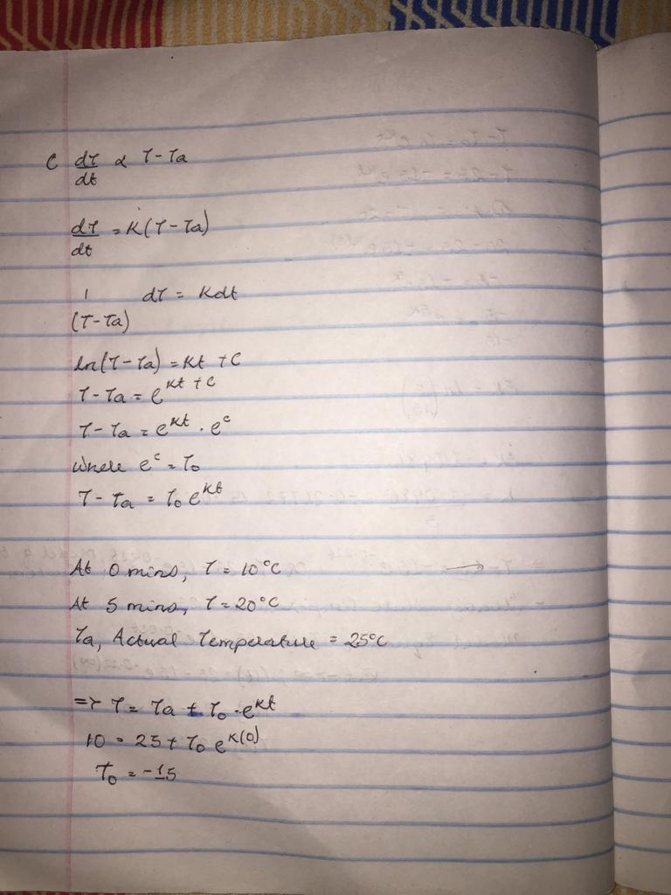*ormone Level*

*4 )* ***USING MICROSOFT EXCEL:***

|  |  |  |  |  |  |  |  |  |  |  |  |  |
| --- | --- | --- | --- | --- | --- | --- | --- | --- | --- | --- | --- | --- |
| *t* | *T* |  |  |  |  |  |  |  |  |  |  |  |
| *0* | *10* |  |  |  |  |  |  |  |  |  |  |  |
| *1* | *12.98266* |  |  |  |  |  |  |  |  |  |  |  |
| *2* | *15.37224* |  |  |  |  |  |  |  |  |  |  |  |
| *3* | *17.28667* |  |  |  |  |  |  |  |  |  |  |  |
| *4* | *18.82042* |  |  |  | | | | | | | | |
| *5* | *20.04919* |  |  |
| *6* | *21.03363* |  |  |
| *7* | *21.82232* |  |  |
| *8* | *22.45419* |  |  |
| *9* | *22.96041* |  |  |
| *10* | *23.36597* |  |  |
| *11* | *23.69089* |  |  |
| *12* | *23.9512* |  |  |
| *13* | *24.15974* |  |  |
| *14* | *24.32682* |  |  |
| *15* | *24.46068* |  |  |
| *16* | *24.56792* |  |  |
| *17* | *24.65384* |  |  |
| *18* | *24.72267* |  |  |
| *19* | *24.77782* |  |  |
| *20* | *24.822* |  |  |  |  |  |  |  |  |  |  |  |
| *21* | *24.85739* |  |  |  |  |  |  |  |  |  |  |  |
| *22* | *24.88575* |  |  |  |  |  |  |  |  |  |  |  |
| *23* | *24.90847* |  |  |  |  |  |  |  |  |  |  |  |
| *24* | *24.92667* |  |  |  |  |  |  |  |  |  |  |  |
| *25* | *24.94125* |  |  |  |  |  |  |  |  |  |  |  |
| *26* | *24.95293* |  |  |  |  |  |  |  |  |  |  |  |
| *27* | *24.96229* |  |  |  |  |  |  |  |  |  |  |  |
| *28* | *24.96979* |  |  |  |  |  |  |  |  |  |  |  |
| *29* | *24.9758* |  |  |  |  |  |  |  |  |  |  |  |
| *30* | *24.98061* |  |  |  |  |  |  |  |  |  |  |  |
| *31* | *24.98446* |  |  |  |  |  |  |  |  |  |  |  |
| *32* | *24.98755* |  |  |  |  |  |  |  |  |  |  |  |
| *33* | *24.99003* |  |  |  |  |  |  |  |  |  |  |  |
| *34* | *24.99201* |  |  |  |  |  |  |  |  |  |  |  |
| *35* | *24.9936* |  |  |  |  |  |  |  |  |  |  |  |
| *36* | *24.99487* |  |  |  |  |  |  |  |  |  |  |  |
| *37* | *24.99589* |  |  |  |  |  |  |  |  |  |  |  |
| *38* | *24.99671* |  |  |  |  |  |  |  |  |  |  |  |
| *39* | *24.99736* |  |  |  |  |  |  |  |  |  |  |  |
| *40* | *24.99789* |  |  |  |  |  |  |  |  |  |  |  |
| *41* | *24.99831* |  |  |  |  |  |  |  |  |  |  |  |
| *42* | *24.99864* |  |  |  |  |  |  |  |  |  |  |  |
| *43* | *24.99891* |  |  |  |  |  |  |  |  |  |  |  |
| *44* | *24.99913* |  |  |  |  |  |  |  |  |  |  |  |
| *45* | *24.9993* |  |  |  |  |  |  |  |  |  |  |  |
| *46* | *24.99944* |  |  |  |  |  |  |  |  |  |  |  |
| *47* | *24.99955* |  |  |  |  |  |  |  |  |  |  |  |
| *48* | *24.99964* |  |  |  |  |  |  |  |  |  |  |  |
| *49* | *24.99971* |  |  |  |  |  |  |  |  |  |  |  |
| *50* | *24.99977* |  |  |  |  |  |  |  |  |  |  |  |
| *51* | *24.99982* |  |  |  |  |  |  |  |  |  |  |  |
| *52* | *24.99985* |  |  |  |  |  |  |  |  |  |  |  |
| *53* | *24.99988* |  |  |  |  |  |  |  |  |  |  |  |
| *54* | *24.99991* |  |  |  |  |  |  |  |  |  |  |  |
| *55* | *24.99992* |  |  |  |  |  |  |  |  |  |  |  |
| *56* | *24.99994* |  |  |  |  |  |  |  |  |  |  |  |
| *57* | *24.99995* |  |  |  |  |  |  |  |  |  |  |  |
| *58* | *24.99996* |  |  |  |  |  |  |  |  |  |  |  |
| *59* | *24.99997* |  |  |  |  |  |  |  |  |  |  |  |
| *60* | *24.99997* |  |  |  |  |  |  |  |  |  |  |  |

*5)* ***USING MATLAB***

*Code:*

* *commandwindow*
* *clear*
* *clc*
* *close all*
* *t =0:1:60*
* *T =-15*exp(-0.2217*t)+25*
* *plot(t,T)*
* *xlabel('time(seconds)')*
* *ylabel('temperature(c)')*
* *grid on*
* *grid minor*

***output:***

*t =*

*Columns 1 through 20*

*0 1 2 3 4 5 6 7 8 9 10 11 12 13 14 15 16 17 18 19*

*Columns 21 through 40*

*20 21 22 23 24 25 26 27 28 29 30 31 32 33 34 35 36 37 38 39*

*Columns 41 through 60*

*40 41 42 43 44 45 46 47 48 49 50 51 52 53 54 55 56 57 58 59*

*Column 61*

*60*

*T =*

*Columns 1 through 12*

*10.0000 12.9827 15.3722 17.2867 18.8204 20.0492 21.0336 21.8223 22.4542 22.9604 23.3660 23.6909*

*Columns 13 through 24*

*23.9512 24.1597 24.3268 24.4607 24.5679 24.6538 24.7227 24.7778 24.8220 24.8574 24.8857 24.9085*

*Columns 25 through 36*

*24.9267 24.9412 24.9529 24.9623 24.9698 24.9758 24.9806 24.9845 24.9876 24.9900 24.9920 24.9936*

*Columns 37 through 48*

*24.9949 24.9959 24.9967 24.9974 24.9979 24.9983 24.9986 24.9989 24.9991 24.9993 24.9994 24.9996*

*Columns 49 through 60*

*24.9996 24.9997 24.9998 24.9998 24.9999 24.9999 24.9999 24.9999 24.9999 25.0000 25.0000 25.0000*

*Column 61*

*25.0000*

*Graph:*

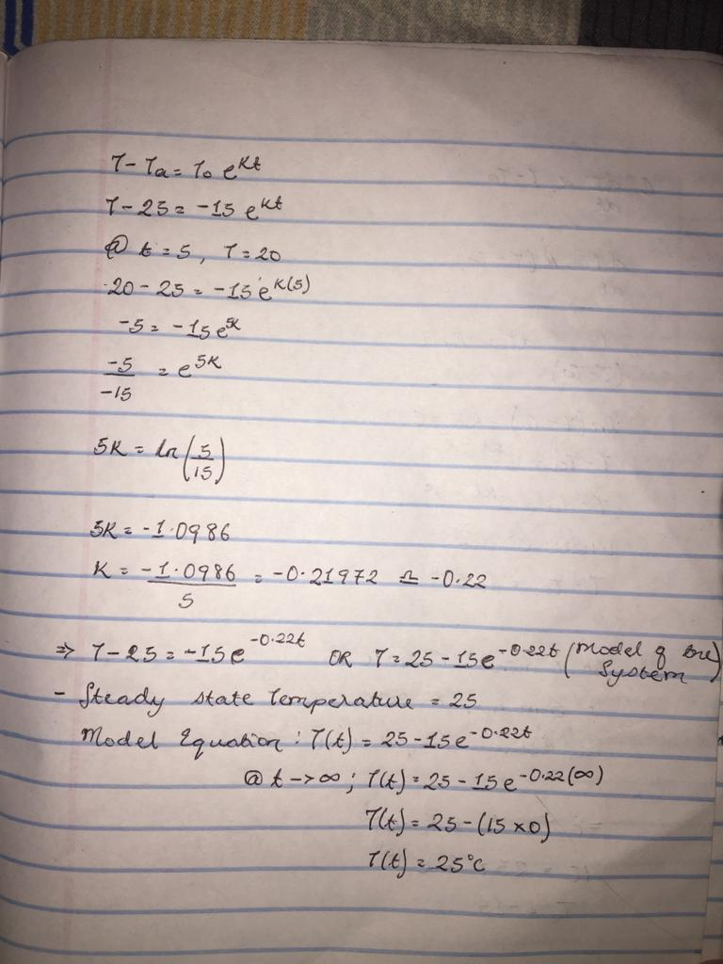**

*6) The steady statetemperature of this system : The graph becomes straight at a time of 22 second and a temperature of 25(celsius)*

*7)*