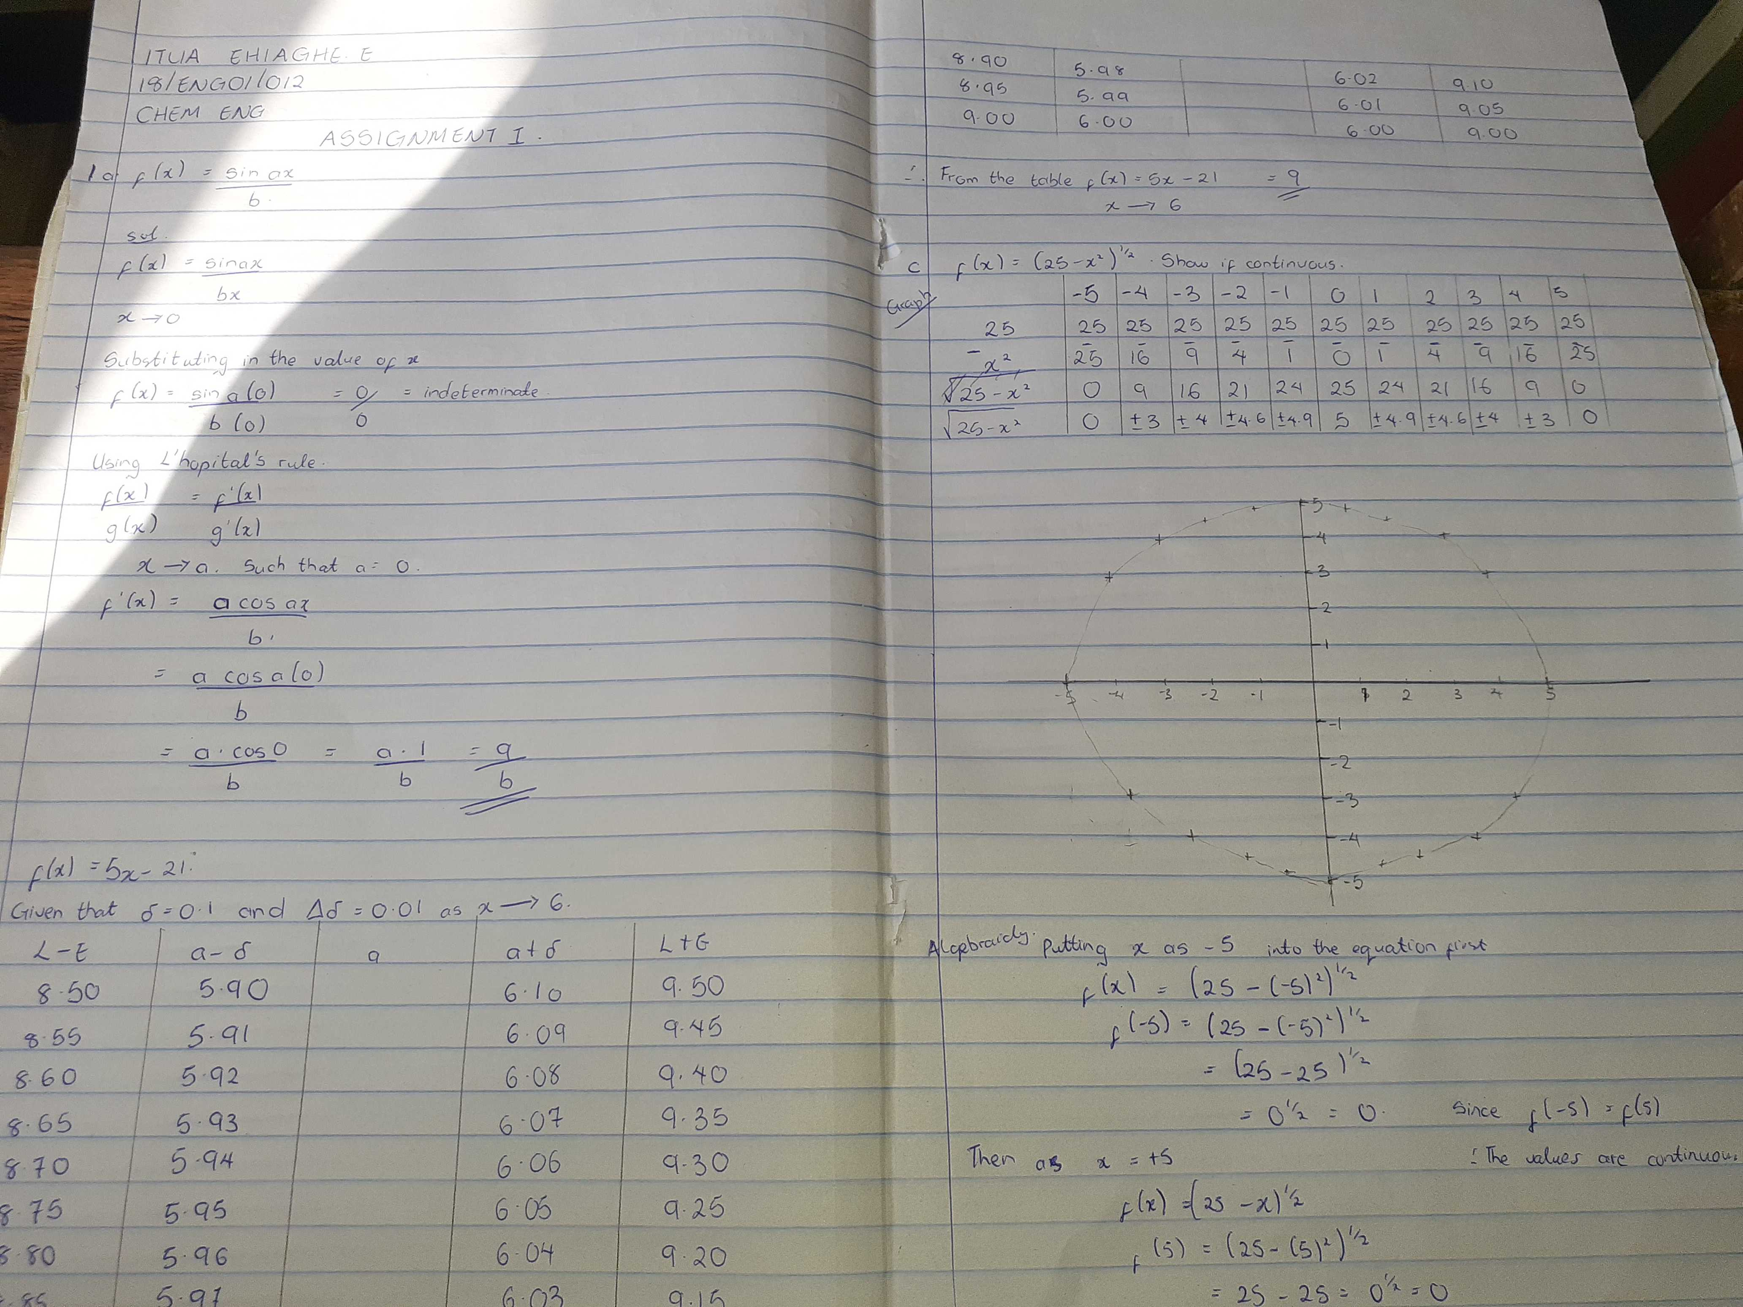
Itua Ehiaghe
18/eng01/012
Chemical engineering

