[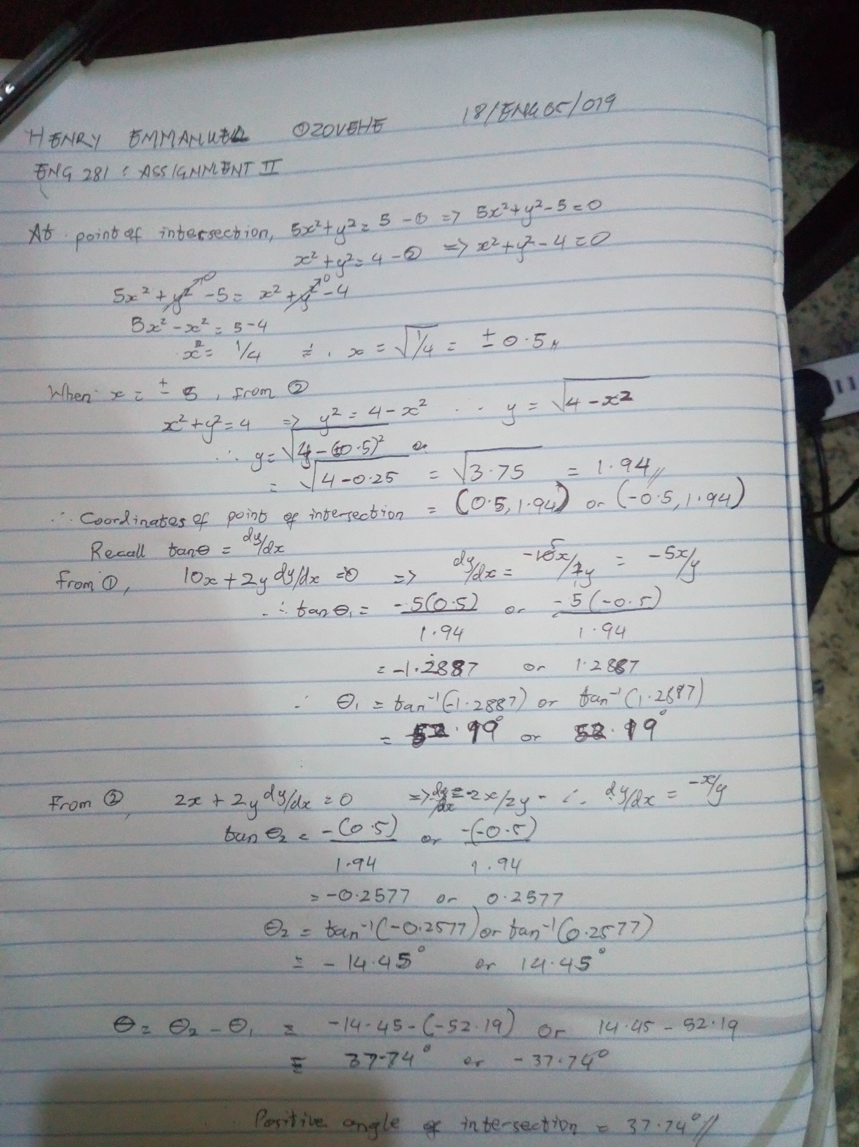](file:///C:\Users\EMMANUEL\Documents\Mathcad%20assignment%202.pdf)

