NAME: WOKOMA BLOSSOM CHINAZOR
MATRIC NUMBER: 18/ENG04/071
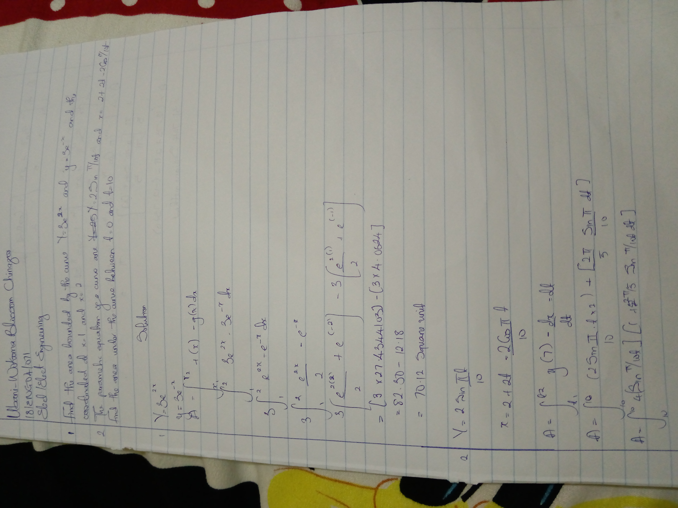
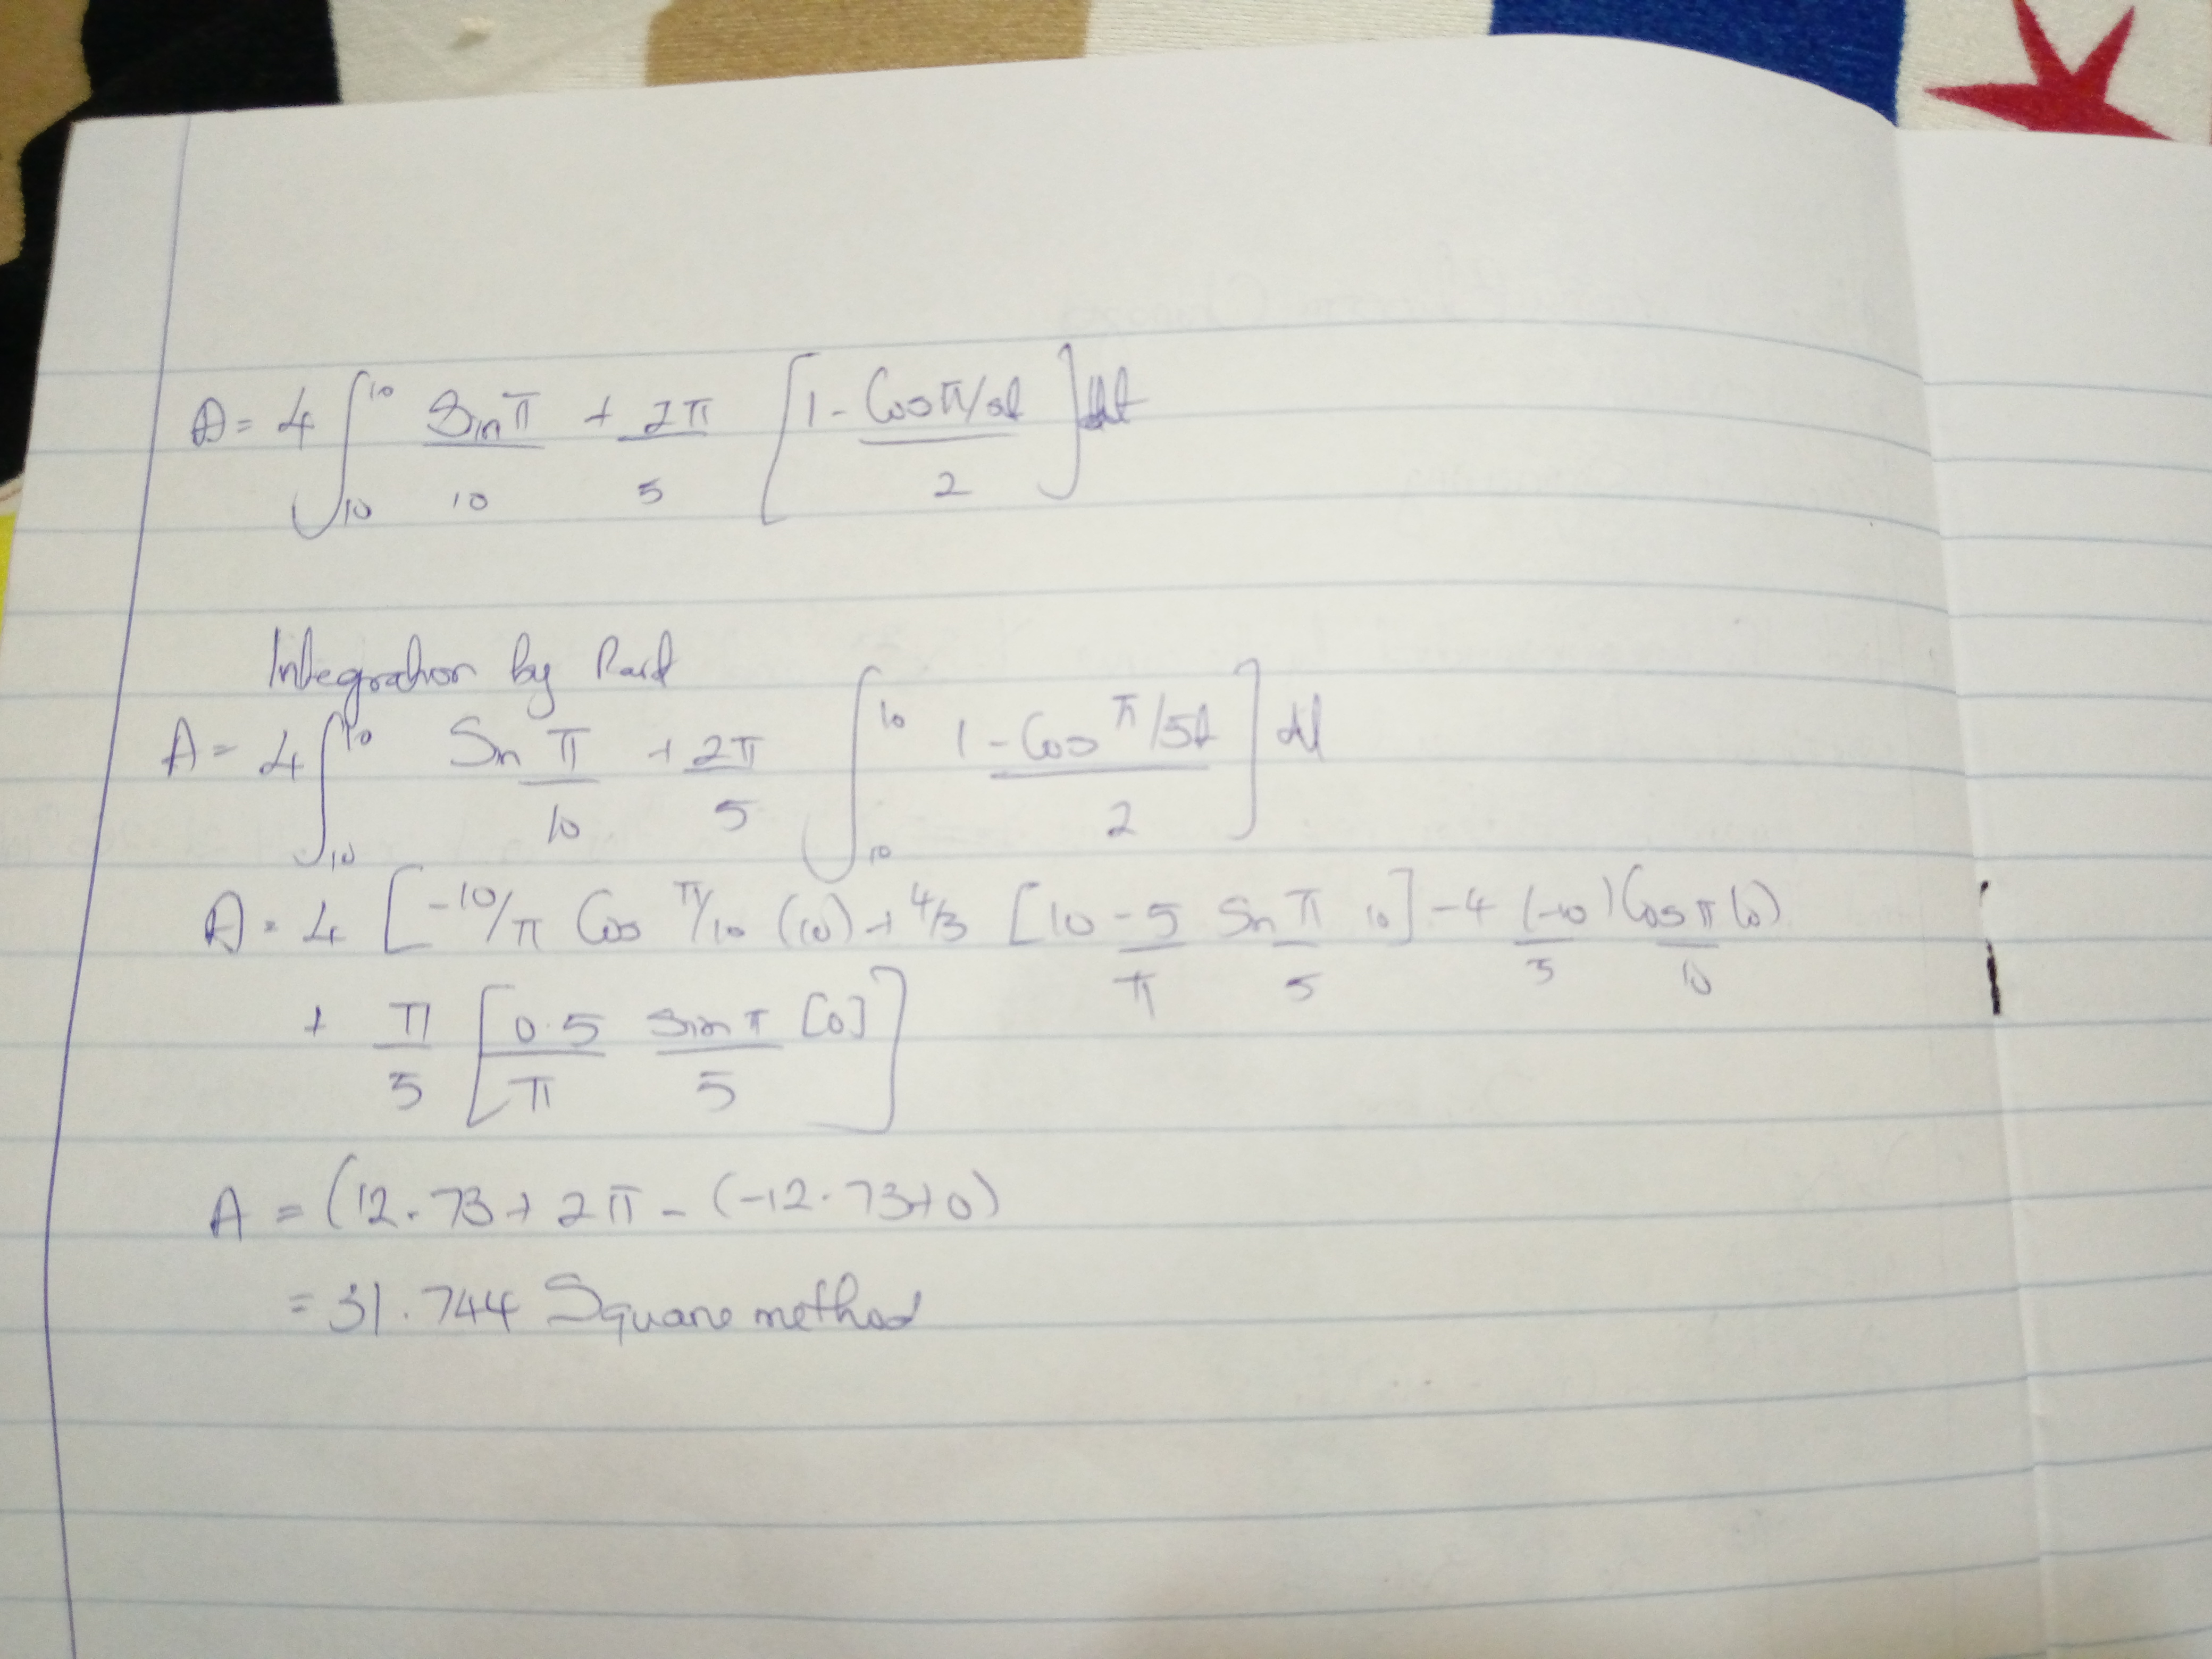
DEPARTMENT: ELECT/ELECT ENGINEERING

