NAMEPLATE: OKEKE CHIDERA SAMUELLA
DEPARTMENT: BIOMEDICAL ENGINEERING
MATRIC NUMBER: 18/ENG08/014
TEST QUESTIONS 4B AND 4D

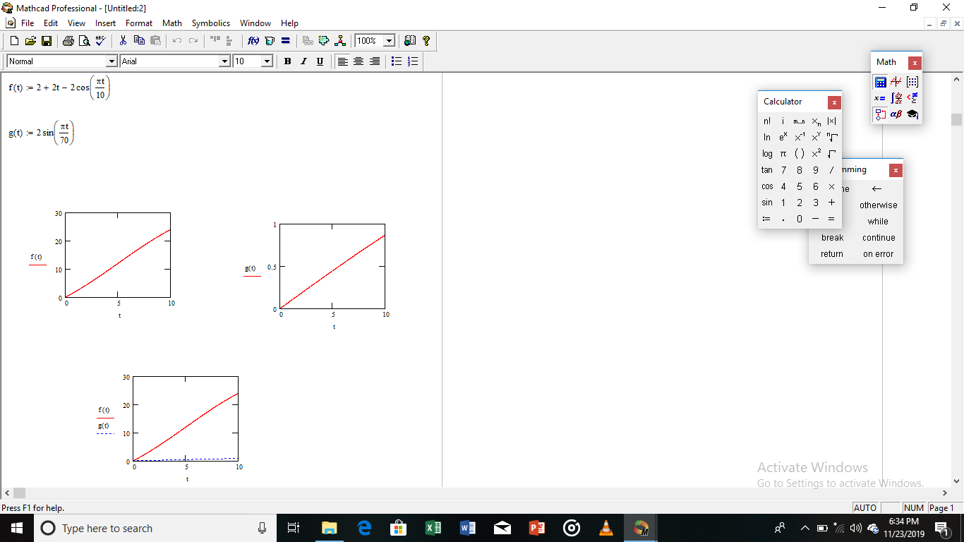
Sir my MATLAB crashed with my system and I currently can not solve the solution and send the screenshot. My sincere apologies.

