NAME: OZOEMENA AUGUSTINE
MATRIC NUMBER: 18/ENG01/027
DEPARTMENT: CHEMICAL ENGINEERING

4(a)

CODE
commandwindow
clc
close all
syms n(t)
D=diff(n)
eqn =(diff(n,t,2))-(diff(n,t))-(12*n)==144*t^3+12.5;
cond1=D(0)==-0.5;
cond2=n(0)==5;
cond3=[cond1 cond2];
sol=dsolve(ode,cond3);
sol1=simplify(sol)
t=[0:0.1:1.5]
sol2=subs(sol1)
plot(t,sol2)
grid on
grid minor
axis tight

OUTPUT

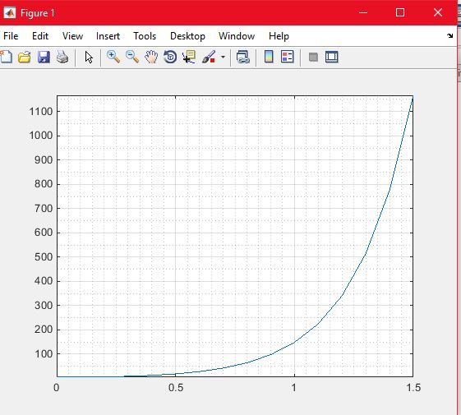

4(b)i

CODE

commandwindow
clear
clc
close all
syms y(t) x(t)
eqn1=diff(y,t)-2*x==exp(-2*t)
eqn2=diff(x,t)+y==exp(-t)
eqn3=[eqn1,eqn2]
cond = [y(0)==0,x(0)==0]
[sol1 sol2]=dsolve(eqn3,cond)
fplot(sol1)
hold on
fplot(sol2)
legend('eqn1','eqn2','location','best')
grid on
grid minor
axis tight

OUTPUT

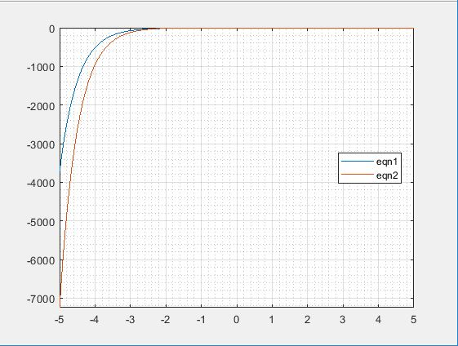
4(b)(ii)
CODE
commandwindow
clear
clc
close all
syms y(t) x(t)
eqn1=diff(y,t)-2*x==exp(-2*t)
eqn2=diff(x,t)+y==exp(-t)
eqn3=[eqn1,eqn2]
cond = [y(0)==0,x(0)==0]
[solA solB]=dsolve(eqn3,cond)
figure (1)
fplot(solA)
grid on
grid minor
figure (2)
fplot(solB)
grid on
grid minor
axis tight

OUTPUT 1
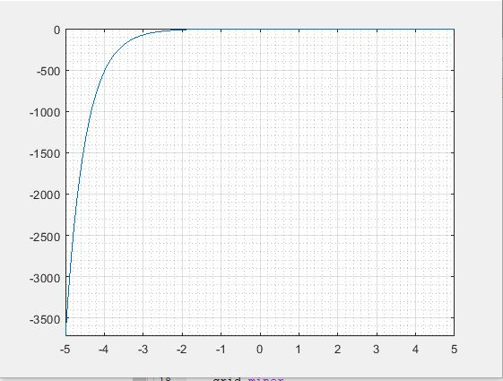

OUTPUT 2
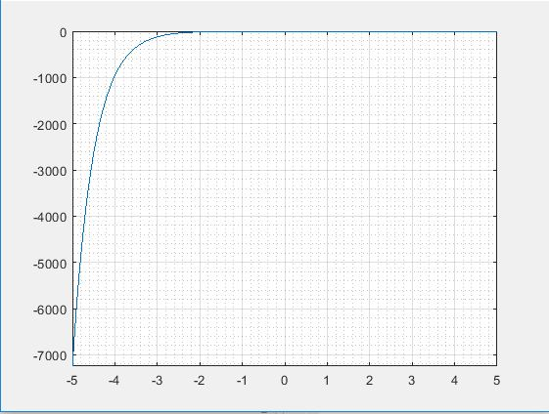

4c(i)
commandwindow
clc
syms w t k a
eqn=k*exp(-a*t)*sin(5*w*t)*cos(3*w*t)
solutionA=laplace(eqn)
solutionB=simplify(solutionA)

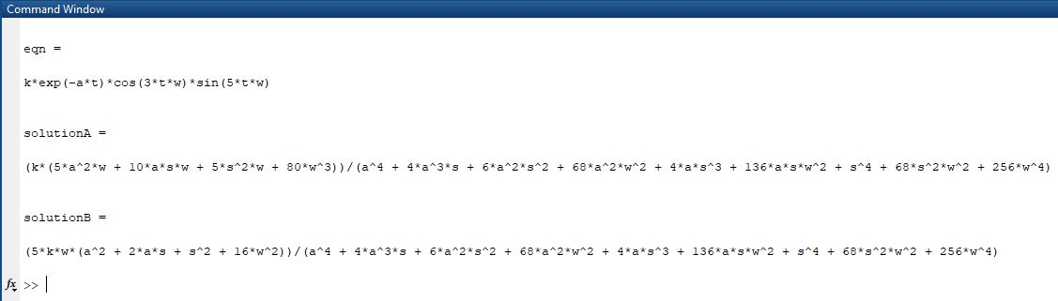

4c(ii)
commandwindow
clear
clc
syms s
solve=((pi)/((s^2)+(15*pi^2*s)+(24*pi^3)))
solution1=ilaplace(solve)
solution2=simplify(solution1)

