FRANCIS SHAPHAN ZIRRA

COMPUTER ENGINEERING

17/ENG02/028

- CODE

commandwindow
clc
close all
syms n(t)
dn=diff(n)
dEqn =(diff(n,t,2))-(diff(n,t))-(12*n)==144*t^3+12.5;
cond1=dn(0)==-0.5;
cond2=n(0)==5;
cond3=[cond1 cond2];
sol=dsolve(dEqn,cond3);
simSol=simplify(sol)
t=[0:0.1:1.5]
ans=subs(sol)
plot(t,ans)
grid on
grid minor
axis tight

OUTPUT

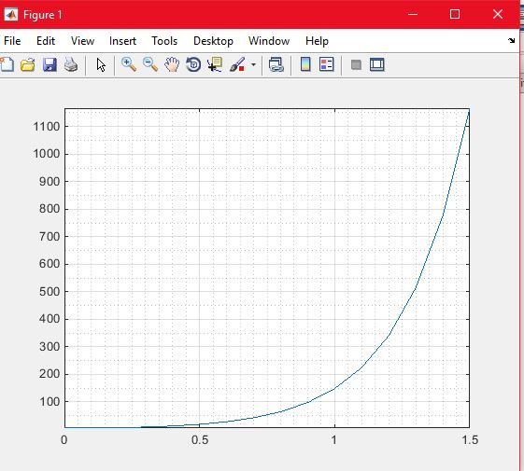

4(Bi). CODE

commandwindow
clear
clc
close all
syms y(t) x(t)
eqn1=diff(y,t)-2*x==exp(-2*t)
eqn2=diff(x,t)+y==exp(-t)
eqn3=[eqn1,eqn2]
cond = [y(0)==0,x(0)==0]
[sol1 sol2]=dsolve(eqn3,cond)
fplot(sol1)
hold on
fplot(sol2)
legend('eqn1','eqn2','location','best')
grid on
grid minor
axis tight

OUTPUT

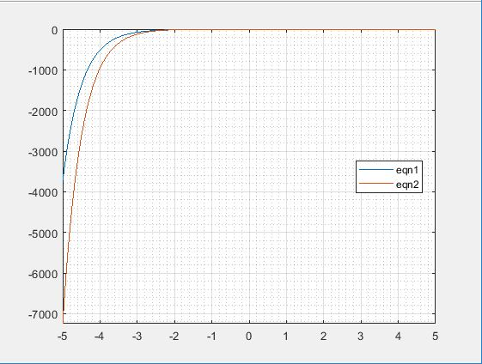
4(Bii). CODE
commandwindow
clear
clc
close all
syms y(t) x(t)
eqn1=diff(y,t)-2*x==exp(-2*t)
eqn2=diff(x,t)+y==exp(-t)
eqn3=[eqn1,eqn2]
cond = [y(0)==0,x(0)==0]
[shaA shaB]=dsolve(eqn3,cond)
figure (1)
fplot(shaA)
grid on
grid minor
figure (2)
fplot(shaB)
grid on
grid minor
axis tight

OUTPUT 1
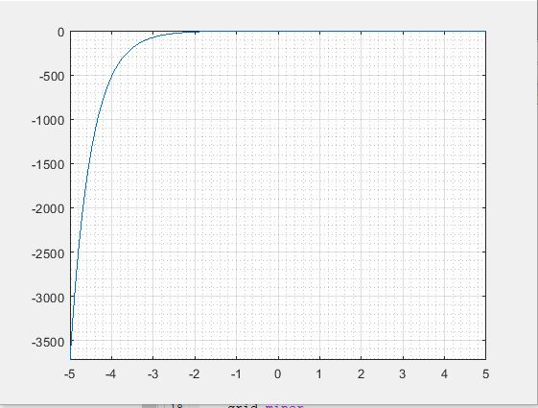

OUTPUT 2
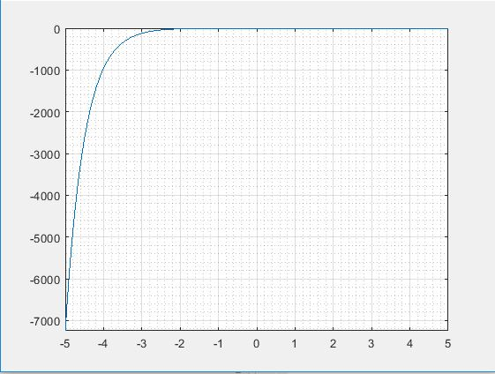

4(Ci). f(t)=ke^{-at}sin(5wt)cos(3wt)
commandwindow
clear
clc
syms t w k a
ft=k*exp(-a*t)*sin(5*w*t)*cos(3*w*t)
fs=laplace(ft)

OUTPUT
ft = k*exp(-a*t)*cos(3*t*w)*sin(5*t*w)
fs = k*(w/((a + s)^2 + 4*w^2) + (4*w)/((a + s)^2 + 64*w^2))

(ii) f(s)=$\frac{π}{(s^{2}+15πs+24π^{3})}$

commandwindow
clear
clc
syms s
fs=pi/(s.^2+15*pi*s+24*pi.^3)
ft=ilaplace(fs)

OUTPUT:
fs =pi/(s^2 + 15*pi*s + 1636404563713415/2199023255552)
ft =(pi*sin(t*(1636404563713415/2199023255552 - (225*pi^2)/4)^(1/2))*exp(-(15*pi*t)/2))/(1636404563713415/2199023255552 - (225*pi^2)/4)^(1/2)

