NAME: Emeni Ashley
MATRIC NUMBER:17/ENG02/022
DEPATMENT: Computer Engineering
ENG 381
4a.)
commandwindow
clc
close all
syms n(t)
D=diff(n)
eqn =(diff(n,t,2))-(diff(n,t))-(12*n)==144*t^3+12.5;
Ref1=D(0)==-0.5;
Ref2=n(0)==5;
Conds=[ref1 ref2];
sol=dsolve(tim,conds);
sol1=simplify(sol)
t=[0:0.1:1.5]
sol2=subs(sol1)
plot(t,sol2)
grid on
grid minor
axis tight

OUTPUT
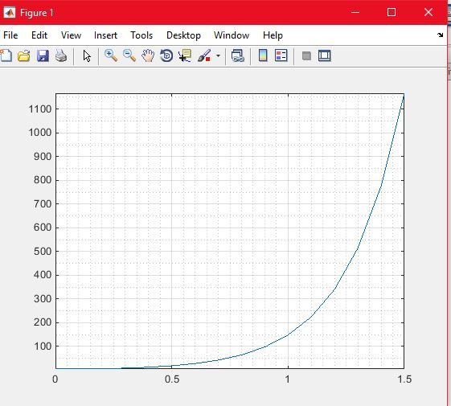

4b.)

commandwindow
clc
syms y(t)x(t)
close all
Tim1=diff(y,t)-2*x==exp(-2*t)
Tim2=diff(x,t)+y==exp(-t)
Tim=[tim1,tim2]
conds=[y(0)==0,x(0)==0]
[yeqxeq]=dsolve(tims,conds)
fplot(yeq)
hold on
fplot(xeq)
grid on
grid minor

OUTPUT: TOGETHER
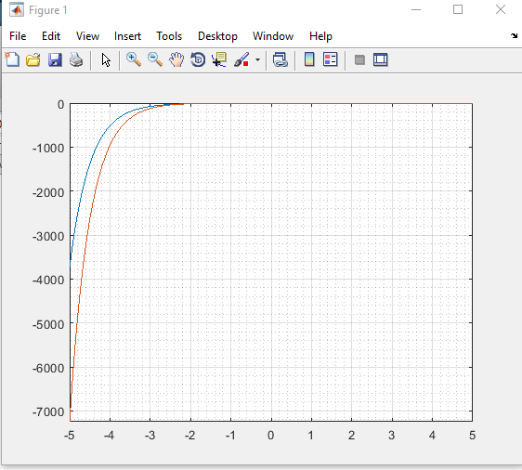

4bii) Separately
commandwindow
clc
clear
syms y(t)x(t)
close all
tim1=diff(y,t)-2*x==exp(-2*t)
tim2=diff(x,t)+y==exp(-t)
tim=[tim1,tim2]
conds=[y(0)==0,x(0)==0]
[yeqxeq]=dsolve(tim,conds)
figure(1)
fplot(yeq)
grid on
grid minor
figure(2)
fplot(xeq)
grid on
grid minor

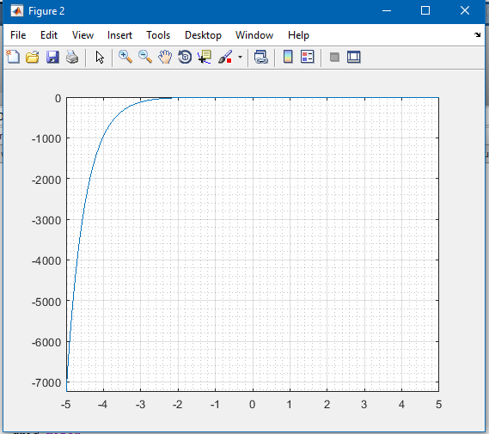

- Commandwindow
clear
Clc
syms wtka
tim=k*exp(-a*t)*sin(5*w*t)*cos(3*w*t)
Ash=laplace(tim)
Ashn=simplify(Ashh)

commandwindow
clear
clc
syms s
Ash=ilaplace((pi/(s^2)+(15*pi*s)+(24*pi^3))
Ashn=simplify(Ash)

