Name: Uzoh Stephanie Amarachi
Matric number: 17/eng03/055
Department: Civil Engineering
ENG 382: (Engineering Mathematics II)
THE CODE
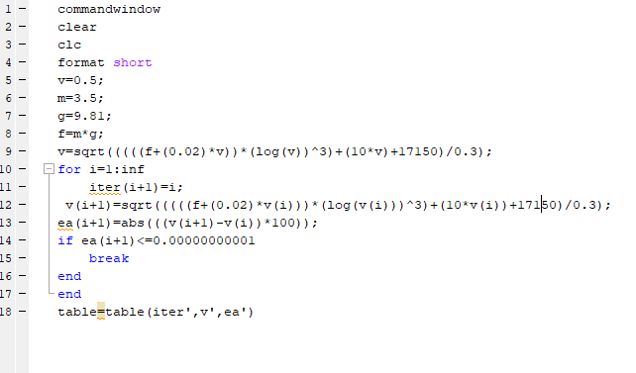

ANSWER;
