NAME: USMAN GIFT AMIRA
MATRIC NUMBER: 17/ENG01/031
DEPARTMENT: CHEMICAL ENGINEERING
ENG 382: (ENGINEERING MATHEMATICS II)
THE CODE
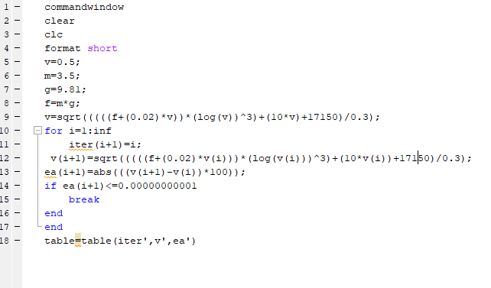

ANSWER;
