NAME: PHILIP LYDIA
MATRIC NUMBER: 17/ENG07/019
DEPARTMENT : PETROLEUM ENGINEERING
ENG 382( ENGINEERING MATHEMATICS II)
THE MATLAB CODE
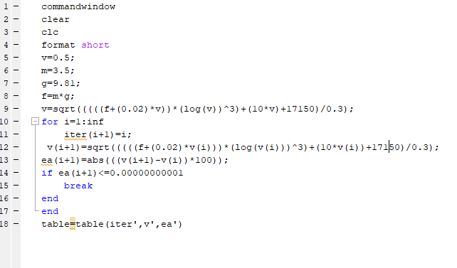

ANSWER;
