Name: Ozoiro Peace Doutimi
Matric number: 17/eng03/048
Department : Civil Engineering
ENG 382: ( Engineering Mathematics II)
THE CODE
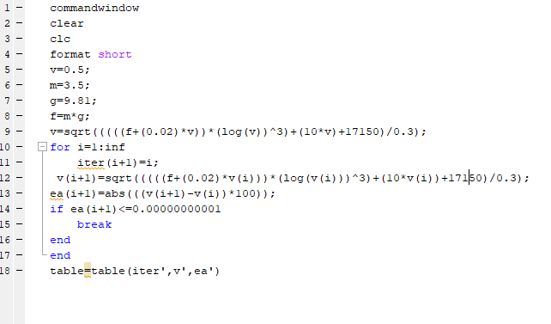

ANSWER;
