Name: Ogundola Damilola Olamide
Department: Chemical Engineering
Matric number: 17/eng01/022
ENG 382 (ENGINEERING MATHEMATICS IV)
The MATLAB PROGRAM;
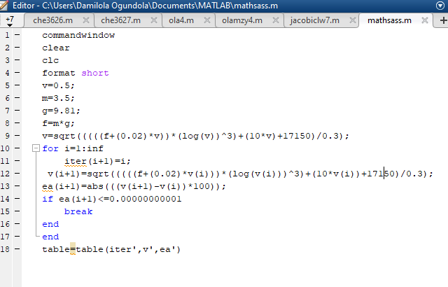

Answer ;
