NAME: DADA TITILOLAMI JADESOLA
MATRIC NUMBER: 19/ENG01/017
DEPARTMENT: CHEMICAL ENGINEERING
ENG 382: (ENGINEERING MATHEMATICS II)
THE CODE
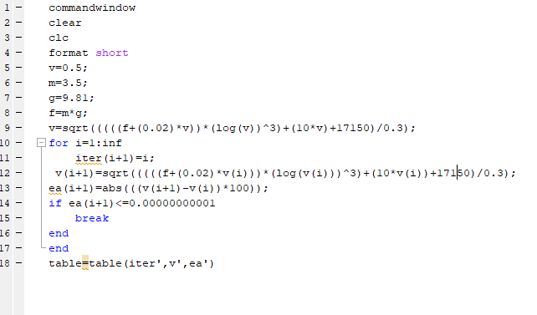

ANSWER;
