Name: Didam Loretta Zugwai
Matric number: 17/eng06/021
Department : Mechanical Engineering
ENG 382: ( Engineering Mathematics IV)
THE CODE
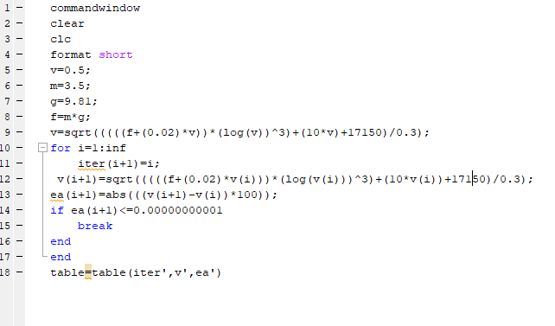

ANSWER;
