NAME: UKPAI CHINENYE SHALOM
MATRIC NUMBER: 17/ENG01/028
DEPARTMENT : CHEMICAL ENGINEERING
ENG 382: ( ENGINEERING MATHEMATICS II)
THE MATLAB CODE
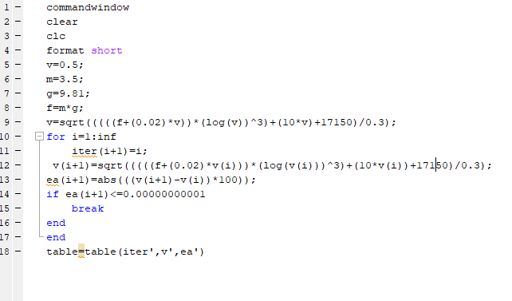

ANSWER;
