Name: Mkpouto ubong obot
Matric number: 17/eng03/015
Department: Civil Engineering
ENG 382: (Engineering Mathematics IV)
THE CODE
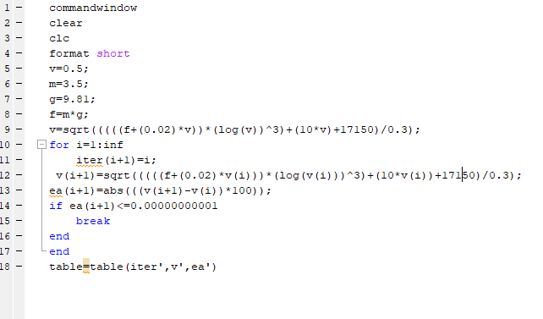

ANSWER;
