ATOLAGBE ABDULBASIT SULEIMAN
17/ENG03/011
ASSIGNMENT TITLE: COMPUTER APPLICATIONS IN HYDROLOGY
COURSE TITLE: BASIC HYDROLOGY
COURSE CODE: CVE302

Question
- Write briefly on any 5 software used in carrying out the hydrological study of a place.

1. PRMS
The modeling code PRMS (Precipitation Runoff Modeling System) is a modular system of spatially distributed parameters, which represent the physical processes of a basin. It was developed by the United States Geological Survey (USGS) to evaluate the effects of several combinations of geomorphology, type of soil, soil use, vegetation and climatic parameters in the hydrological response of a basin.

SWAT
SWAT is a tool to evaluate soil and water at a basin scale. It is focused in precipitation-runoff modeling and transport of water and solutes through surface flow. It predicts the impacts of soil management practices in water resources and sediments

- The Hydrologic Modeling System (HEC-HMS) is designed to simulate the hydrologic processes in basins. The software includes traditional procedures of hydrologic analysis, such as infiltration events, unit hydrograph and routing. HEC-HMS also includes modules for evapotranspiration, snow melting and calculus of soil humidity.

SAGA GIS
SAGA GIS is a GIS platform oriented to spatial analysis. SAGA GIS is a simple but powerful tool, with a big library focused on spatial analysis and characterization of basins. The interpolation options in SAGA GIS are better implemented than in other free and commercial software.

QGIS
QGIS is the most popular GIS tool with an impressive trajectory and a vibrant community. It also even has a particular ecosystem of complements called “plugins”. QGIS is a completely open source alternative that reduces the cost barriers since it does not need a paid license and can be executed in any operative system.

- Using the total direct runoff hydrograph given in fig. Q1, derive a unit hydrograph for the 1715 ac drainage area (provide soft copy of table and all necessary graphs)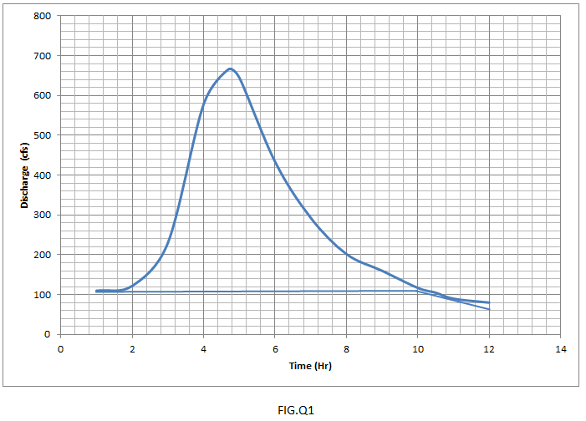

ANSWER

