NAME: OTUBELA PRINCESS OLUWAPAMILERIN
MATRIC NUMBER: 19/MHS01/366
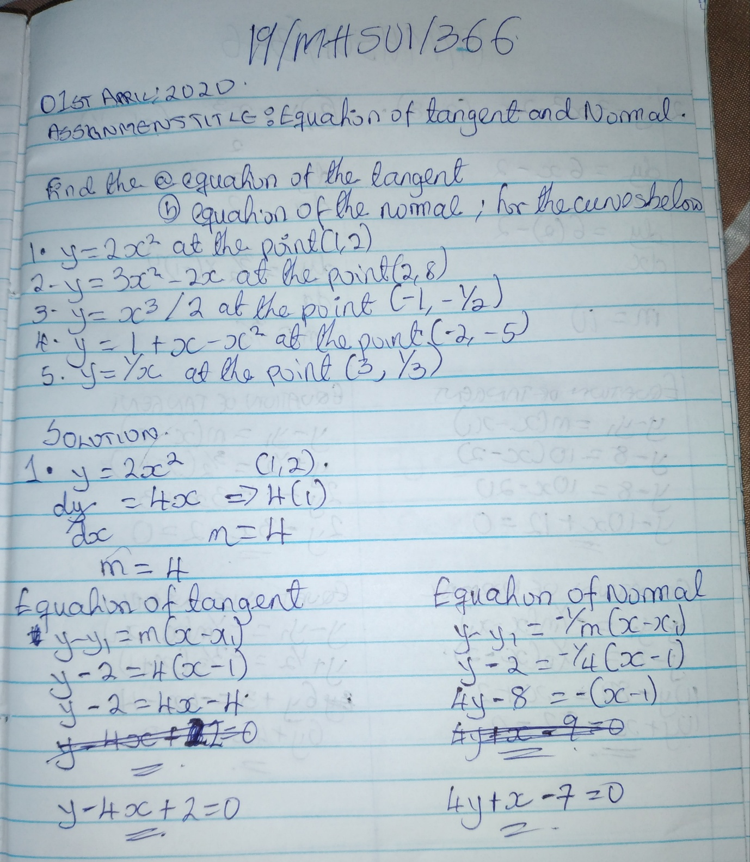
ONLINE ASSIGNMENT (LMS)

