MLS 406 VIROLOGY OPEN TEST
MATRIC NUMBER: 16/MHS06/040
QUESTION: DISCUSS THE ETIOLOGY, ORIGIN, STRUCTURE AND PATHOPHYSIOLOGY OF COVID-19

ETIOLOGY
Coronavirus disease COVID-19 caused by severe acute respiratory syndrome coronavirus 2 (SARS- CoV-2), represents a causative agent of a potentially fatal disease that is of great global public health concern. It is a previously unknown beta coronavirus that was discovered in Bronchoalveolar lavage samples taken from patients who present with pneumonia of unknown case.
Coronavirus are a large family of enveloped RNA viruses, some of which cause illness in people e.g. (common colds, SARS, MERS-middle eastern respiratory syndrome) and others that circulate among mammals. Rarely but possible, animal coronavirus can be spread to humans and subsequently spread between people.
SARS-CoV-2 belongs to the Sarbecovirus subgenus of the Coronaviridae family and is the 7th coronavirus known to affect humans
The SARS Cov-2 has been found to be 96.2% similar to the SARS from bats, but distinct from SARs CoV and the MERS (Middle East Respiratory Syndrome)-CoV.
ORIGIN
The SARS-CoV-2 Is a β-corona virus which is an enveloped non-segmented positive sense RNA virus and belongs to the Sarbecovirus subgenus, Orthocoronavirinae subfamily. Corona viruses are divided into 4 genera including α- β- γ- δ- CoV. The α and β can infect humans while the γ and δ tend to infect birds. Previously six CoVs have been identified as human susceptible virus, among which the α-CoVs: HCOV-229E and HCOV-NL63, and the β-CoVs: HCOV-HKU1 and HCOV-OC43 with low pathogenicity, cause mild respiratory symptoms similar to common cold. The other two β-CoVs: SARS-CoV and MERS-CoV lead to severe and potentially fatal respiratory tract infections
The Initial stages of the outbreak dates back in late December 2019, where a cluster of patients were admitted to hospital with an initial diagnosis of pneumonia of an unknown etiology. These patients were epidemiologically linked to the Huanan seafood and wet animal wholesale market in Wuhan, Hubei Province, South China.
The potential animal reservoir and intermediary host are yet unknown although some studies suggest they may have been derived from a recombinant virus between the bat coronavirus and an origin unknown corona virus, however it is yet to be confirmed that the pangolins have been suggested as the intermediate host as they have been found to be a natural reservoir of SARS-CoV-2
STRUCTURE
Studies have shown that one strain of the SARS-CoV-2 is 29.9Kb while SARS-CoV AND MERS-CoV have RNA genomes of 27.9kb and 30.1kb respectively. it has also been shown that the CoVs contain variable number (6-11) of open reading frames ORFs, Two-third of the Viral RNA, mainly located at the first
ORF translates two polyproteins pp1a and pp1ab, and encodes 16 non structural proteins while the remaining ORFs encode accessory and structural proteins. The other part of the virus genome encodes 4 essential structural proteins including Spike glycoprotein, Small Envelope protein, Matrix protein, Nucleocapsid protein and also several accessory proteins that interfere with the host innate immune response.
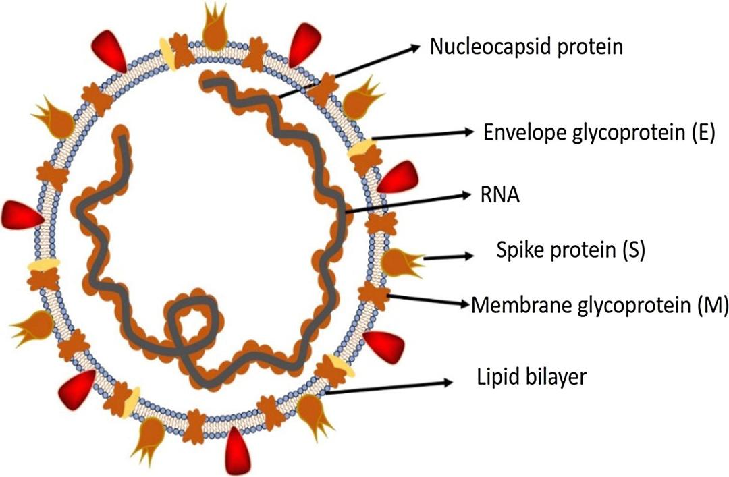
There’re are two major types/strains of the SARS COV2 Virus, designated L and S. The L type has been found to be more prevalent and more aggressive.
PATHOPHYSIOLOGY
The pathophysiology of covid 19 infection as respiratory system targeting virus is severe pneumonia RNAaemie combined with the incidence of ground glass opacities and acute cardiac injury. Significantly high blood level of cytokines and chemokines are noted in patients with covid 19 infection that includes ILI-B, IL1RA, IL7, IL8, IL9, IL10, basic FGF2, GCSF etc. some of the severe cases that were admitted to the intensive care unit showed high levels of pro inflammatory cytokines including IL2, IL7, IL10, GCSF,IP10, TNFa etc. that are reasoned to promote disease severity.
The symptoms of covid 19 infections appear after an incubation period of 5 days. The period from onset of covid 19 symptoms to death ranged from 6 to 41 days with a median of 14 days. This period is largely dependent on the age of the individual and the status of the patient’s immune system. The incubation period is shorter in patients between and above the age 70. The most common symptoms at onset of covid 19 illness are Fever, dry cough and fatigue while other symptoms include sputum production, headache, hemoptysis, diarrhea, dyspnea, and lymphopenia. Clinical features revealed by a chest CT scan presented as pneumonia, however there are abnormal features like RNAaemia, acute respiratory distress syndrome acute cardiac injury incidence of grand-glass opacities
REFRENCES
https://newbp.bmj.com/topics/en-us/3000168/aetiology
https://www.researchgate.net/publication/339925460_The_origin_transmission_and_clinical_therapies_on_coronavirus_disease_2019_COVID-19_outbreak_-_an_update_on_the_status
https://www.sciencedirect.com/science/article/pii/S2090123220300540
https://www.sciencedirect.com/science/article/pii/S0896841120300469?via%3Dihub

