MATRIC NUMBER: 17/MHS06/068
COURSE CODE: MLS 406 (VIROLOGY)
ASSIGNMENT: Discuss the etiology, origin, structure and pathophysiology of COVID – 19

INTRODUCTION
Corona virus comprises of a large family of viruses that are common in human beings as well animals (camels, cattle, cats, and bats). There are seven different strains of corona virus but the strain of concern is;
- SARS-CoV-2 (the novel coronavirus that causes coronavirus disease 2019, or COVID-19)
Sometimes corona virus from animals infect people and spread further via human to human transmission such as with MERS-CoV, SARS-CoV, and now with this COVID 19 (Corona disease 2019). The virus that causes COVID-19 is designated severe acute respiratory syndrome corona virus 2 (SARS-CoV-2); previously, referred to as 2019-nCoV. Towards December 2019, this novel corona virus was identified as a cause of upper and lower respiratory tract infections in Wuhan, a city in the Hubei Province of China. It rapidly spread, resulting in an epidemic throughout China and then gradually spreading to other parts of the world in pandemic proportions. It has affected almost every continent in this world, except Antarctica. In February 2020, the World Health Organization designated the disease COVID-19, which stands for corona virus disease 2019.

ORIGIN
The outbreak was initiated from the Hunan seafood market in Wuhan city of China and rapidly infected more than 50 peoples. The live animals are frequently sold at the Hunan seafood market such as bats, frogs, snakes, birds, marmots and rabbits. On 12 January 2020, the National Health Commission of China released further details about the epidemic, suggested viral pneumonia.
From the sequence-based analysis of isolates from the patients, the virus was identified as a novel coronavirus. Moreover, the genetic sequence was also provided for the diagnosis of viral infection. Initially, it was suggested that the patients infected with Wuhan coronavirus induced pneumonia in China may have visited the seafood market where live animals were sold or may have used infected animals or birds as a source of food. However, further investigations revealed that some individuals contracted the infection even with no record of visiting the seafood market. These observations indicated a human to the human spreading capability of this virus, which was subsequently reported in more than 100 countries in the world. The human to the human spreading of the virus occurs due to close contact with an infected person, exposed to coughing, sneezing, respiratory droplets or aerosols.

ETIOLOGY
Many health experts believe that the new strain of coronavirus likely originated in bats or pangolins. The first transmission to humans was in Wuhan, China. Since then, the virus has mostly spread through person-to-person contact.
Coronaviruses are enveloped single-stranded RNA viruses that are zoonotic in nature and cause symptoms ranging from those similar to the common cold to more severe respiratory, enteric, hepatic, and neurological symptoms. Other than SARS-CoV-2, there are six known coronaviruses in human;
229E (alpha coronavirus)
NL63 (alpha coronavirus)
OC43 (beta coronavirus)
HKU1 (beta coronavirus)
MERS-CoV (the beta coronavirus that causes Middle East Respiratory Syndrome or MERS)
SARS-CoV (the beta coronavirus that causes severe acute respiratory syndrome, or SARS)

To detect the infection source of COVID-19, China CDC researchers collected 585 environmental samples from the Huanan Seafood Market in Wuhan, Hubei Province, China on 1 January and 12 January 2020. They detected 33 samples containing SARS-CoV-2 and indicated that it originated from wild animals sold in the market. Then, researchers used the lung fluid, blood, and throat swab samples of 15 patients to conduct laboratory tests. These laboratory tests found that the virus-specific nucleic acid sequences in the sample are different from those of known human coronavirus species. Laboratory results also indicated that SARS-CoV-2 is similar to some of the beta (β) coronaviruses genera identified in bats, which is situated in a group of SARS/SARS-like CoV.
To conduct next-generation sequencing from bronchoalveolar lavage fluid and cultured isolates, researchers enrolled nine inpatients in Wuhan with viral pneumonia and negative in common respiratory pathogens. The results of this next-generation sequencing indicated that SARS-CoV-2 was more distant from SARS-CoV (with about 79% sequence identity) and MERS-CoV (with about 50% sequence identity) than from two bat-derived SARS-like coronaviruses – bat-SL-CoVZC45 (with 87.9% sequence identity) and bat-SL-CoVZXC21 (with 87.2% sequence identity). Studies also reported that COVID-19 S-protein supported strong interaction with human ACE2 molecules despite the dissimilarity of its sequence with that of SARS-CoV.

STRUCTURE OF CORONA VIRUS (COVID-19)
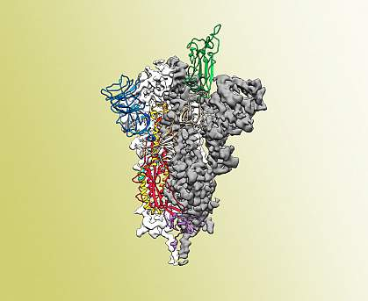
Coronavirus virions are spherical to pleomorphic enveloped particles. The envelope is studded with projecting glycoproteins, and surrounds a core consisting of matrix protein enclosed within which is a single strand of positive-sense RNA (Mr 6 × 106) associated with nucleoprotein. The envelope glycoproteins are responsible for attachment to the host cell and also carry the main antigenic epitopes, particularly the epitopes recognized by neutralizing antibodies. OC43 also possesses a haemagglutin.
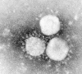
Electron micrograph showing human coronavirus 229E. Bar, 100 mn (Courtesy S.Sikotra, Leicester Royal Infirmary, Leicester, England.)

PATHOPHYSIOLOGY OF CORONA VIRUS (COVID-19)
The covid-19 virus could be transmitted via two various routes;
- Feacal-oral route
- Respiratory droplets (airborne)

Feacal-oral Route
The fecal–oral route (also called the oral–fecal route or orofecal route) describes a particular route of transmission of a disease wherein pathogens in fecal particles pass from one person to the mouth of another person. This could be due to improper hygiene and contact of poorly washed hands on surfaces wherein others come in contact and inoculate themselves with the virus through the oral route.
This could also be due to faulty plumbing system in poorly developed households.

Respiratory Droplet (Airborne )
Some diseases can be transferred by infected droplets contacting surfaces of the eye, nose, or mouth. This is referred to as droplet contact transmission. Droplets containing microorganisms can be generated when an infected person coughs, sneezes, or talks. Droplets can also be generated during certain medical procedures, such as bronchoscopy. Droplets are too large to be airborne for long periods of time, and quickly settle out of air.
Airborne transmission refers to situations where droplet nuclei (residue from evaporated droplets) or dust particles containing microorganisms can remain suspended in air for long periods of time. These organisms must be capable of surviving for long periods of time outside the body and must be resistant to drying. Airborne transmission allows organisms to enter the upper and lower respiratory tracts. Fortunately, only a limited number of diseases are capable of airborne transmission. E.g covid 19

PATHOPHYSIOLOGY
The virus gets into the respiratory system and migrates down to the alveoli where it attaches to cause a cytopathic effect.
In the alveoli, the virus attaches to Type 2 pneumocyte (The cell responsible for the production and secretion of surfactant (the molecule that reduces the surface tension of pulmonary fluids and contributes to the elastic properties of the lungs).
The covid-19 has different types of spike proteins located on its surface. It contain the S-spike which is majorly responsible for its attachment to specific receptors found on the type 2 pneumocyte known as the Angiotensin converting enzyme type 2 (an enzyme attached to the outer surface (cell membranes) of cells in the lungs, arteries, heart, kidney, and intestines.)
The binding of the virus to the receptor sites on the alveoli allows the virus to be engulfed into the cell. In the cell the virus releases RNA (+ sense single stranded RNA) into the cytoplasm of the type 2 pneumocyte .Once released into the host cell it uses the host cell ribosomes to covert mRNA into proteins through a process called Translation. Hence this single stranded RNA are converted into specific proteins molecules

The + stranded RNA also uses another enzyme called RNA dependent RNA polymerase which synthesizes RNA. This leads to the production of more RNA molecules which are more + stranded RNA. Other enzymes known as proteinases which proteolytically cleave the specific proteins which forms spike proteins, nucleic capsid, enzymes and other viral components which forms more viral entity as they bud off from the type 2 pneumocyte which in turn destroys the type 2 pneumocyte cell
As the type 2 pneumocyte cell are been destroyed they release specific inflammatory mediators, once these mediators are released they stimulate activation of macrophages which releases specific cytokines. They are;
- Interleukin 1
- Interleukin 6
- Tumor necrotic factor-alpha

PATHOPHYSIOLOGICAL EFFECT
- Interstitial Odema/ Alveoli Odema And Alveoli Collapse
These cytokines migrates to the bloodstream and causes the endothelial cells to dialate but increase the capillary permeability by causing endothelial cell contraction
This leads to vasodilation and increase capillary contraction as this occurs plasma starts leaking into the interstitial spaces (interstitial odema) and also into the alveoli (alveoli odema). Accumulation of all these fluids outside the alveoli leads to compression of the alveoli. As these happen some of this fluid also tries to migrate into the alveoli causing fluid to accumulate in the alveoli reducing the surfactants concentrtion and increase the surface tension causing the alveoli to collapse.
NOTE: As surface tension increase collapsing pressure also increases
These whole process leads to decrease gas exchange which leads to hypoxemia which increases the work of breathing.
The inflammatory mediators are also responsible for the migration of neutrophils to the site of infection where they try to destroy the virus by releasing reactive oxygen species such as proteases which destroys some of the virus but also damage some of the cells found in the alveoli especially the type 1 & 2 pneumocyte
This process leads to decrease gas exchange and also decrease in the concentration of surfactant leading to the compression of the alveoli which leads to shortness of breath.
Degradation of alveoli with its constituents leads to coughing out of mucous substances as a reflex action to expel contaminants.
- FEVER
When IL-1 and IL-6 are released in high concentration in the body it travels via the blood to the central nervous system. In the CNS we have the hypothalamus which controls the temperature these inflammatory mediators stimulates the hypothalamus to release specific prostaglandins (PGE2 ) which reset the thermostat and cause increase the body temperature known as Fever.
- SYSTEMIC INFLAMMATORY RESPONSE SYNDROME
Inflammation of the lungs leads to a condition called inflammatory response syndrome Systemic inflammatory response syndrome (SIRS) is an exaggerated defense response of the body to a noxious stressor (infection, trauma, surgery, acute inflammation, ischemia or reperfusion, or malignancy to name a few) to localize and then eliminate the endogenous or exogenous source of the insult. It involves the release of acute-phase reactants which are direct mediators of widespread autonomic, endocrine, hematological and immunological alteration in the subject. Increase of inflammation round the circulatory system leads to increase capillary permeability within the circulatory system as fluids start leaking out and accumulating in tissue spaces the overall blood volume decreases causing vasodilation of systemic arterioles and peripheral resistance drops.
Decrease in total peripheral resistance and blood volumes leads to a sudden decrease in blood pressure known as hypotension. These decrease the profusion to multiple different organs and these can lead to multisystem organ failure such as kidney failure(indicators are high BuN, Creatinine),liver failure(causing rise in ALT, ASP,ALT Bilirubin, fibrinogen,IL-6 e,t,c).
Even though the purpose is defensive, the dysregulated cytokine storm has the potential to cause massive inflammatory cascade leading to septic shocm,reversible or irreversible end-organ dysfunction and even death
The incubation period for this virus is 4-14 days

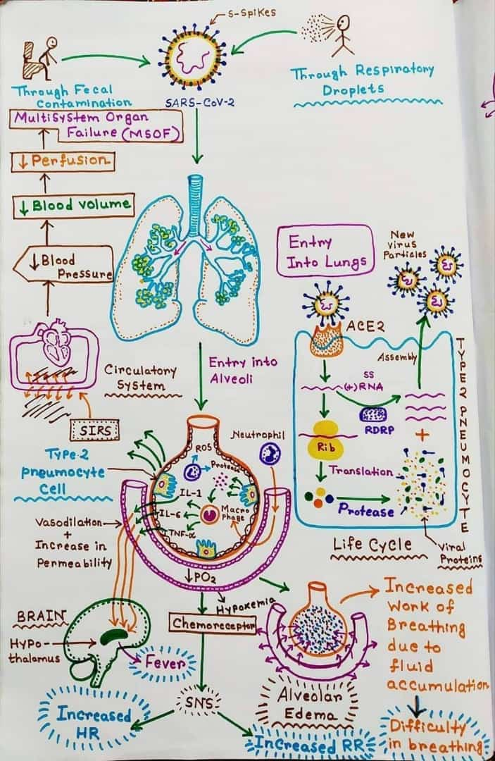
REFERNCES
- https://eportal.mountsinai.ca/Microbiology/faq/transmission.shtml
- https://www.ncbi.nlm.nih.gov/books/NBK547669/
- https://www.ncbi.nlm.nih.gov/books/NBK7782/
- https://www.sciencedirect.com/topics/biochemistry-genetics-and-molecular-biology/type-ii-pneumocyte
- https://youtu.be/PWzbArPgo-o
- INTERNATIONAL PULMONOLOGIST’S CONSENSUS ON COVID-19 : Chief Editors Dr. Tinku Joseph (India), Dr. Mohammed Ashkan Moslehi (Iran), 2020.

