16/MHS01/033
MLS 406
TEST
QUESTION: Discuss etiology, origin, structure and pathophysiology of COVID-19.
ANSWERS:
THE ETIOLOGY AND ORIGIN OF COVID-19
The Coronavirus (COVID-19) is an enveloped single-stranded RNA viruses that are zoonotic in nature and cause symptoms ranging from those similar to the common cold to more severe respiratory, enteric, hepatic, and neurological symptoms .Other than SARS-CoV-2, there are six known coronaviruses in humans: HCoV-229E, HCoV-OC43, SARS-CoV, HCoV- NL63, HCoV-HKU1, and MERS-CoV [2,]. Coronavirus has caused two large-scale pandemics in the last two decades: SARS] and MERS].. SARS-CoV-2 is a β-coronavirus, which is enveloped non-segmented positive-sense RNA virus (subgenus sar-becovirus,Orthocoronavirinae subfamily) ]. Corona-viruses (CoV) are divided into four genera, including α−/β−/γ−/δ-CoV. α- and β-CoV are able to infect mammals ,while γ- and δ-CoV tend to infect birds. Previously, sixCoVs have been identified as human-susceptible virus, among which α-CoVs HCoV-229E and HCoV-NL6 ,and β-CoVs HCoV-HKU1 and HCoV-OC43 with low pathogenicity, cause mild respiratory symptoms similar to a common cold, respectively. The other two knownβ-CoVs, SARS-CoV and MERS-CoV lead to severe and potentially fatal respiratory tract infections ]. It was found that the genome sequence of SARS-CoV-2 is96.2% identical to a bat CoV RaTG13, whereas it shares79.5% identity to SARS-CoV. Based on virus genome sequencing results and evolutionary analysis, bat or pangolins has been suspected as natural host of virus origin, and SARS-CoV-2 might be transmitted from bats via unknown intermediate hosts to infect humans. It is clear now thatSARS-CoV-2 could use angiotensin-converting enzyme2 (ACE2), the same receptor as SARS-CoV , to infect humans. The acute respiratory tract infection broke out first in Wuhan, China, possibly related to a seafood market. Several studies suggested that bat or pangolins may be the potential reservoir ofSARS-CoV-2 .

THE GENOME STRUCTURE
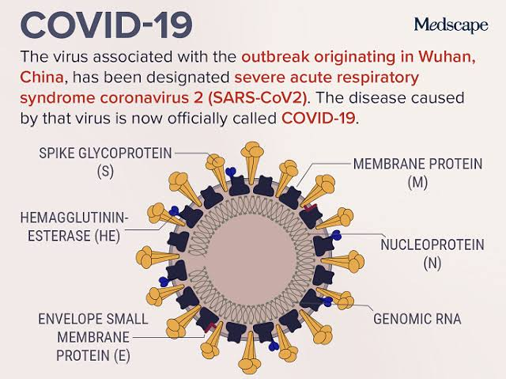
one strain of SARS-CoV-2, is 29.9 kb [14]. While SARS-CoV and MERS- CoV have positive-sense RNA genomes of 27.9 kb and 30.1 kb, respectively . It has been shown that the genome ofCoVs contains a variable number (6–11) of open reading frames (ORFs) [20]. Two-thirds of viral RNA, mainly located in the first ORF (ORF1a/b) translates two poly proteins , pp1a and pp1ab, and encodes 16 non-structural proteins (NSP), while the remaining ORFs encode accessory and structural proteins. The rest part of virus genome encodes four essential structural proteins, including spike (S) glycoprotein, small envelope (E) protein matrix (M) protein, and nucleocapsid (N) protein and also several accessory proteins, that interfere with the host innate immune response. Wu et al. [14]have recently preformed deep meta- transcript sequencing onWHCV, which contained 16 predicted NSP. WHCV exhibit some genomic and phylogenetic similarity toSARS-CoV, particularly in the S-glycoprotein gene receptor binding domain indicating the capability of direct human transmission.
S protein attaching to host receptor ACE2, including 2 sub units S1 &S2
S1 determines the virus host range by RBD
S2 mediated virus cell membrane fusion by HR1 & HR2

M protein responsible for the transmembrane transport of nutrients, the
Bud release and formation of envelope

N, E protein and several accessory proteins interfered with host immune
Response or unknown function

PATHOPHYSIOLOGY
Similar mechanisms may underline the pathogenesis of both MERS and SARS
Spike protein bind to ACE2 ( angiotensin – converting enzyme 2)causing its down regulation
. Lung injury occurs because ACE2 naturally protects against acute lung injury
. Excessive angiotensin II protection by the related enzyme ACE1
. Excessive angiotensin II causes excessive stimulation of type 1a angiotensin II (AGTR1A)
Which increases pulmonary vascular permeability .
. This explains the increased lung pathology when the expression of ACE2 is decreased.
SARS-CoV-2 is transmitted predominantly via respiratory droplet, contact, and potential in fecal-oral [14]. Primary viral replication is presumed to occur in mucosal epithelium of upper respiratory tract (nasal cavity and pharynx), with further multiplication in lower respiratory tract and gastrointestinal mucosa [50], giving rise to a mild viremia. Few infections are controlled at this point and remain asymptomatic. Some patients have also exhibited non-respiratory symptoms such as
acute liver and heart injury, kidney failure, diarrhea, implying multiple organ involvement. ACE2 is broadly expressed in nasal mucosa, bronchus, lung, heart, esophagus, kidney, stomach, bladder, and ileum, and these human organs are all vulnerable to SARS-CoV-2 .

REFERENCES
1. Li, Q.; Guan, X.; Wu, P.; Wang, X.; Zhou, L.; Tong, Y.; Ren, R.; Leung, K.S.M.; Lau, E.H.Y.; Wong, J.Y.; et al. Early Transmission Dynamics in Wuhan, China, of Novel Coronavirus–Infected Pneumonia. N. Engl. J. Med. 2020. [CrossRef] [PubMed]
Viruses 2020, 12, 372 13 of 17
2. Zhu, N.; Zhang, D.; Wang, W.; Li, X.; Yang, B.; Song, J.; Zhao, X.; Huang, B.; Shi, W.; Lu, R.; et al. A Novel Coronavirus from Patients with Pneumonia in China, 2019. N. Engl. J. Med. 2020. [CrossRef] [PubMed]
3. World Health Organization Press Conference. The World Health Organization (WHO) Has Officially Named the Disease Caused by the Novel Coronavirus as COVID-19. Available online: https://www.who.int/ emergencies/diseases/novel-coronavirus-2019 (accessed on 11 February 2020).
4. Gorbalenya, A.E.; Baker, S.C.; Baric, R.S.; de Groot, R.J.; Drosten, C.; Gulyaeva, A.A.; Hangman’s, B.L.; Lauber, C.; Leontovich, A.M.; Neuman, B.W.; et al. Severe acute respiratory syndrome-related coronavirus: The species and its viruses—A statement of the Coronavirus Study Group. bioRxiv 2020. [CrossRef]
5. Huang, C.; Wang, Y.; Li, X.; Ren, L.; Zhao, J.; Hu, Y.; Zhang, L.; Fan, G.; Xu, J.; Gu, X.; et al. Clinical features of patients infected with 2019 novel coronavirus in Wuhan, China. Lancet (Lond. Engl.) 2020, 395, 497–506. [CrossRef]
6.. Angeletti S, Benvenuto D, Bianchi M, Giovanetti M, Pascarella S, Ciccozzi M.COVID-2019: the role of the nsp2 and nsp3 in its pathogenesis. J Med Virol.2020.
7. Zhang L, Shen FM, Chen F, Lin Z. Origin and evolution of the 2019 novel Coronavirus. Clin Infect Dis. 2020. https://doi.org/10.1093/cid/ciaa112 [Epubahead of print].
8.. Wu D, Zou S, Bai T, Li J, Zhao X, Yang L, et al. Poultry farms as a source of avian influenza a (H7N9) virus reassortment and human infection. Sci Rep.2015;5:7630.
9.Wu J, Chen ZJ. Innate immune sensing and signaling of cytosolic nucleic acids. Annu Rev Immunology . 2014;32:461–88
.10.. Yoo JS, Kato H, Fujita T. Sensing viral invasion by RIG-I like receptors. CurrOpin Microbiol. 2014;20:131–8.
11 Wu J, Sun L, Chen X, Du F, Shi H, Chen C, et al. Cyclic GMP-AMP is an endogenous second messenger in innate immune signaling by cytosolicDNA. Science. 2013;339(6121):826–30

