NAME: GBADAMOSI LATIFAH TEMIDAYO
MATRIC NO: 16/MHS06/023
COURSE: MLS 406 (VIROLOGY)

OPEN TEST
Discuss the etiology, origin, structure and pathophysiology of COVID – 19

ANSWER
INTRODUCTION
Coronaviruses belong to the Coronaviridae family in the Nidovirales order that may cause various symptoms such as pneumonia, fever, breathing difficulty, and lung infection. Corona represents crown-like spikes on the outer surface of the virus; thus, it was named as a coronavirus. Coronaviruses are minute in size (65–125 nm in diameter) and contain a single-stranded RNA as a nucleic material, size ranging from 26 to 32kbs in length. The subgroups of coronaviruses family are 8 in number:
- alpha (α),
- beta (β),
- gamma (γ),
- delta (δ) coronavirus,
- the severe acute respiratory syndrome coronavirus (SARS-CoV),
- H5N1 influenza A, H1N1 2009,
- SARS-CoV-2 (the novel coronavirus that causes coronavirus disease 2019, or COVID-19) and
- Middle East respiratory syndrome coronavirus (MERS-CoV) cause acute lung injury (ALI) and acute respiratory distress syndrome (ARDS) which leads to pulmonary failure and result in fatality.
These viruses were thought to infect only animals until the world witnessed a severe acute respiratory syndrome (SARS) outbreak caused by SARS-CoV, 2002 in Guangdong, China. Only a decade later, another pathogenic coronavirus, known as Middle East respiratory syndrome coronavirus (MERS-CoV) caused an endemic in Middle Eastern countries.
The World Health Organization (WHO) used the term 2019 novel coronavirus to refer to a coronavirus that affected the lower respiratory tract of patients with pneumonia in Wuhan, China on 29 December 2019. The WHO announced that the official name of the 2019 novel coronavirus is coronavirus disease (COVID-19). And the current reference name for the virus is severe acute respiratory syndrome coronavirus 2 (SARS-CoV-2). It was reported that a cluster of patients with pneumonia of unknown cause was linked to a local Huanan South China Seafood Market in Wuhan, Hubei Province, China in December 2019.
In response to the outbreak, the Chinese Centre for Disease Control and Prevention (China CDC) dispatched a rapid response team to accompany health authorities of Hubei province and Wuhan city to conduct epidemiological and etiological investigations. The WHO confirmed that the outbreak of the coronavirus epidemic was associated with the Huanan South China Seafood Marketplace, but no specific animal association was identified. Scientists immediately started to research the source of the new coronavirus, and the first genome of COVID-19 was published by the research team led by Prof. Yong-Zhen Zhang, on 10 January 2020. Within 1 month, this virus spread quickly throughout China during the Chinese New Year – a period when there is a high level of human mobility among Chinese people. Although it is still too early to predict susceptible populations, early patterns have shown a trend similar to that of Severe Acute Respiratory Syndrome (SARS) and Middle East respiratory syndrome (MERS) coronaviruses. Susceptibility seems to be associated with age, biological sex, and other health conditions. COVID-19 has now been declared as a Public Health Emergency of International Concern by the WHO.
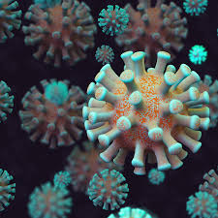

ETIOLIGY OF COVID – 19
Recently, by the end of 2019, WHO was informed by the Chinese government about several cases of pneumonia with unfamiliar etiology. The outbreak was initiated from the Hunan seafood market in Wuhan city of China and rapidly infected more than 50 peoples. The live animals are frequently sold at the Hunan seafood market such as bats, frogs, snakes, birds, marmots and rabbits. On 12 January 2020, the National Health Commission of China released further details about the epidemic, suggested viral pneumonia. From the sequence-based analysis of isolates from the patients, the virus was identified as a novel coronavirus. Moreover, the genetic sequence was also provided for the diagnosis of viral infection. Initially, it was suggested that the patients infected with Wuhan coronavirus induced pneumonia in China may have visited the seafood market where live animals were sold or may have used infected animals or birds as a source of food. However, further investigations revealed that some individuals contracted the infection even with no record of visiting the seafood market. These observations indicated a human to the human spreading capability of this virus, which was subsequently reported in more than 100 countries in the world. The primary human to the human spreading of the virus occurs due to close contact with an infected person, exposed to coughing, sneezing, respiratory droplets or aerosols. These respiratory droplets or aerosols can penetrate the human body (lungs) via inhalation through the nose or mouth. Another mode of transmission is through the fecal to oral route. Viruses are deposited in faeces and these viral particles get into the oral cavity of an uninfected person.
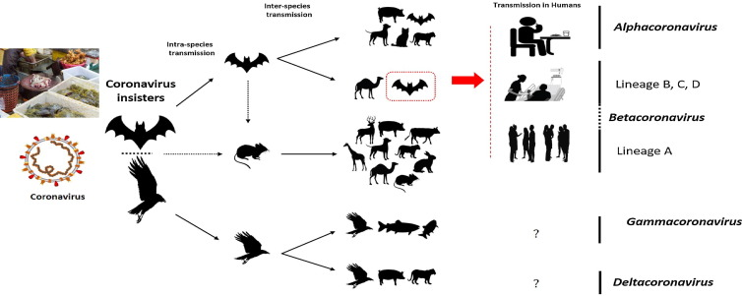
: The key reservoirs and mode of transmission of coronaviruses (suspected reservoirs of SARS-CoV-2 are red encircled); only α and β coronaviruses have the ability to infect humans, the consumption of infected animal as a source of food is the major cause of animal to human transmission of the virus and due to close contact with an infected person, the virus is further transmitted to healthy persons. Dotted black arrow shows the possibility of viral transfer from bat whereas the solid black arrow represents the confirmed transfer.

ORIGIN OF COVID – 19
According to the World Health Organization, COVID-19 is the infectious disease caused by the most recently discovered coronavirus. A school of thought believes that a 55-year-old individual from Hubei province in China may have been the first person to have contracted COVID-19, the disease caused by the new coronavirus spreading across the globe. That case dates back to Nov. 17, 2019, according to the South Morning China Post.
The recent outbreak began in Wuhan, a city in the Hubei province of China. Reports of the first COVID-19 cases started in December 2019.
Coronaviruses are common in certain species of animals, such as cattle and camels. Although the transmission of coronaviruses from animals to humans is rare, this new strain likely came from bats, though one study suggests pangolins may be the origin.
However, it remains unclear exactly how the virus first spread to humans.
Some reports trace the earliest cases back to a seafood and animal market in Wuhan. It may have been from here that SARS-CoV-2 started to spread to humans.

STRUCTURE OF COVID – 19
Coronavirus virions are spherical to pleomorphic enveloped particles. SARS-CoV-2 possesses the typical coronavirus structure with its envelope studded with projecting spike protein and also expressed other polyproteins, nucleoproteins, and membrane proteins, such as RNA polymerase, 3-chymotrypsin-like protease, papain-like protease, helicase, glycoprotein, and accessory proteins. It surrounds a core consisting of matrix protein enclosed within which is a single strand of positive-sense RNA (Mr 6 × 10⁶) associated with nucleoprotein. The envelope glycoproteins are responsible for attachment to the host cell and also carry the main antigenic epitopes, particularly the epitopes recognized by neutralizing antibodies. OC43 also possesses a haemagglutin.
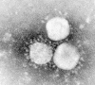
Electron micrograph showing human coronavirus 229E. Bar, 100 mn (Courtesy S.Sikotra, Leicester Royal Infirmary, Leicester, England.)

The spike protein of SARS-CoV-2 contains a 3-D structure in the RBD region to maintain the Vander Waals forces. The 394-glutamine residue in the RBD region of SARS-CoV-2 is recognized by the critical lysine 31 residue on the human ACE2 receptor.
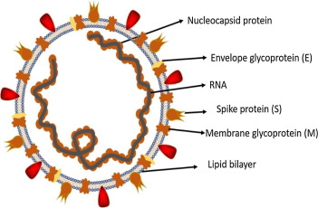

PATHOPHYSIOLOGY OF COVID – 19
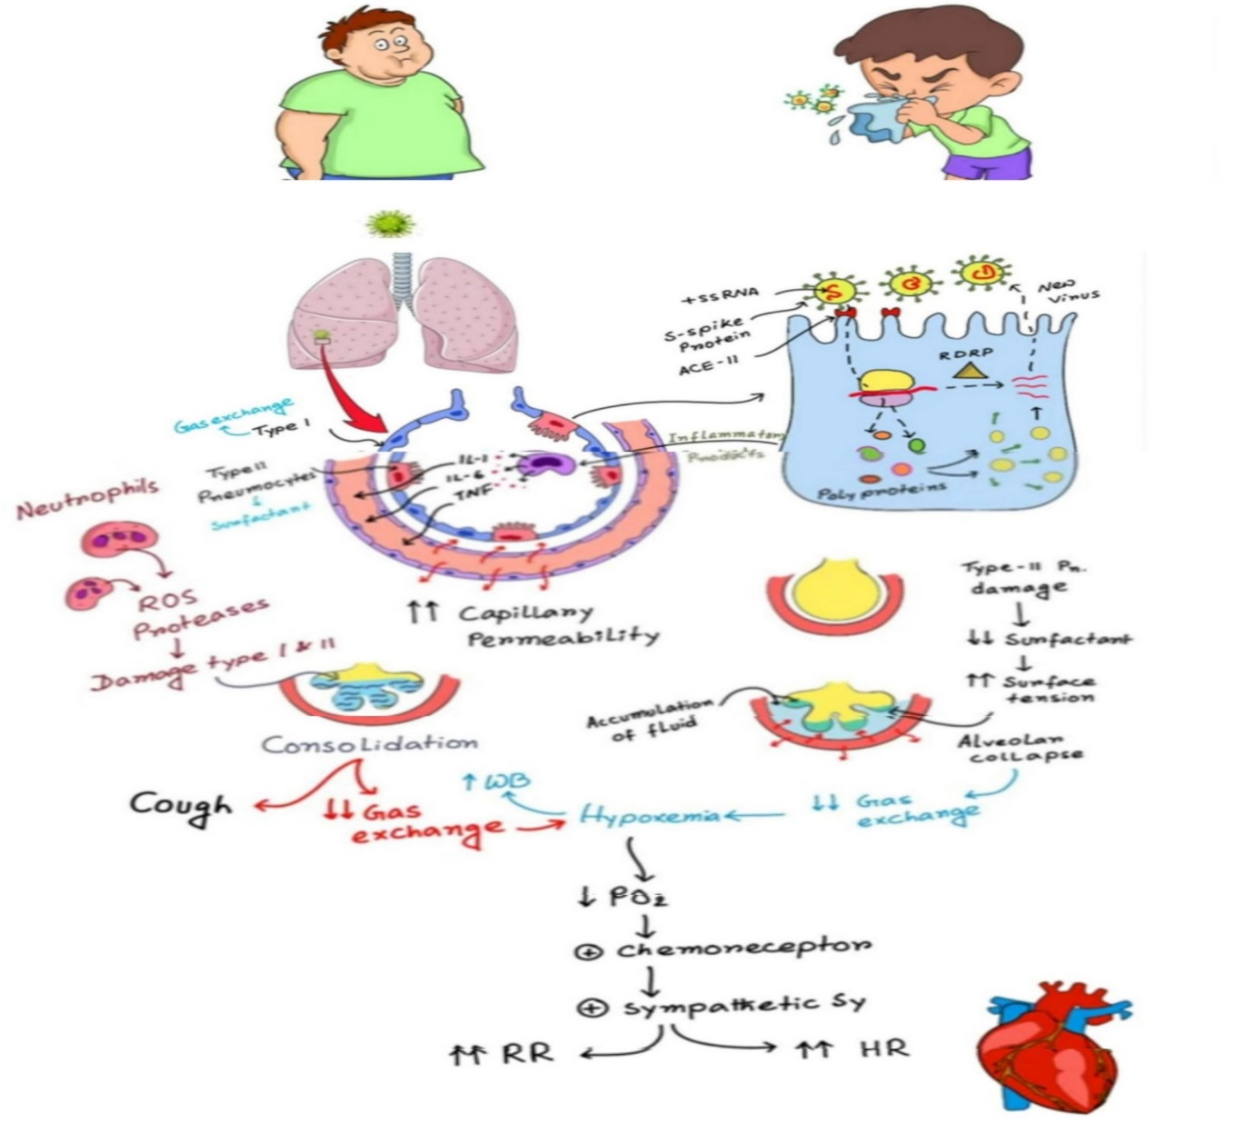
All coronaviruses contain specific genes in ORF1 downstream regions that encode proteins for viral replication, nucleocapsid and spikes formation. The glycoprotein spikes on the outer surface of coronaviruses are responsible for the attachment and entry of the virus to host cells. The receptor-binding domain (RBD) is loosely attached among virus, therefore, the virus may infect multiple hosts. Other coronaviruses mostly recognize aminopeptidases or carbohydrates as a key receptor for entry to human cells while SARS-CoV and MERS-CoV recognize exopeptidases.
Once the COVID-19 virus enters the respiratory system, it first goes to the alveoli. There are 2 important cells in the alveoli, the type 1 and type 2 Pneumocytes. The type 1 Pneumocytes help in gas exchange and type 2 Pneumocytes produce surfactants. The surfactants help to decrease the surface tension in the alveoli and prevent it from collapsing. The virus mainly attacks the type 2 pneumocytes. The receptors on the type 2 pneumocytes are called Angiotensin Converting Enzyme type 2 (ACE-II) and they attach to the spike protein on the virus and allows the virus entry into the cell. When inside the type 2 pneumocytes, they release single stranded adenine which enters the host cell’s ribosome to start producing different protein molecules (polyproteins) which are products of the virus itself. The virus also uses another important enzyme called RNA-dependent RNA polymerase (RdRP, RDR) to synthesize more RNA molecules. Combination of the virus’s polyproteins and RNA molecules in the host’s cell can give rise to a complete new COVID-19 virus. This causes the body to replicate tons new COVID-19 virus as the process is repeated continuously.
As the virus damages the type 2 pneumocytes, it releases numerous cytokines and inflammatory products which in turn activates macrophages. These activated macrophages release specific cytokines such as interleukin-1 (IL-1), interlekin-6 (IL-6) and tumour necrosis factor (TNF). These specific cytokines enter the capillaries which are surrounded by the alveoli and cause capillary smooth muscle relaxation and endothelial cell rejection and contraction. All those events finally lead to vasodilation and increased capillary permeability. The consequences of this is plasma spillage into the interstitial spaces and compression of the alveoli to accumulate more fluid which washes out the surfactant.
Therefore, damage to type 2 pneumocytes reduced surfactant increased surface tension alveolar collapse reduced gas exchange HYPOXEMIA. Hypoxemia (reduced oxygen tension in blood) in turn causes an increased work of breathing.

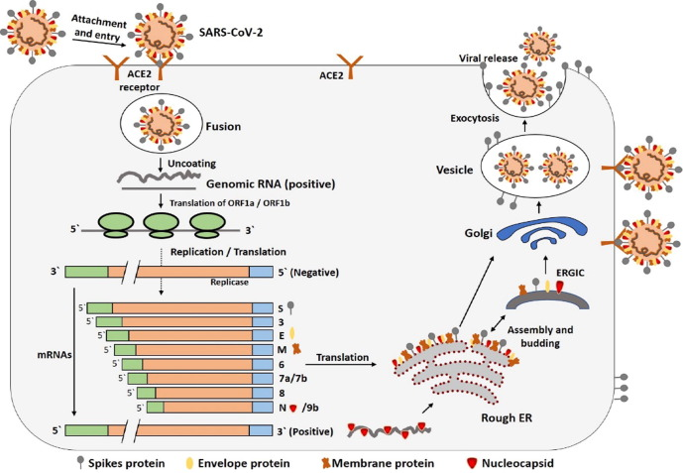
Fig. 3. The life cycle of SARS-CoV-2 in host cells; begins its life cycle when S protein binds to the cellular receptor ACE2. After receptor binding, the conformation change in the S protein facilitates viral envelope fusion with the cell membrane through the endosomal pathway. Then SARS-CoV-2 releases RNA into the host cell. Genome RNA is translated into viral replicase polyproteins pp1a and 1ab, which are then cleaved into small products by viral proteinases. The polymerase produces a series of subgenomic mRNAs by discontinuous transcription and finally translated into relevant viral proteins. Viral proteins and genome RNA are subsequently assembled into virions in the ER and Golgi and then transported via vesicles and released out of the cell. ACE2, angiotensin-converting enzyme 2; ER, endoplasmic reticulum; ERGIC, ER–Golgi intermediate compartment.

CONCLUSION AND PERSPECTIVE
As of 1st of April 2020, The coronavirus COVID-19 is affecting 203 countries and territories around the world with a total infected population of 930,819 individuals, 193,750 recovered cases and 46,781 death cases. Meanwhile, 174 total cases have been confirmed, 9 recovered cases and 2 death cases of COVID-19 has been recorded in Nigeria.
Till date, no promising clinical treatments or prevention strategies have been developed against human coronaviruses. Initially, interferons-α nebulization, broad-spectrum antibiotics, and anti-viral drugs were used to reduce the viral load, however, only remdesivir has shown promising impact against the virus. Remdesivir only and in combination with chloroquine or interferon beta significantly blocked the SARS-CoV-2 replication and patients were declared as clinically recovered. Various other anti-virals are currently being evaluated against infection. Nafamostat, Nitazoxanide, Ribavirin, Penciclovir, Favipiravir, Ritonavir, AAK1, Baricitinib, and Arbidol exhibited moderate results when tested against infection in patients and in-vitro clinical isolates. Several other combinations, such as combining the antiviral or antibiotics with various traditional medicines were also evaluated against SARS-CoV-2 induced infection in humans and mice. Recently in Shanghai, doctors isolated the blood plasma from clinically recovered patients of COVID-19 and injected it in the infected patients who showed positive results with rapid recovery. In a recent study, it was identified that monoclonal antibody (CR3022) binds with the spike RBD of SARS-CoV-2. This is likely due to the antibody’s epitope not overlapping with the divergent ACE2 receptor-binding motif. CR3022 has the potential to be developed as a therapeutic candidate, alone or in combination with other neutralizing antibodies for the prevention and treatment of COVID-19 infection.
Also, there is no available vaccine against COVID-19, while previous vaccines or strategies used to develop a vaccine against SARS-CoV can be effective. Recombinant protein from the Urbani (AY278741) strain of SARS-CoV was administered to mice and hamsters, resulted in the production of neutralizing antibodies and protection against SARS-CoV. The DNA fragment, inactivated whole virus or live-vectored strain of SARS-CoV (AY278741), significantly reduced the viral infection in various animal models. Different other strains of SARS-CoV were also used to produce inactivated or live-vectored vaccines which efficiently reduced the viral load in animal models. These strains include, Tor2 (AY274119), Utah (AY714217), FRA (AY310120), HKU-39849 (AY278491), BJ01 (AY278488), NS1 (AY508724), ZJ01 (AY297028), GD01 (AY278489) and GZ50 (AY304495). However, there are few vaccines in the pipeline against SARS-CoV-2. The mRNA-based vaccine prepared by the US National Institute of Allergy and Infectious Diseases against SARS-CoV-2 is currently under phase 1 trial. INO-4800-DNA based vaccine will be soon available for human testing. Chinese Centre for Disease Control and Prevention (CDC) working on the development of an inactivated virus vaccine. Soon mRNA-based vaccine’s sample (prepared by Stermirna Therapeutics) will be available. GeoVax-BravoVax is working to develop a Modified Vaccina Ankara (MVA) based vaccine. While Clover Biopharmaceuticals is developing a recombinant 2019-nCoV S protein subunit-trimer based vaccine.
Diagnostic Methods for COVID-19 include Chest X-Ray, Chest CT. Although, The Gold Standard for the diagnosis of COVID-19 is Reverse Transcription Polymerase Chain Reaction Method (RT-PCR) due to its sensitivity of 95%.

REFERENCES
- N. Zhong, B. Zheng, Y. Li, L. Poon, Z. Xie, K. Chan, et al.Epidemiology and cause of severe acute respiratory syndrome (SARS) in Guangdong, People's Republic of China, in February, 2003
The Lancet, 362 (9393) (2003), pp. 1353-1358
- N. Wang, X. Shi, L. Jiang, S. Zhang, D. Wang, P. Tong, et al.Structure of MERS-CoV spike receptor-binding domain complexed with human receptor DPP4
Cell Res, 23 (8) (2013), p. 986
- J. Cui, F. Li, Z.-L. ShiOrigin and evolution of pathogenic coronaviruses
Nat Rev Microbiol, 17 (3) (2019), pp. 181-192
- C.-C. Lai, T.-P. Shih, W.-C. Ko, H.-J. Tang, P.-R. HsuehSevere acute respiratory syndrome coronavirus 2 (SARS-CoV-2) and corona virus disease-2019 (COVID-19): the epidemic and the challenges
Int J Antimicrob Agents, 105924 (2020)
- Organization WH. Laboratory testing for coronavirus disease 2019 (COVID-19) in suspected human cases: interim guidance, 2 March 2020. World Health Organization, 2020.
- J. Peiris, Y. Guan, K. YuenSevere acute respiratory syndrome
Nat Med, 10 (12) (2004), pp. S88-S97
- K. Pyrc, B. Berkhout, L. Van Der HoekIdentification of new human coronaviruses
Expert Review of Anti-infective Therapy, 5 (2) (2007), pp. 245-253
- A. Rahman, A. SarkarRisk factors for fatal middle east respiratory syndrome coronavirus infections in Saudi Arabia: analysis of the WHO Line List, 2013–2018
Am J Public Health, 109 (9) (2019), pp. 1288-1293
- Z.A. Memish, A.I. Zumla, R.F. Al-Hakeem, A.A. Al-Rabeeah, G.M. StephensFamily cluster of Middle East respiratory syndrome coronavirus infections
N Engl J Med, 368 (26) (2013), pp. 2487-2494
- C. Wang, P.W. Horby, F.G. Hayden, G.F. GaoA novel coronavirus outbreak of global health concern
The Lancet (2020)
- L.T. Phan, T.V. Nguyen, Q.C. Luong, T.V. Nguyen, H.T. Nguyen, H.Q. Le, et al.Importation and human-to-human transmission of a novel coronavirus in Vietnam
N Engl J Med (2020)
- Riou J, Althaus CL. Pattern of early human-to-human transmission of Wuhan 2019 novel coronavirus (2019-nCoV), December 2019 to January 2020. Eurosurveillance. 2020;25(4).
- WMHC. Wuhan Municipal Health and Health Commission’s Briefing on the current Pneumonia Epidemic Situation in Our City. 2020. http://wjw.wuhan.gov.cn/front/web/showDetail/2019123108989. Accessed 1 Feb 2020.
- Li Q, Guan X, Wu P, Wang X, Zhou L, Tong Y, et al. Early transmission dynamics in Wuhan, China, of novel coronavirus-infected pneumonia. NEngl J Med. 2020. https://doi.org/10.1056/NEJMoa2001316.
- CDC. 2019 Novel coronavirus, Wuhan, China. 2020. https://www.cdc.gov/coronavirus/2019-nCoV/summary.html. Accessed 1 Feb 2020.
- WHO. Novel Coronavirus–China. 2020. https://www.who.int/csr/don/12-january-2020-novel-coronavirus-china/en/. Accessed 1 Feb 2020.
- Zhu N, Zhang D, Wang W, Li X, Yang B, Song J, et al. A novel coronavirus from patients with pneumonia in China, 2019. N Engl J Med. 2020. https://doi.org/10.1056/NEJMoa2001017.
- WHO. Novel Coronavirus-Japan (ex-China). 2020. https://www.who.int/csr/don/17-january-2020-novel-coronavirus-japan-ex-china/en/. Accessed 1 Feb 2020.
- Virological.org. Novel 2019 Coronavirus Genome 2020. http://virological.org/t/novel-2019-coronavirus-genome/319. Accessed 1 Feb 2020.

