NAME; OLAMIDE OLUSEGUN E
MATRIC NOS; 16/MHS06/056
TOPIC; THE ETIOLOGY, ORIGIN, STRUCTURE AND PATHOPHYSIOLOGICAL OF COVID-19
INTRODUCTION
COVID-19 is an infectious disease caused by a new virus called corona, it causes respiratory illness like flu with symptoms such as cough, fever and in more severe cases difficulty in breathing
ORIGIN OF COVID-19
Coronaviruses are minute in size (65–125 nm in diameter) and contain a single-stranded RNA as a nucleic material, size ranging from 26 to 32kbs in length. The subgroups of coronaviruses
Family are alpha (a), beta (b), gamma (c) and delta (d) coronavirus. The severe acute respiratory syndrome coronavirus (SARS-CoV), H5N1 influenza A, H1N1 2009 and Middle East respiratory syndrome coronavirus (MERS-CoV) cause acute lung injury (ALI) and acute respiratory distress syndrome (ARDS) which leads to pulmonary failure and result in fatality. These viruses were thought to infect only animals until the world witnessed a severe acute respiratory syndrome (SARS) outbreak caused by SARS-CoV in 2002 in Guangdong, China (Zhong N et al 2003). Only a decade later, another pathogenic coronavirus, known as Middle East respiratory syndrome coronavirus (MERS-CoV) caused an endemic in Middle Eastern countries(Wang N et al 2013). Recently in December 2019, Wuhan an emerging business hub of China experienced an outbreak of a novel coronavirus that killed more than eighteen hundred and infected over seventy thousand individuals within the first fifty days of the epidemic. This virus was reported to be a member of the b (beta) group of coronaviruses. The novel virus was named as Wuhan coronavirus or 2019 novel coronavirus (2019-nCov) by the Chinese researchers. The International Committee on Taxonomy of Viruses (ICTV) named the virus as SARS-CoV-2 and the disease as COVID-19 (Cui J et al 2019), ( Lai C-C et al 2019), (WHO 2020). In the history, SRAS-CoV (2003) infected 8098 individuals with mortality rate of 9%, across 26 countries in the world; on the other hand, novel corona virus (2019) infected 120,000 individuals with mortality rate of 2.9%, across 109 countries, till date of this writing. It shows that the transmission rate of SARS-CoV-2 is higher than SRAS-CoV and the reason could be genetic recombination event at S protein in the RBD region of SARS-CoV-2 may have enhanced its transmission ability.
ETIOLOGY OF COVID-19
The SARS-CoV-2 is a β-coronavirus, which is an enveloped non-segmented positive-sense RNA virus with the subgenus sarbecovirus and subfamily Orthocoronavirinae (Zhu N, et al 2019). Coronaviruses (CoV) are divided into four genera which including α−/β−/γ−/δ-CoV. The α- and β-CoV are able to infect mammals, while γ- and δ-CoV tends to infect birds. Previously, six CoVs have been identified as human-susceptible virus, among which α-CoVs HCoV-229E and HCoV-NL63, and β-CoVs HCoV-HKU1 and HCoV-OC43 with low pathogenicity, cause mild respiratory symptoms similar to a common cold, respectively. The other two known as β-CoVs, SARS-CoV and MERS-CoV lead to severe and potentially fatal respiratory tract infections (Yin Y, et al 2018.).
It was found that the genome sequence of SARS-CoV-2 is 96.2% identical to a bat CoV RaTG13, whereas it shares 79.5% identity to SARS-CoV. Based on virus genome sequencing results and evolutionary analysis, bat has been suspected as natural host of virus origin, and SARSCoV-2 might be transmitted from bats via unknown intermediate hosts to infect humans. It is clear now that SARS-CoV-2 could use angiotensin-converting enzyme 2 (ACE2), the same receptor as SARS-CoV to infect humans (Zhou P, et al.2020).
The disease is caused by the severe acute respiratory syndrome coronavirus 2 (SARS-CoV-2)(Kelland K 2012). It is primarily spread between people during close contact and via respiratory droplets from coughs and sneezes.( Nouveau coronavirus 2013 ) A study investigating the rate of decay of the virus found no viable viruses after four hours on copper, 24 hours on cardboard, 72 hours on stainless steel, and 72 hours on plastic. However, detection rates did not reach 100% and varied between surface types. Estimation of the rate of decay with a Bayesian regression model suggests that viruses may remain viable up to 18 hours on copper, 55 hours on cardboard, 90 hours on stainless steel, and over 100 hours on plastic. The virus remained viable in aerosols throughout the time of the experiment (three hours).(CDC 2019) The virus has also been found in faeces of as many as 53% (World Health Association. 2013) of hospitalized people and more anal swab positives have been found than oral swab positives in the later stages of infection. The virus was found in faeces from one to twelve days, and seventeen percent of patients continued to present the virus in faeces after no longer presenting them in respiratory samples, indicating that the viral gastrointestinal infection and the potential fecal-oral transmission can last even after viral clearance in the respiratory tract (World Health Association. 2013). Reoccurrence of the virus has also been detected through anal swabs suggesting a shift from more oral positive during the early stages of the disease to more anal positive during later periods. The disease spreads faster where people are close together or travel between areas. Travel restrictions can reduce the basic reproduction number from 2.35 to 1.05, allowing the epidemic to be more manageable (Sang-Hun C 2015)

PATHOPHYSIOLOGY

The lungs are the organs most affected by COVID-19 because the virus accesses host cells via the enzyme ACE2, which is most abundant in the type II alveolar cells of the lungs. The virus uses a special surface glycoprotein called a "spike" (peplomer) to connect to ACE2 and enter the host cell (WHO 2020) The density of ACE2 in each tissue correlates with the severity of the disease in that tissue and some have suggested that decreasing ACE2 activity might be protective (CDC 2020), though another view is that increasing ACE2 using angiotensin II receptor blocker medications could be protective and that these hypotheses need to be tested. As the alveolar disease progresses, respiratory failure might develop and death may follow (CDC 2020). The virus also affects gastrointestinal organs as ACE2 is abundantly expressed in the glandular cells of gastric, duodenal and rectal epithelium(World Health Association. 2013), as well as endothelial cells and enterocytes of the small intestine.(Cohen J 2020)

STRUCTURE
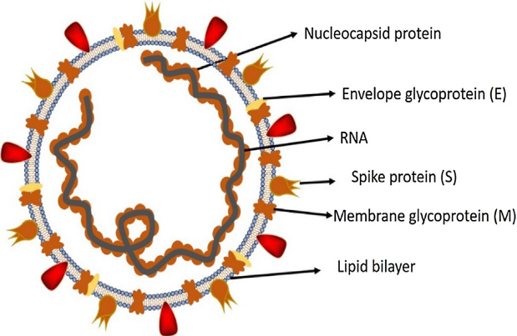
Structure of respiratory syndrome causing human coronavirus

Coronaviruses are large, enveloped, positive-stranded RNA viruses. They have the largest genome among all RNA viruses, typically ranging from 27 to 32 kb. The genome is packed inside a helical capsid formed by the nucleo capsid protein (N) and further surrounded by an envelope. Associated with the viral envelope are at least three structural proteins: The membrane protein (M), the envelope protein (E) which are involved in virus assembly, and the spike protein (S) which mediates virus entry into host cells. Some coronaviruses also encode an envelope-associated hemagglutinin-esterase protein (HE). Among these structural proteins, the spike forms large protrusions from the virus surface, giving coronaviruses the appearance of having crowns (hence their name; corona in Latin means crown). In addition to mediating virus entry, the spike is a critical determinant of viral host range and tissue tropism and a major inducer of host immune responses. The coronavirus spike contains three segments: a large ectodomain, a single-pass transmembrane anchor, and a short intracellular tail. The ectodomain consists of a receptor-binding subunit S1 and a membrane-fusion subunit S2. Electron microscopy studies revealed that the spike is a clove-shaped trimer with three S1 heads and a trimeric S2 stalk (Kirchdoerfer RN, et al. 2016), (Walls AC, et al. 2016), (Beniac DR, et al 2006), (Li F, et al 2006). During virus entry, S1 binds to a receptor on the host cell surface for viral attachment, and S2 fuses the host and viral membranes, allowing viral genomes to enter host cells. Receptor binding and membrane fusion are the initial and critical steps in the coronavirus infection cycle; they also serve as primary targets for human inventions.

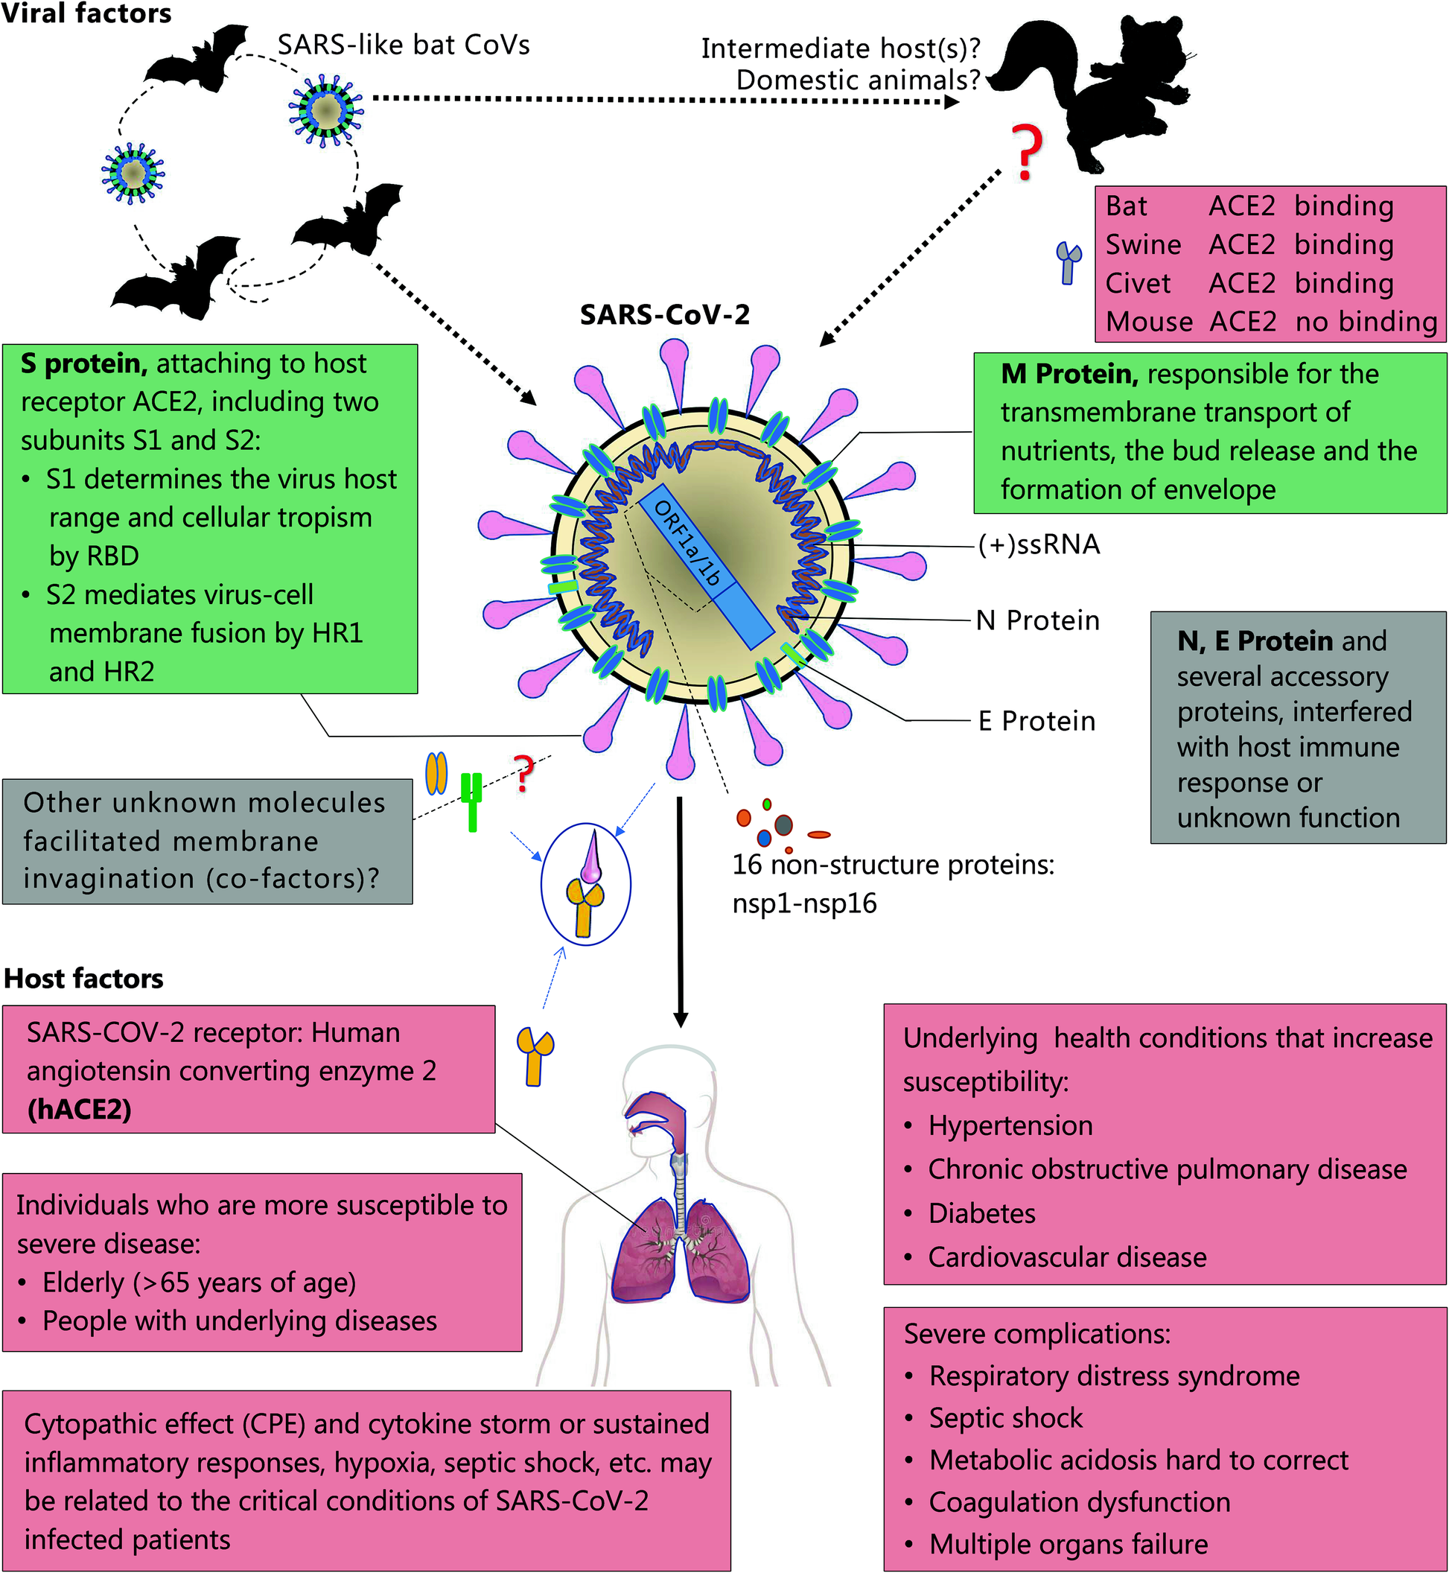

Viral and host factors that influence the pathogenesis of SARS-CoV-2.

REFERENCES

- Zhong N, Zheng B, Li Y, Poon L, Xie Z, Chan K, et al. Epidemiology and cause of severe acute respiratory syndrome (SARS) in Guangdong, People’s Republic of China, in February, 2003. The Lancet 2003;362(9393):1353–8.
- Wang N, Shi X, Jiang L, Zhang S, Wang D, Tong P, et al. Structure of MERS-CoV spike receptor-binding domain complexed with human receptor DPP4. Cell Res 2013;23(8):986.
- Cui J, Li F, Shi Z-L. Origin and evolution of pathogenic coronaviruses. Nat Rev Microbiol 2019;17(3):181–92.
- Lai C-C, Shih T-P, Ko W-C, Tang H-J, Hsueh P-R. Severe acute respiratory syndrome coronavirus 2 (SARS-CoV-2) and corona virus disease-2019 (COVID-19): the epidemic and the challenges. Int J Antimicrob Agents 2020;105924.
- Organization WH. Laboratory testing for coronavirus disease 2019 (COVID-19) in suspected human cases: interim guidance, 2 March 2020. World Health Organization, 2020.
- Zhu N, Zhang D, Wang W, Li X, Yang B, Song J, et al. A novel coronavirus from patients with pneumonia in China, 2019. N Engl J Med. 2020;382(8):727–33.
- Yin Y, Wunderink RG. MERS, SARS and other coronaviruses as causes of pneumonia. Respirology. 2018;23(2):130–7.
- Zhou P, Yang XL, Wang XG, Hu B, Zhang L, Zhang W, et al. A pneumonia outbreak associated with a new coronavirus of probable bat origin. Nature 2020. https://doi.org/10.1038/s41586-020-2012-7.
- Kelland K (2012-09-28). "New virus not spreading easily between people: WHO". Reuters. Archived from the original on 2012-11-24. Retrieved 2013-03-16
- Nouveau coronavirus – Point de situation : Un nouveau cas d'infection confirmé Archived 8 June 2013 at the Wayback Machine (Novel coronavirus – Status report: A new case of confirmed infection) 12 May 2013, social-sante.gouv.fr
- "MERS Transmission". Centers for Disease Control and Prevention (CDC). 2019-08-02. Archived from the original on 2019-12-07. Retrieved 2019-12-10.
- "Novel coronavirus infection". World Health Association. 2013-05-22. Archived from the original on 2013-06-07. Retrieved 2013-05-23.
- The Editorial Board (2020-01-29). "Is the World Ready for the Coronavirus? – Distrust in science and institutions could be a major problem if the outbreak worsens". The New York Times. Retrieved 2020-01-30.
- Sang-Hun C (2015-06-08). "MERS Virus's Path: One Man, Many South Korean Hospitals". The New York Times. Archived from the original on 2017-07-15. Retrieved 2017-03-01.

- "WHO Statement Regarding Cluster of Pneumonia Cases in Wuhan, China". www.who.int. 2020-01-09. Archived from the original on 2020-01-14. Retrieved 2020-01-10.

- "Laboratory testing of human suspected cases of novel coronavirus (nCoV) infection. Interim guidance, 10 January 2020" (PDF). Archived (PDF) from the original on 2020-01-20. Retrieved 2020-01-14.

- "Novel Coronavirus 2019, Wuhan, China". www.cdc.gov (CDC). 2020-01-23. Archived from the original on 2020-01-20. Retrieved 2020-01-23.

- "2019 Novel Coronavirus infection (Wuhan, China): Outbreak update". Canada.ca. 2020-01-21.

- Cohen J (2020-01-26). "Wuhan seafood market may not be source of novel virus spreading globally". ScienceMag American Association for the Advancement of Science. (AAAS). Archived from the original on 2020-01-27. Retrieved 2020-01-29.

- Kirchdoerfer RN, Cottrell CA, Wang N, Pallesen J, Yassine HM, et al. 2016. Pre-fusion structure of a human coronavirus spike protein. Nature 531:118–21
- Walls AC, Tortorici MA, Bosch BJ, Frenz B, Rottier PJ, et al. 2016. Cryo-electron microscopy structure of a coronavirus spike glycoprotein trimer. Nature 531:114–17
- Beniac DR, Andonov A, Grudeski E, Booth TF. 2006. Architecture of the SARS coronavirus prefusion spike. Nat. Struct. Mol. Biol. 13:751–52
- Li F, Berardi M, Li WH, Farzan M, Dormitzer PR, Harrison SC. 2006. Conformational states of the severe acute respiratory syndrome coronavirus spike protein ectodomain. J. Virol. 80:6794–800

