MATRIC NO : 16/MHS06/010

VIROLOGY OPEN TEST

CORONA VIRUS DISEASE (COVID-19)
Coronaviruses are a type of virus. There are many different kinds, and some cause disease.
- Coronaviruses are common in different animals. Rarely, an animal coronavirus can infect humans.
- There are many different kinds of coronaviruses. Some of them can cause colds or other mild respiratory (nose, throat, lung) illnesses.
- Other coronaviruses can cause more serious diseases, including severe acute respiratory syndrome (SARS) and Middle East respiratory syndrome (MERS).
- Coronaviruses are named for their appearance: Under the microscope, the viruses look like they are covered with pointed structures that surround them like a corona, or crown.
ETIOLOGY OF COVID-19
COVID-19 is caused by SARS-CoV-2 (Severe Acute Respiratory Syndrome Corona Virus 2 )
The corona virus disease (COVID-19) is a disease caused by the new corona virus. This new corona virus can spread from person to person.
ORIGIN OF COVID-19
- Originally, scientists believed the virus may have developed in bats, and later pangolins.
- However, genomic comparisons suggest that the SARS-Cov-2 virus is the result of a recombination between two different viruses, meaning the exact origin of the virus is still unclear.
- Genomic analysis revealed that SARS-CoV-2 is phylogenetically related to severe acute respiratory syndrome-like (SARS-like) bat viruses, therefore bats could be the possible primary reservoir.
STRUCTURE :

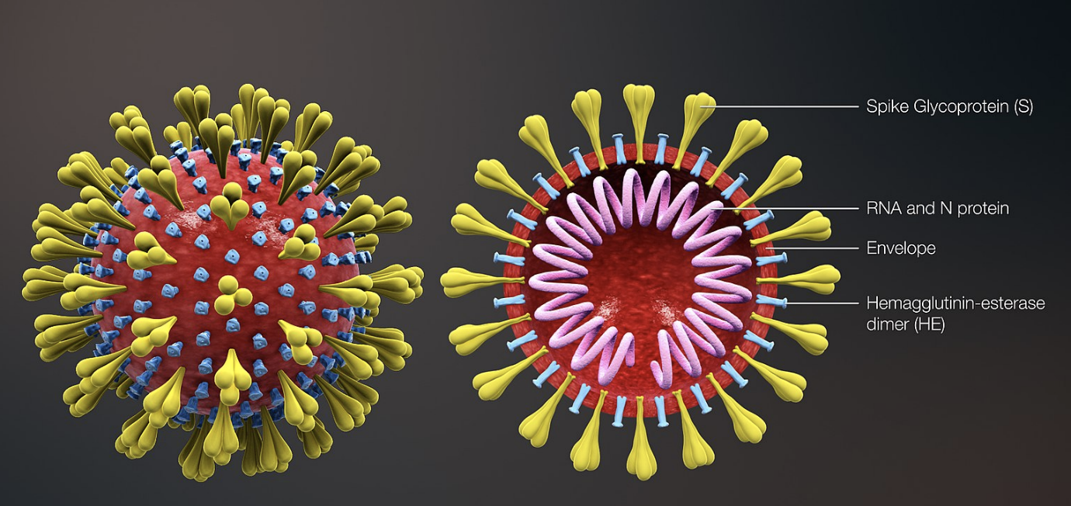

PATHOPHYSIOLOGY OF ( COVID-19 ) :
Corona viruses are enveloped, positive-stranded RNA viruses with nucleocapsid.
- The virus is surrounded by a lipid envelope and is usually fragile.
- This virus is not a strong virus and it can’t really last long outside the body.
- This virus is zoonotic meaning that it can cross from a bat to a pangolin to a human
- It is transmitted through respiratory droplets like mucus through sneezing or coughing.

- The S-spikes on the COVID-19 virus binds to specific receptors known as ACE 2.
- These receptors are found on mucosa cells, goblet cells and some other tissues.
- Starting from the viral RNA, the synthesis of polyprotein in the host is realized.
The transcription works through the replication-transcription complex (RCT) organized in double-membrane vesicles and via the synthesis of subgenomic RNAs (sgRNAs) sequences.
- The pathogenic mechanism that produces pneumonia seems to be particularly complex
- The effect is extensive tissue damage. The protagonist of this storm is interleukin 6 (IL-6). IL-6 is produced by activated leukocytes and acts on a large number of cells and tissues.
- Among the structural elements of Corona virus , there are the spike glycoproteins composed of two subunits (S1 and S2). Homotrimers of S proteins compose the spikes on the viral surface, guiding the link to host receptors. The S2 subunit containing a fusion peptide, a transmembrane domain, and cytoplasmic domain is highly conserved. Thus, it could be a target for antiviral (anti-S2) compounds.
The COVID-19 virus affects different people in different ways. COVID-19 is a respiratory disease and most infected people will develop mild to moderate symptoms and recover without requiring special treatment. People who have underlying medical conditions and those over 60 years old have a higher risk of developing severe disease and death.
Common symptoms include:
- fever
- tiredness
- dry cough.
Other symptoms include:
- shortness of breath
- aches and pains
- sore throat
- and very few people will report diarrhoea, nausea or a runny nose.

