NAME: DELE-PETERS INIOLUWA LOIS
MATRIC NO: 16/MHS06/015
TOPIC: ETIOLOGY,ORIGIN, STRUCTURE AND PATHPHYSIOLOGY OF COVID-19

INTRODUCTION
What is a virus?
A virus is an obligate, ultramicroscopic entity, made up of DNA or RNA never both, has a capsid made up of capsomeres. Its either enveloped or unenvelpoed. Most viruses have tissue tropism.
Coronavirus is an infectious disease that spreads primarily through droplets of saliva or discharge from the nose when an infected person coughs or sneezes. The virus is another cause of common cold. The virus has a high affinity for the lungs. The virus growth is detected by ciliary immobilisation and electron microscopy of harvests. Coronaviruses are a group of viruses that can cause disease in both animals and humans. The SARS virus strain known as SARS-CoV is an example of a coronavirus. SARS spread rapidly in 2002–2003.
The new strain of coronavirus is called severe acute respiratory syndrome coronavirus 2 (SARS-CoV-2). The virus causes coronavirus disease 19 (COVID-19).
It is assumed that the virus got into a Bat which is its reservoir and then got mutated in another animal which then went ahead to infect man.

ETIOLOGY
When people with COVID-19 breathe out or cough, they expel tiny droplets that contain the virus. These droplets can enter the mouth or nose of someone without the virus, causing an infection to occur. The most common way that this illness spreads is through close contact with someone who has the infection. Close contact is within around 6 feet.
The disease is most contagious when a person’s symptoms are at their peak. However it is possible for someone without symptoms to spread the virus suggests that 10% of infections are from people exhibiting no symptoms. Droplets containing the virus can also land on nearby surfaces or objects. Other people can pick up the virus by touching these surfaces or objects. Infection is likely if the person then touches their nose, eyes, or mouth.
Some scientists exploring how coronaviruses like COVID-19 infect human cells have shown that the SARS-CoV-2 spike (S) glycoprotein binds to the cell membrane protein angiotensin-converting enzyme 2 (ACE2) to enter human cells.
COVID-19 has been shown to bind to ACE2 via the S protein on its surface. During infection, the S protein is cleaved into subunits, S1 and S2. S1 contains the receptor binding domain (RBD) which allows coronaviruses to directly bind to the peptidase domain (PD) of ACE2. S2 then likely plays a role in membrane fusion.

ORIGIN
Coronaviruses are common in certain species of animals, such as cattle and camels. Although the transmission of coronaviruses from animals to humans is rare However, it remains unclear exactly how the virus first spread to humans strain likely came from bats, though one study suggests pangolins may be the origin.
STRUCTURE
Coronaviruses is a virus whose genome is a single stranded mRNA, complete with a 3’-UTR and poly-A-tail. Coronavirus that includes SARS-CoV-2(2019-nCoV), SARS-CoV-1, and MERS, the 3'-UTR contains a highly-conserved sequence (in an otherwise rather variable message) that folds into a unique structure, called the s2m (stem-loop two motif).
Although the s2m appears to be extremely conserved in sequence, and is required for virus viability, its exact function is not known. SARS-CoV-2 posesses almost exactly the same s2m sequence (and therefore structure) as found in the original SARS virus genome. Because the two viruses are nearly identical in this region, we also have the structure of the SARS-CoV-2 s2m RNA. The s2m structure reveals several unique features that include potential sites for antiviral drugs to bind.
.

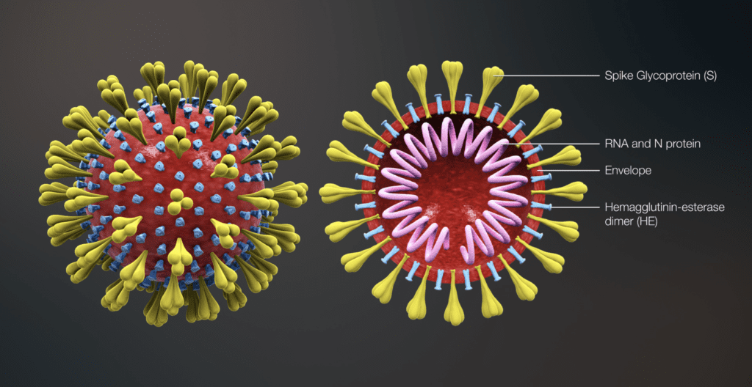
.
PATHOPHYSIOLOGY
Pathophysiology describes the changes a disease or condition causes in a person’s physical function as it develops. COVID-19 reduces lung function by damaging the airways and air sacs in the lungs.
The virus can get into the body system either by inhaling the nasal droplets from an infected person or by using hands that have touched infected surfaces on the nose, mouth and eyes.
The virus has a way of attaching to a specific receptor on lung cells called ACE-2. The ACE-2 receptors are the lock while the coronavirus SARS-CoV-2 has a key that allows it into the lung tissue. As the virus takes a hold in the lung cells, the body tries to fight it off which creates an inflammatory process to contain the virus in the lungs which floods the lungs with inflammatory cells.
The combination of the infection and inflammation is what causes the breathlessness these patients experience as the disease worsens. The shortness of breath can cause oxygen level to drop leading to the need for a ventilator. Most of the time these patients die from systemic organ failure.
REFERENCES
www.medicalnewstoday.com
scottlab.ucsc.edu
www.frontiersin.org
who.int
BAKER AND SILVERTON-VIROLOGY

