MLS406: Virology
16\mhs06\034
Answers

ETIOLOGY OF COVID 19
Coronaviruses are common in certain species of animals, such as cattle, camel, and bat. Although transmission of coronavirus from animals to human is rare, and this new strain likely came from bats, pangolins.
-these viruses are found in bats then mutates and then transmitted to a pangolin mutated enough then transmitted to man this is the cause of covid 1

ORIGIN
Coronavirus belongs to coronaviridae family in the Nidovirales order.
-Covid 19 originated from Wuhan chain in late 2019.
This virus covid 19 is traced back to severe acute respiratory syndrome (SARS) outbreak in Guangdong china in 2002.
Also the Middle East respiratory syndrome (MERS) IN 2012
HOW IT SPREADS
SARS-CoV-2 spreads from person to person through close communities.

When people with COVID-19 breathe out or cough, they expel tiny droplets that contain the virus. These droplets can enter the mouth or nose of someone without the virus, causing an infection to occur.

The most common way that this illness spreads is through close contact with someone who has the infection. Close contact is within around 6 feet.

The disease is most contagious when a person’s symptoms are at their peak. However it is possible for someone without symptoms to spread the virus. A new study suggests that 10% of infections are from people exhibiting no symptoms.

Droplets containing the virus can also land on nearby surfaces or objects. Other people can pick up the virus by touching these surfaces or objects. Infection is likely if the person then touches their nose, eyes, or mouth.

STRUCTURE OF COVID 19 VIRUSE
Coronaviruses are enveloped viruses with a positive-sense single-stranded RNA genome and a helical symmetry. The genomic size of coronaviruses ranges from approximately 16 to 31 kilobases, extraordinarily large for an RNA virus. The name coronavirus is derived from the Greek (κορώνα, meaning crown) as the virus envelope appears under electron microscopy (E.M.) to be crowned by a characteristic ring of small bulbous structures. This morphology is actually formed by the viral spike (S) peplomers, which are proteins that populate the surface of the virus and determine host tropism. Coronaviruses are grouped in the order Nidovirales, named for the Latin (nidus, meaning nest) as all viruses in this order produce a 3' co-terminal nested set of subgenomic mRNA's during infection.

Proteins that contribute to the overall structure of all coronaviruses are the spike (S), envelope (E), membrane (M) and nucleocapsid (N). In the specific case of SARS, a defined receptor-binding domain on S mediates the attachment of the virus to its cellular receptor, angiotensin-converting enzyme 2 (ACE2). Members of the group 2 coronaviruses also have a shorter spike-like protein called hemagglutinin esterase (HE) encoded in their genome, but for some reason this protein is not always brought to expression (produced) in the cell.

-Nucleocapsid protein (N):-bound to the RNA genome to make up nucleocapsid.
-Spike proteins:-critical for binding of host cells receptors to facilitate entry of host cell.
-Envelope protein (E):-interacts with m to form viral envelope.
-Membrane protein (M):-central organizer of cov assembly
-determines shapes of viral envelope
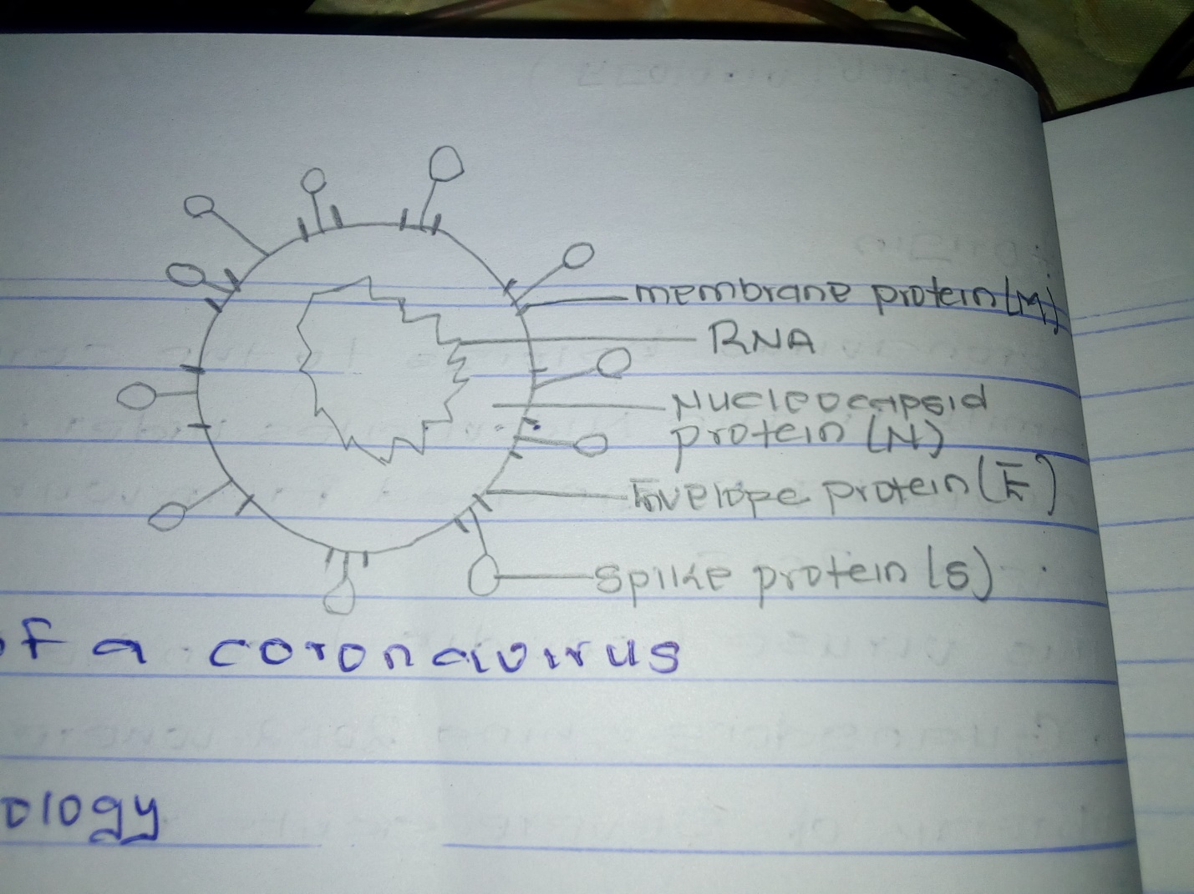

PATHOPHYSIOLOGY OF COVID 19
The lungs are the organs most affected by covid 19 because the virus accesses host cells via the enzyme ACE2, which is most abundassnt in the type 2 alveolar cells of the lungs .the virus uses a special surface glycoprotein called spike (peplomer) to connect to ACE2 and enter the host cell. The density of ACE2 in each tissue correlates with the severity of the disease in that tissue and some have suggested that decreasing ACE2 activity might be protective, though another view is that increasing ACE2 using angiotensin 2 receptor blocker medications could be protective and that these hypotheses need to be tested. As the alveolar disease progresses, respiratory failure might develop and death may follow.
The virus also affects gastrointestinal organs as ACE2 is abundantly expressed in the granular cells of gastric, duodenal and rectal epithelium as well as endothelial cells and enterocytes of the small intestine.

REFERENCES
N. Zhong, B. Zheng, Y. Li, L. Poon, Z. Xie, K. Chan, et al.
Epidemiology and cause of severe acute respiratory syndrome (SARS) in Guangdong, People's Republic of China, in February, 2003

C.-C. Lai, T.-P. Shih, W.-C. Ko, H.-J. Tang, P.-R. Hsueh
Severe acute respiratory syndrome coronavirus 2 (SARS-CoV-2) and corona virus disease-2019 (COVID-19): the epidemic and the challenges

WMHC.WUHAN Municipal Health Commissions Briefing on the current pneumonia epidemic situation 2020

