NAME: EVAH OGHENELURE FAVOUR
DEPARTMENT: CHEMICAL ENGINEERING
MATRIC NO: 17/EN01/011
COURSE: ENG382 (ENGINEERING MATHEMATICS IV)
Engineering maths assignment 3
a)
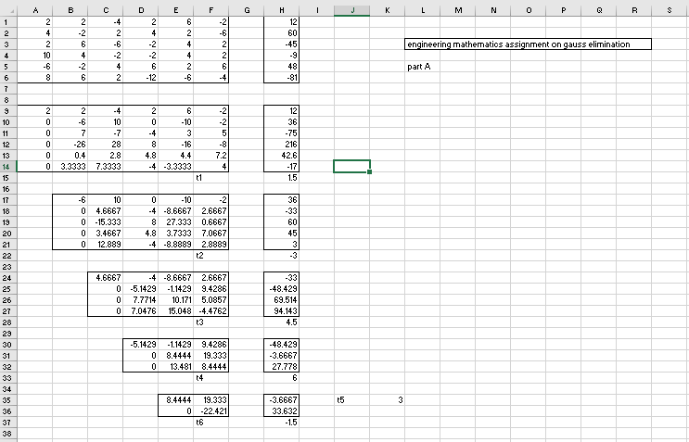

b)
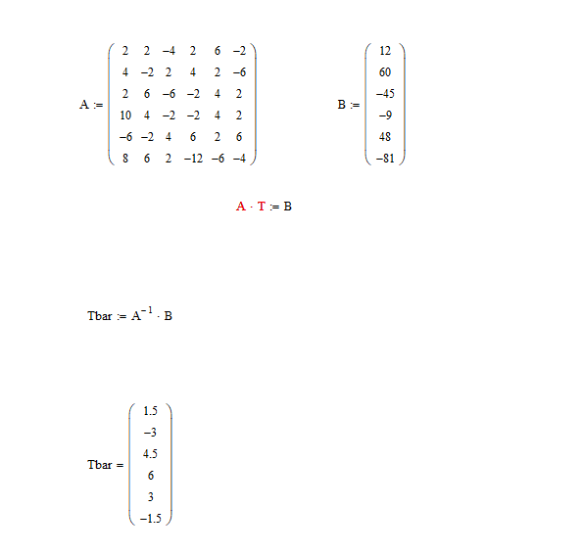

c) 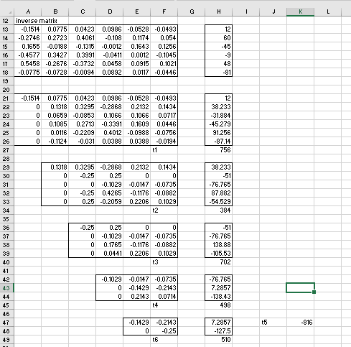
d) 