VIROLOGY ASSIGNMENT
MLS 406
QUESTION
DISCUSS THE ETIOLOGY, ORIGIN, STRUCTURE AND PATHOPYHSIOLOGY OF COVID-19
16/MHS01/241.

ANSWER
Etiology
The coronaviruses which were said to affect humans were until the early 2000’s recognized as a reoccurring cause of common cold following the symptoms, occasionally a cause of lower respiratory tract disease, but rarely if ever cause serious disease. In 2003, coronavirus was introduced into humans from animals as the etiologic agent of the outbreak of severe acute respiratory syndrome (SARS)
It was reported that a cluster of patients with pneumonia of unknown cause was linked to a local Huanan South China Seafood Market in Wuhan, Hubei Province, China in December 2019. The WHO confirmed that the outbreak of the coronavirus epidemic was associated with the Huanan South China Seafood Marketplace, but no specific animal association was identified.
on 10 January 2020. Within 1 month, this virus spread quickly throughout China during the Chinese New Year – a period when there is a high level of human mobility among Chinese people. Although it is still too early to predict susceptible populations, early patterns have shown a trend similar to Severe Acute Respiratory Syndrome (SARS) and Middle East respiratory syndrome (MERS) coronaviruses. Susceptibility seems to be associated with age, biological sex, and other health conditions . COVID-19 has now been declared as a Public Health Emergency of International Concern by the WHO
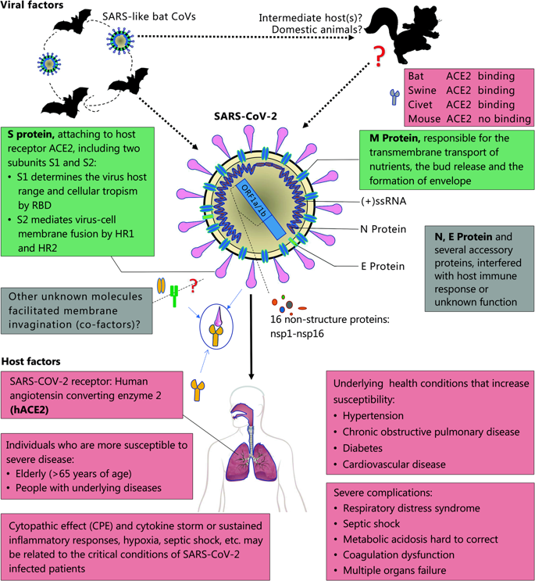

ORIGIN
The epidemic of unknown acute respiratory tract infection broke out first in Wuhan, China, since 12 December 2019, possibly related to a seafood market. Several studies suggested that bat may be the potential reservoir of SARS-CoV-2. However, there is no evidence so far that the origin of SARS-CoV-2 was from the seafood market. Rather, bats are the natural reservoir of a wide variety of CoVs, including SARS-CoV-like and MERS-CoV-like viruses Upon virus genome sequencing, the COVID-19 was analyzed throughout the genome to Bat CoV RaTG13 and showed 96.2% overall genome sequence identity , suggesting that bat CoV and human SARS-CoV-2 might share the same ancestor, although bats are not available for sale in this seafood market. Besides, protein sequences alignment and phylogenetic analysis showed that similar residues of receptor were observed in many species, which provided more possibility of alternative intermediate hosts, such as turtles, pangolin and snacks.

Human-to-human transmission of SARS-CoV-2 occurs mainly between family members, including relatives and friends who intimately contacted with patients or incubation carriers. It is reported that 31.3% of patients recent travelled to Wuhan and 72.3% of patients contacting with people from Wuhan among the patients of non-residents of Wuhan. Transmission between healthcare workers occurred in 3.8% of COVID-19 patients, issued by the National Health Commission of China on 14 February 2020. By contrast, the transmission of SARS-CoV and MERS-CoV is reported to occur mainly through nosocomial transmission. Infections of healthcare workers in 33–42% of SARS cases and transmission between patients (62–79%) was the most common route of infection in MERS-CoV cases . Direct contact with intermediate host animals or consumption of wild animals was suspected to be the main route of SARS-CoV-2 transmission. However, the source(s) and transmission routine(s) of SARS-CoV-2 remain elusive.
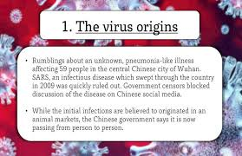

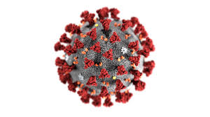
STRUCTURE
Schematic diagram of the SARS coronavirus structure (reproduced from ref. 20).The viral surface proteins (spike, envelope and membrane) are embedded in a lipid bilayer envelope derived from the host cell. Unlike group 2 coronaviruses, SARS-CoV does not possess a hemagglutinin esterase glycoprotein. The single-stranded positive-sense viral RNA is associated with the nucleocapsid protein.

A distinctive feature of coronaviruses is that they have evolved to recognize a variety of receptors including both protein receptors and sugar receptors. Coronaviruses enter cells through a two-step process: they first recognize a host-cell-surface receptor for viral attachment and then fuse viral and host membranes for entry. Receptors not only determine the viral attachment step, but also play important roles in the membrane fusion process.Coronaviruses are large, enveloped and positive-stranded RNA viruses that infect many mammalian and avian species and cause respiratory, enteric, gastrointestinal, and neurological diseases. They can be divided into four genera: α, β, γ, and δ. for coronaviruses from all four genera, an envelope-anchored spike protein guide’s coronavirus entry into host cell. The spike is present in two very different forms: pre-fusion (the form on mature virions) and post-fusion (the form after membrane fusion has been completed). The pre-fusion structure is a homo-trimer, with three receptor-binding S1 heads sitting on top of a trimeric membrane-fusion S2 stall. The post-fusion structure is a coiled-coil structure, containing S2 only. The pre-fusion form is a metastable state: S2 is prevented from transitioning to the post-fusion structure due to the structural constraints imposed by S1. During cell entry, however, the spike is cleaved sequentially by host proteases at two sites: first at the S1/S2 boundary (i.e., S1/S2 site) and second within S2 (i.e., S2’ site). After the cleavages, S1 dissociates from S2, allowing S2 to transition to the post-fusion structure. The transition from pre-fusion to post-fusion form is irreversible, and hence this process is tightly regulated during the entry process.
Receptor binding is part of the regulation mechanisms for the structural transition of coronavirus spikes. Each S1 subunit of the spike contains an N-terminal domain (S1-NTD) and a C-terminal domain (S1-CTD). Depending on the virus, one or both of these S1 domains can function as the receptor-binding domain (RBD). S1-CTD is located on the tip of the spike trimer and is known to recognize protein receptors. For coronaviruses whose S1-CTD functions as the RBD, such as SARS coronavirus (SARS-CoV) and MERS coronavirus (MERS-CoV), their S1-CTD constantly transitions between two conformations: standing up and lying down. Receptor binding stabilizes the S1-CTD in the standing-up conformation, weakening the S1/S2 interactions and facilitating the dissociation of S1 from S2. Thus, S1-CTD plays a double role in coronavirus entry: it determines viral attachment and facilitates membrane fusion. On the other hand, S1-NTD is located on the side of the spike trimer and mainly recognizes sugar receptors. To date S1-NTD has not been observed to undergo any dynamic conformational changes. Therefore, it is a mystery how S1-NTD would play any role in activation of the membrane fusion process, other than its established role in viral attachment.
MHV from the β-genus is an extensively studied prototypic coronavirus. MHV is the only known coronavirus that uses the S1-NTD to recognize a protein receptor, CEACAM1a. CEACAM1a is a cell adhesion protein. The structure showed that MHV S1-NTD has the same fold as human galectins (galactose-binding lectin), but it does not bind any sugar; instead, it binds to D1 of CEACAM1a through protein-protein interactions. The cryo-EM structures of MHV spike in pre-fusion and post-fusion have been determined. However, the structure of MHV spike in complex with CEACAM1a is still not available. As a result, although previous biochemical studies have shown that CEACAM1a binding triggers the conformational changes of MHV , the molecular mechanism for the role of CEACAM1a in the MHV-spike-mediated membrane fusion is unknown.. Using proteolysis and negative-stain EM assays, we further investigated the impact of receptor binding on proteases sensitivity and the final structural transitions of MHV.

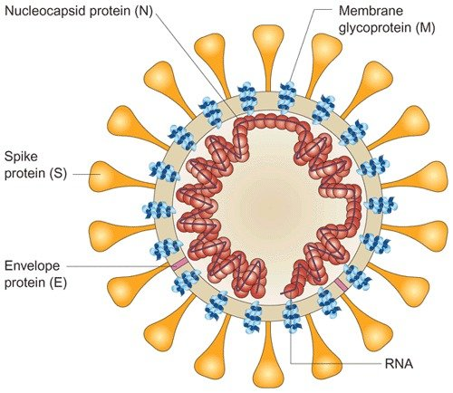

PATHOPHYSIOLOGY

CoVs are enveloped, positive-stranded RNA viruses with nucleocapsid. For addressing pathogenetic mechanisms of SARS-CoV-2, its viral structure, and genome must be considerations. In CoVs, the genomic structure is organized in a +ssRNA of approximately 30 kb in length — the largest known RNA viruses — and with a 5′-cap structure and 3′-poly-A tail. Starting from the viral RNA, the synthesis of polyprotein 1a/1ab (pp1a/pp1ab) in the host is realized. The transcription works through the replication-transcription complex (RCT) organized in double-membrane vesicles and via the synthesis of subgenomic RNAs (sgRNAs) sequences. Of note, transcription termination occurs at transcription regulatory sequences, located between the so-called open reading frames (ORFs) that work as templates for the production of subgenomic mRNAs. In the atypical CoV genome, at least six ORFs can be present. Among these, a frameshift between ORF1a and ORF1b guides the production of both pp1a and pp1ab polypeptides that are processed by virally encoded chymotrypsin-like protease (3CLpro) or main protease (Mpro), as well as one or two papain-like proteases for producing 16 non-structural proteins (nsps). Apart from ORF1a and ORF1b, other ORFs encode for structural proteins, including spike, membrane, envelope, and nucleocapsid proteins. and accessory proteic chains. Different CoVs present special structural and accessory proteins translated by dedicated sgRNAs.

Pathophysiology and virulence mechanisms of CoVs, and therefore also of SARS-CoV-2 have links to the function of the nsps and structural proteins. For instance, research underlined that nsp is able to block the host innate immune response.[7] Among functions of structural proteins, the envelope has a crucial role in virus pathogenicity as it promotes viral assembly and release. However, many of these features (e.g., those of nsp 2, and 11) have not yet been described.

Among the structural elements of CoVs, there are the spike glycoproteins composed of two subunits (S1 and S2). Homotrimers of S proteins compose the spikes on the viral surface, guiding the link to host receptors Of note, in SARS-CoV-2, the S2 subunit — containing a fusion peptide, a transmembrane domain, and cytoplasmic domain — is highly conserved. Thus, it could be a target for antiviral (anti-S2) compounds. On the contrary, the spike receptor-binding domain presents only a 40% amino acid identity with other SARS-CoVs. Other structural elements on which research must necessarily focus are the ORF3b that has no homology with that of SARS-CoVs and a secreted protein (encoded by ORF8), which is structurally different from those of SARS-CoV.gene mapping is of fundamental importance allowing researchers to trace the phylogenetic tree of the virus and, above all, the recognition of strains that differ according to the mutations. According to recent research, a spike mutation, which probably occurred in late November 2019, triggered jumping to humans compared the Sars-Cov-2 gene sequence with that of Sars-CoV. They analyzed the transmembrane helical segments in the ORF1ab encoded 2 (nsp2) and nsp3 and found that position 723 presents a serine instead of a glycine residue, while the position 1010 is occupied by proline instead of isoleucine.[9] The matter of viral mutations is key for explaining potential disease relapses.

Research will be needed to determine the structural characteristics of SARS-COV-2 that underlie the pathogenetic mechanisms. Compared to SARS, for example, initial clinical data show less extra respiratory involvement, although due to the lack of extensive data, it is not possible to draw definitive clinical information.

The pathogenic mechanism that produces pneumonia seems to be particularly complex. Clinical and preclinical research will have to explain many aspects that underlie the particular clinical presentations of the disease. The data so far available seem to indicate that the viral infection is capable of producing an excessive immune reaction in the host. In some cases, a reaction takes place which as a whole is labeled a 'cytokine storm'. The effect is extensive tissue damage. The protagonist of this storm is interleukin 6 (IL-6). IL-6 is produced by activated leukocytes and acts on a large number of cells and tissues. It is able to promote the differentiation of B lymphocytes, promotes the growth of some categories of cells, and inhibits the growth of others. It also stimulates the production of acute phase proteins and plays an important role in thermoregulation, in bone maintenance and in the functionality of the central nervous system. Although the main role played by IL-6 is pro-inflammatory, it can also have anti-inflammatory effects. In turn, IL-6 increases during inflammatory diseases, infections, autoimmune disorders, cardiovascular diseases and some types of cancer. It is also implicated into the pathogenesis of the cytokine release syndrome (CRS) that is an acute systemic inflammatory syndrome characterized by fever and multiple organ dysfunction.

REFERENCES
1. Lu R, Zhao X, Li J, Niu P, Yang B, Wu H, et al. Genomic characterisation and epidemiology of 2019 novel coronavirus: implications for virus origins and receptor binding. Lancet. 2020; 395(10224):565–74.

2. WMHC. Wuhan Municipal Health and Health Commission’s Briefing on the Current Pneumonia Epidemic Situation in Our City. 2020.
Li Q, Guan X, Wu P, Wang X, Zhou L, Tong Y, et al. Early transmission dynamics in Wuhan, China, of novel coronavirus-infected pneumonia. N Engl J Med. 2020.
3. Li F. Receptor recognition mechanisms of coronaviruses: a decade of structural studies. J Virol. 2015;89(4):1954–64. Epub 2014/11/28. pmid:25428871; PubMed Central PMCID: PMC4338876..
4. Chen Y, Liu Q, Guo D. Emerging coronaviruses: Genome structure, replication, and pathogenesis. J. Med. Virol. 2020 Apr;92(4):418-423

. vv. . . vv.

