ONUH UGOCHINYERE NZUBECHUKWU.
16/MHS01/206.
MLS 406- VIROLOGY (ASSIGNMENT).
DISCUSS THE ETIOLOGY, ORIGIN, STRUCTURE AND PATHOPHYSIOLOGY OF COVID-19.

INTRODUCTION AND ETIOLOGY: WHAT IS COVID-19?
Coronaviruses are a family of viruses that can cause illnesses such as the common cold, severe acute respiratory syndrome (SARS) and Middle East respiratory syndrome (MERS). In 2019, a new coronavirus was identified as the cause of a disease outbreak that originated in China.
The virus is now known as the severe acute respiratory syndrome coronavirus 2 (SARS-CoV-2). The disease it causes is called coronavirus disease 2019 (COVID-19).
Coronaviruses belong to the Coronaviridae family in the Nidovirales order. Corona represents crown-like spikes on the outer surface of the virus; thus, it was named as a coronavirus. Coronaviruses are minute in size (65–125 nm in diameter) and contain a single-stranded RNA as a nucleic material, size ranging from 26 to 32kbs in length. The subgroups of coronaviruses family are alpha (α), beta (β), gamma (γ) and delta (δ) coronavirus. The severe acute respiratory syndrome coronavirus (SARS-CoV), H5N1 influenza A, H1N1 2009 and Middle East respiratory syndrome coronavirus (MERS-CoV) cause acute lung injury (ALI) and acute respiratory distress syndrome (ARDS) which leads to pulmonary failure and result in fatality. These viruses were thought to infect only animals until the world witnessed a severe acute respiratory syndrome (SARS) outbreak caused by SARS-CoV, 2002 in Guangdong, China. Only a decade later, another pathogenic coronavirus, known as Middle East respiratory syndrome coronavirus (MERS-CoV) caused an endemic in Middle Eastern countries.
ORIGIN.
Many health experts believe that the new strain of coronavirus likely originated in bats or pangolins. The strain of virus is believed to have mutated to be able to cause an infection in humans.
In 2003, the Chinese population was infected with a virus causing Severe Acute Respiratory Syndrome (SARS) in Guangdong province. The virus was confirmed as a member of the Beta-coronavirus subgroup and was named SARS-CoV . The infected patients exhibited pneumonia symptoms with a diffused alveolar injury which lead to acute respiratory distress syndrome (ARDS). SARS initially emerged in Guangdong, China and then spread rapidly around the globe with more than 8000 infected persons and 776 deceases. A decade later in 2012, a couple of Saudi Arabian nationals were diagnosed to be infected with another coronavirus. The detected virus was confirmed as a member of coronaviruses and named as the Middle East Respiratory Syndrome Coronavirus (MERS-CoV). The World health organization reported that MERS-coronavirus infected more than 2428 individuals and 838 deaths. MERS-CoV is a member beta-coronavirus subgroup and phylogenetically diverse from other human-CoV. The infection of MERS-CoV initiates from a mild upper respiratory injury while progression leads to severe respiratory disease. Similar to SARS-coronavirus, patients infected with MERS-coronavirus suffer pneumonia, followed by ARDS and renal failure.

STRUCTURE.
Coronavirus virions are spherical to pleomorphic enveloped particles. The envelope is studded with projecting glycoproteins, and surrounds a core consisting of matrix protein enclosed within which is a single strand of positive-sense RNA (Mr 6 × 10⁶) associated with nucleoprotein. The envelope glycoproteins are responsible for attachment to the host cell and also carry the main antigenic epitopes, particularly the epitopes recognized by neutralizing antibodies.
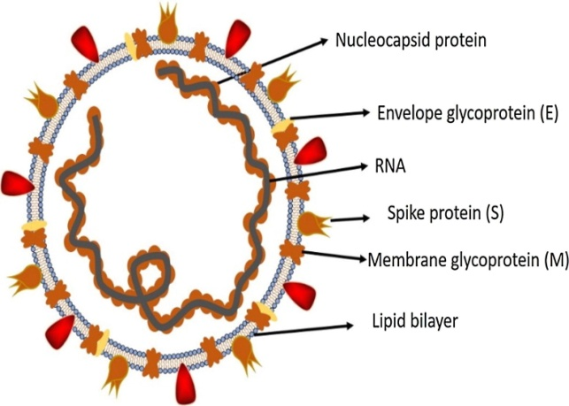

PATHOPHYSIOLOGY.
The pathogenic mechanism that produces pneumonia seems to be particularly complex. Clinical and preclinical research will have to explain many aspects that underlie the particular clinical presentations of the disease. The data so far available seem to indicate that the viral infection is capable of producing an excessive immune reaction in the host. In some cases, a reaction takes place which as a whole is labelled a 'cytokine storm'. The effect is extensive tissue damage. The protagonist of this storm is interleukin 6 (IL-6). IL-6 is produced by activated leukocytes and acts on a large number of cells and tissues. It is able to promote the differentiation of B lymphocytes, promotes the growth of some categories of cells, and inhibits the growth of others. It also stimulates the production of acute phase proteins and plays an important role in thermoregulation, in bone maintenance and in the functionality of the central nervous system. Although the main role played by IL-6 is pro-inflammatory, it can also have anti-inflammatory effects. In turn, IL-6 increases during inflammatory diseases, infections, autoimmune disorders, cardiovascular diseases and some types of cancer. It is also implicated into the pathogenesis of the cytokine release syndrome (CRS) that is an acute systemic inflammatory syndrome characterized by fever and multiple organ dysfunction.

SPREAD.
The virus is thought to spread mainly from person-to-person.
- Between people who are in close contact with one another (within about 6 feet).
- Through respiratory droplets produced when an infected person coughs or sneezes.
These droplets can land in the mouths or noses of people who are nearby or possibly be inhaled into the lungs.
- People are thought to be most contagious when they are most symptomatic (the sickest).
- Some spread might be possible before people show symptoms; there have been reports of this occurring with this new coronavirus, but this is not thought to be the main way the virus spreads.
It may be possible that a person can get COVID-19 by touching a surface or object that has the virus on it and then touching their own mouth, nose, or possibly their eyes, but this is not thought to be the main way the virus spreads.

SYMPTOMS.
COVID-19 symptoms range from mild to severe. It takes 2-14 days after exposure for symptoms to develop.
The most common symptoms of COVID-19 are fever, tiredness, and dry cough. Some patients may have aches and pains, nasal congestion, runny nose, sore throat or diarrhoea. These symptoms are usually mild and begin gradually. Some people become infected but don’t develop any symptoms and don't feel unwell. Most people (about 80%) recover from the disease without needing special treatment. Around 1 out of every 6 people who gets COVID-19 becomes seriously ill and develops difficulty breathing. Older people, and those with underlying medical problems like high blood pressure, heart problems or diabetes, are more likely to develop serious illness. People with fever, cough and difficulty breathing should seek medical attention.
REFERENCES.
https://www.mayoclinic.org/diseases-conditions/coronavirus/symptoms-causes/syc-20479963., https://www.sciencedirect.com/science/article/pii/S2090123220300540., https://ars.els-cdn.com/content/image/1-s2.0-S2090123220300540-gr1_lrg.jpg., https://www.medicalnewstoday.com/articles/coronavirus-causes., https://www.ncbi.nlm.nih.gov/books/NBK7782/., https://www.who.int/news-room/q-a-detail/q-a-coronaviruses#:~:text=symptoms.

