MLS 406 -VIROLOGY
VIROLOGY OPEN TEST
KHAIRAH ADEDOTUN
16/MHS06/003
Discuss the etiology, origin, structure and pathophysiology of COVID-19.
ANSWERS
INTRODUCTION
COVID-19, also referred to as SARS CoV-2, is a new strain of the coronavirus that has been discovered in December 2019. The World Health Organization (WHO) announced the COVID-19 to be a pandemic, after the virus had spread past its country of origin, to other countries. This novel coronavirus is still undergoing a lot of research, and discoveries are yet to be made.
COVID-19 causes a disease of the upper and lower respiratory tract.
ETIOLOGY
COVID-19 is said to be caused by a new strain of coronavirus believed to have come from bats (as reservoir host), mutated enough to have been transferred to a pangolin, and mutated enough to infect humans and cause disease.
ORIGIN
COVID-19 is said to have been originated from Wuhan, China. It has rapidly spread to other parts of the world in pandemic proportions. Wuhan is known for having a large seafood market, which is believed to have caused the transmission of the infection, as most initial patients worked or visited there.
STRUCTURE
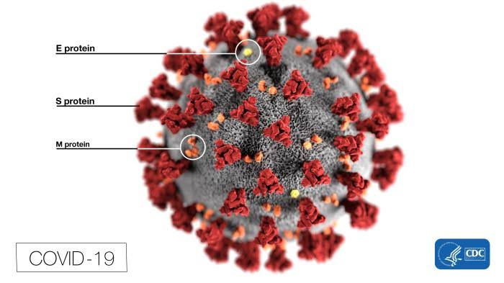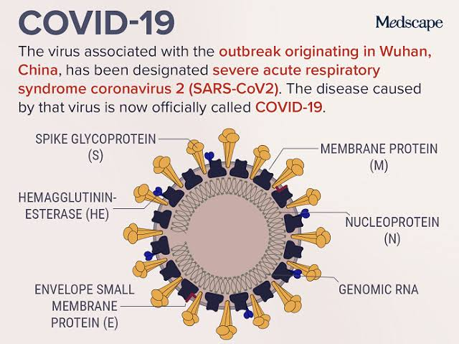
COVID-19 is classified as a single-stranded RNA virus, with a viral envelope. It is a positive sense RNA and has three types of proteins on its viral envelope;
- The S-spike glycoprotein (which is responsible for the disease, as it attaches to the ACE receptor on the type 2 pneumocytes)
- Hemagglutinin esterase.
- Membrane protein. (M protein)
The coronavirus recived its name from its appreacance under the electron microsope, with spike-like projections on its surface creating the effect of ‘corona’ which means ‘crown’ in Latin.

PATHOPHYSIOLOGY OF COVID-19
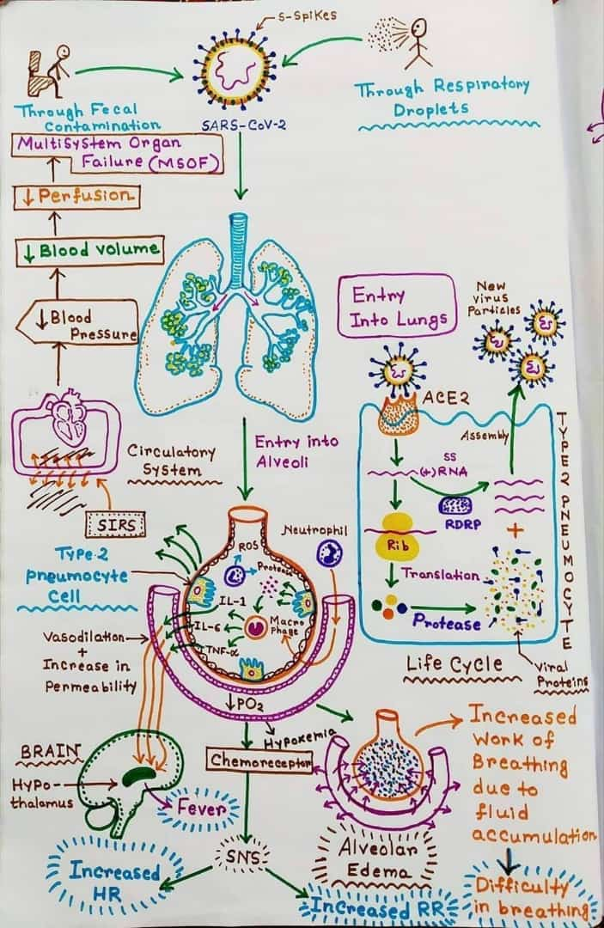
The virus enters into the lungs in two major ways;
- Through the inhalation of respiratory droplets produced by an infected person when he/she coughs or sneezes.
- Through the fecal-oral route [fecal contamination] in which the virus gets into the lungs by putting in fecal matter into the mouth.
Also, the virus could enter the lungs by hands that have touched formites getting in contact with the eyes, nose or mouth.

When the virus enters into the lungs, it travels down to the alveoli. Inside of the alveoli is lined with type 1 and 2 pneumocyte cells. The type 1 pneumocyte is responsible for gas exchange between the lungs and the bloodstream. The type 2 pneumocyte is responsible for the secretion of surfactant which helps to reduce surface tension and collapsing pressure in the alveoli.
What makes this virus unique and dangerous is its tissue trophism. COVID-19 has unique spikes (specifically the S-spike) on its surface which has its receptors on the type 2 pneumocytes of the alveoli. This specific receptor is called Angiotensin Converting Enzyme 2 [ACE 2].
The S-spikes on the virus binds to the ACE2 receptor, which allows the virus to be endocytosed into the cell. As typical of viruses, the COVID-19 then uses the type 2 pneumocyte for viral replication.
When the virus enters into the cell, it breaks down, releasing its genetic material. COVID-19 has a positive sense, single-stranded RNA [(+) ssRNA]. The virus makes use of the ribosomes inside the cell to translate its RNA into poly-proteins. This virus also makes use of another enzyme in the cell called RNA-dependedent-RNA-polymerase [RDRP] enzyme. This enzyme synthesizes the viral RNA and produces several copies of its genetic material.
After several copies of the RNA has been made, the virus needs to re-make several copies of its viral proteins too. These viral proteins are the capsid, envelope and surface spikes. In order to do this, the proteins translated by the ribosomes are cleved by enzymes, specifically proteases, which helps synthesize the viral proteins.
The replicated viruses assemble themselves in the type 2 pneumocytes, and comes out of the cell, hence producing more viruses. This process of replication is repeated, until the type 2 pneumocytes eventally breaks down and is destroyed.
This damaged pneumocyte releases specific inflammatory mediators, which attract neutrophils and macrophages to the site of damage. These phagocytes, especially the macrophages, releases the following cytokines;
- Interleukin-1 (IL-1)
- Interleukin-6 (IL-6)
- Tumor Necrotic Factor-Alpha (TNF-α)
These cytokines then trigger a cascade of events, including;
- Vasodilation of the blood vessels lining the alveoli
- Increase in permeability of the walls of the blood vessels.
- Fluid leaking out of the vessels into the interstitial spaces and eventually entering into the alveoli causing alveolar edema.
Remember that the type 2 pneumocytes are responsible for the production of surfactant which reduces surface tension. But these type 2 cells have been destroyed. This leads to increase in surface tension. As the surface tension increases, the collapsing pressure increases, which leads to alveolar collapse.
Alveolar edema causes;
- Increased work of breathing due to the accumulation of fluid inside the alveoli, and alveolar collapse.
- Difficulty in breathing as gas exchange is harder due to the fluid-filled air sacs (alveoli).
- Hypoxemia.
Neutrophils also travel to the site of damage to try to destroy the virus. To destroy the virus, these phagocytes releases Reactive Oxygen Species (ROS) and proteases. This eventually leads to the damage of all these pneumocyte cells in the process. Gas exchange is inhibited, surface tension increases, increasing collapsing pressure eventually collapses the alveoli, and the cells are sloughed off the walls. This leads to consolidation, which is seen in a chest CT scan, and hypoxemia sets in. This consolidation causes the patient to cough in order to attempt to empty the fluid-filled alveoli, and expel productive mucus.
IL-1, IL-6 and TNF-α released by these macrophages at the site of damage travels through the blood into the Central Nervous System (CNS). It reaches the hypothalamus in the brain, and mediates the release of special prostaglandins. These prostaglandins cause a change in the thermostat of the body, and increases body temperature. This increase in body temperature causes fever, which is a symptom of the viral infection.
This hypoxemia shows that there is a reduced partial oxygen pressure (PO2). Reduced PO2 stimulates the chemoreceptors, which stimulate the Sympathetic Nervous System (SNS) and increases heart rate. This causes tachycardia.
If this inflammation becomes very severe, it leads to Systemic Infection Respiratory Syndrome (SIRS). SIRS is caused by the inflammation spreading to other parts of the body. As the inflammation spreads, it causes vasodialation of all the blood vessels, causing fluid to leak out into interstitial spaces, and eventually causing septic shock. As fluid leaks out of the blood vessels, blood volume drops, which reduces blood pressure. Hence the patient becomes hypotensive. The reduction in blood pressure and volume, causing reduced perfusion into the other organs of the body. As blood supply becomes limited to organs of the body, it leads to Multisystem Organ Failure (MSOF).
CONCLUSION
As this coronavirus is still undergoing a lot of research, vaccines are still undergoing trials, and a suitable treatment is yet to be discovered.
Right now, the best form of treatment being given to severe cases is the use of ventilators, and some specific anti-bacterial drugs to manage super-infections. Among these antibacterial drugs are those with anti-viral tendencies and properties, to help manage it to an extent.
Those who have recovered from the virus have only done so by the work of their immune system.
REFRENCES
- COVID-19| Coronavirus: Epidemiology, Pathophysiology, Diagnostics; Ninja Nerd Medicine on YouTube.
- Dr. Tinku Joseph; Dr. Mohammed Askhan Mollehi; International Pulmonologists Consensus on COVID-19. E-book.
- American Center for Disease Control (CDC); COVID-19. www.cdc.gov
- Medscape -Coronavirus Disease 2019 (COVID-19); www.emedicine.medscape.com
- Coronavirus SARS-CoV-2 structure; Biolution on YouTube.

COVID-19; Ninja Nerd Medicine on Youtube.
International Pulmonologists Consensus on COVID-19.
Angiotensin Converting Enzyme receptor
Coronavirus SARS-CoV-2 structure; Biolution on YouTube.
Pathophysiology of COVID-19; shared by Dr. R. Akele.

