16/MHS06/018
VIROLOGY OPEN TEST
Coronavirus disease 2019 (COVID-19)
INTRODUCTION
Coronaviruses are important human and animal pathogens. At the end of 2019, a novel coronavirus was identified as the cause of a cluster of pneumonia cases in Wuhan, a city in the Hubei Province of China. It rapidly spread, resulting in an epidemic throughout China, followed by an increasing number of cases in other countries throughout the world. In February 2020, the World Health Organization designated the disease COVID-19, which stands for coronavirus disease 2019 . The virus that causes COVID-19 is designated severe acute respiratory syndrome coronavirus 2 (SARS-CoV-2); previously, it was referred to as 2019-nCoV. Coronavirus disease (COVID-19) is an infectious disease caused by a newly discovered coronavirus.
Most people infected with the COVID-19 virus will experience mild to moderate respiratory illness and recover without requiring special treatment. Older people, and those with underlying medical problems like cardiovascular disease, diabetes, chronic respiratory disease, and cancer are more likely to develop serious illness.
The best way to prevent and slow down transmission is be well informed about the COVID-19 virus, the disease it causes and how it spreads. Protect yourself and others from infection by washing your hands or using an alcohol based rub frequently and not touching your face.
The COVID-19 virus spreads primarily through droplets of saliva or discharge from the nose when an infected person coughs or sneezes, so it’s important that you also practice respiratory etiquette (for example, by coughing into a flexed elbow).
At this time, there are no specific vaccines or treatments for COVID-19. However, there are many ongoing clinical trials evaluating potential treatments.

VIROLOGY
Full-genome sequencing and phylogenic analysis indicated that the coronavirus that causes COVID-19 is a betacoronavirus in the same subgenus as the severe acute respiratory syndrome (SARS) virus (as well as several bat coronaviruses), but in a different clade. The structure of the receptor-binding gene region is very similar to that of the SARS coronavirus, and the virus has been shown to use the same receptor, the angiotensin-converting enzyme 2 (ACE2), for cell entry . The Coronavirus Study Group of the International Committee on Taxonomy of Viruses has proposed that this virus be designated severe acute respiratory syndrome coronavirus 2 (SARS-CoV-2) .

EPIDEMIOLOGY
Geographic distribution — Globally, more than 800,000 confirmed cases of COVID-19 have been reported. Cases have been reported in all continents, and have been steadily rising in many countries. These include the United States, most countries in Western Europe (including the United Kingdom), and Iran.

Route of transmission —Person-to-person spread of severe acute respiratory syndrome coronavirus 2 (SARS-CoV-2) is thought to occur mainly via respiratory droplets, resembling the spread of influenza. With droplet transmission, virus released in the respiratory secretions when a person with infection coughs, sneezes, or talks can infect another person if it makes direct contact with the mucous membranes; infection can also occur if a person touches an infected surface and then touches his or her eyes, nose, or mouth. Droplets typically do not travel more than six feet (about two meters) and do not linger in the air. Given the current uncertainty regarding transmission mechanisms, airborne precautions are recommended in certain situations.
Period of infectivity — The interval during which an individual with COVID-19 is infectious is uncertain. Most data informing this issue are from studies evaluating viral RNA detection from respiratory and other specimens. However, detection of viral RNA does not necessarily indicate the presence of infectious virus.The duration of viral shedding is also variable; there appears to be a wide range, which may depend on severity of illness
STRUCTURE

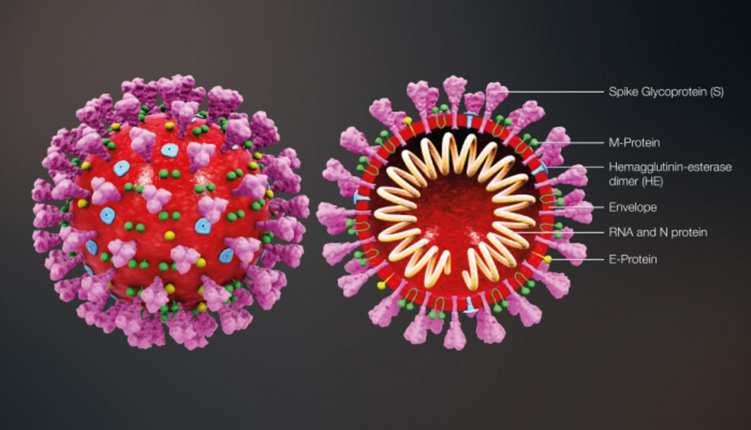
SOURCE-mronline.org

CLINICAL FEATURES

Incubation period — The incubation period for COVID-19 is thought to be within 14 days following exposure, with most cases occurring approximately four to five days after exposure
Spectrum of illness severity — The spectrum of symptomatic infection ranges from mild to critical; most infections are not severe
Risk factors for severe illness — Severe illness can occur in otherwise healthy individuals of any age, but it predominantly occurs in adults with advanced age or underlying medical comorbidities.
Comorbidities that have been associated with severe illness and mortality include :

●Cardiovascular disease

●Diabetes mellitus

●Hypertension

●Chronic lung disease

●Cancer

●Chronic kidney disease
Impact of age — Individuals of any age can acquire severe acute respiratory syndrome coronavirus 2 (SARS-CoV-2) infection, although adults of middle age and older are most commonly affected, and older adults are more likely to have severe disease.

PATHOPHYSIOLOGY

Initial presentation — Pneumonia appears to be the most frequent serious manifestation of infection, characterized primarily by fever, cough, dyspnea, and bilateral infiltrates on chest imaging
Course and complications — As above, symptomatic infection can range from mild to critical.
Some patients with initially mild symptoms may progress over the course of a week.
Acute respiratory distress syndrome (ARDS) is a major complication in patients with severe disease and can manifest shortly after the onset of dyspnea.
Other complications have included arrhythmias, acute cardiac injury, and shock ; Some patients with severe COVID-19 have laboratory evidence of an exuberant inflammatory response, similar to cytokine release syndrome, with persistent fevers, elevated inflammatory markers (eg, D-dimer, ferritin), and elevated proinflammatory cytokines; these laboratory abnormalities have been associated with critical and fatal illnesses.According to the WHO, recovery time appears to be around two weeks for mild infections and three to six weeks for severe disease .

