NAME: AYODELE ALFRED AYOMIDE
MATRIC NO: 19/ENG02/007
DEPARTMENT: COMPUTER ENGINEERING
SECTION 1

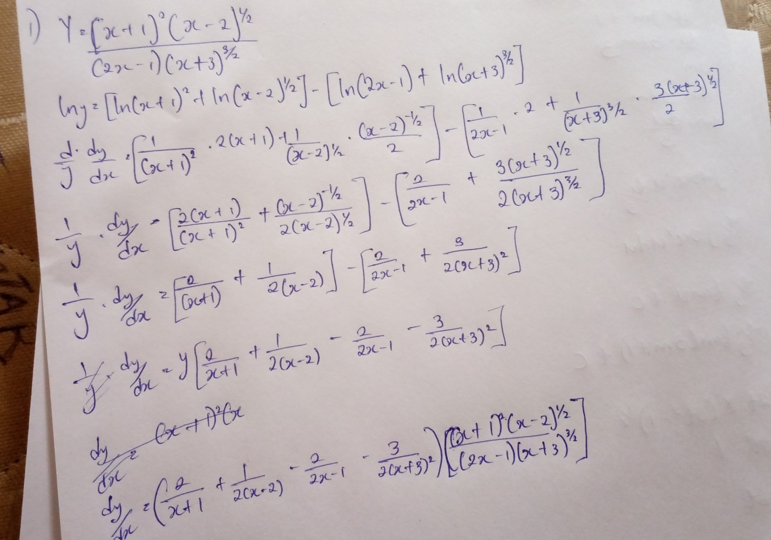

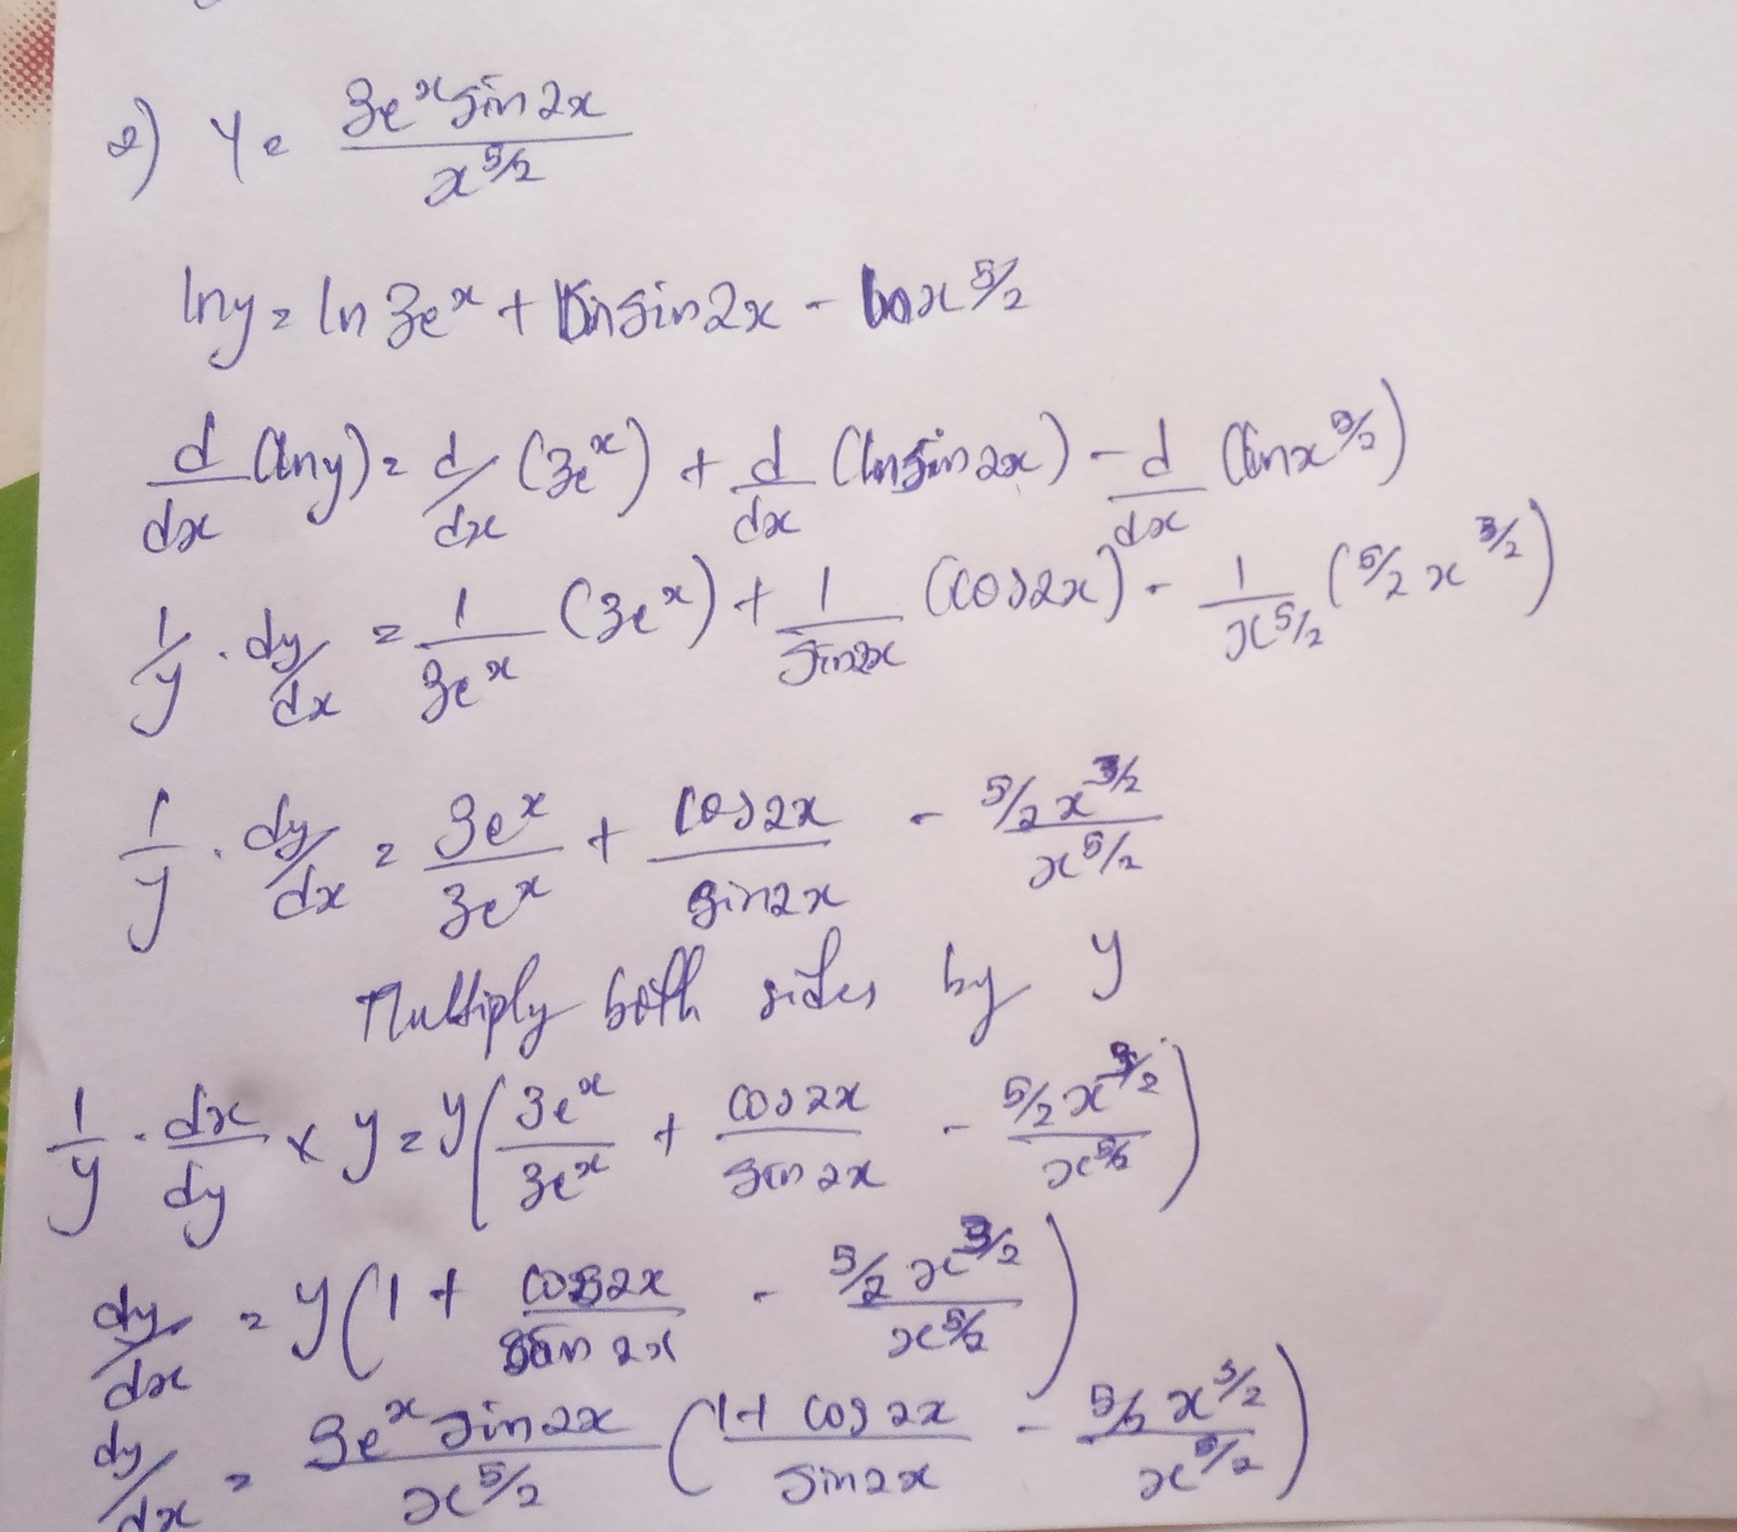

SECTION 2

