NAME: Akuma Sunny
DEPARTMENT: Electrical/Electronic Engineering
MATRIC NO: 17/eng04/009
ENG 382 (Mathematics) Assignment 3
a)
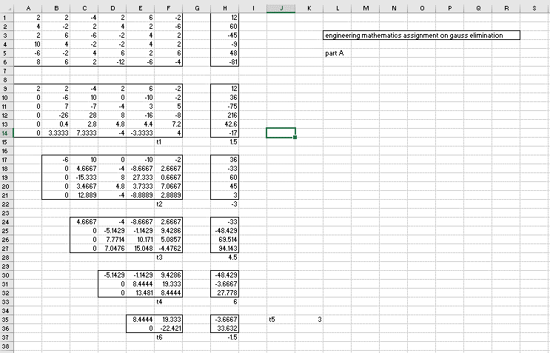

b)

c) 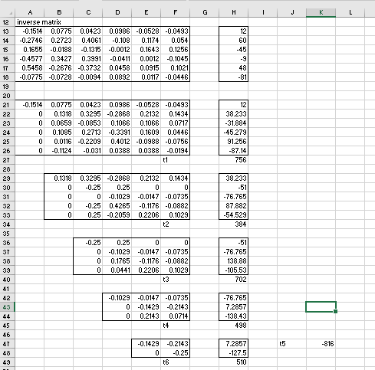

d)

