NAME: OLADIPO TOMI ISAAC
MATRIC NO.: 17/ENG05/030
DEPARTMENT: MECHATRONICS ENGINEERING
ENGINEERING MATHS ASSIGNMENT 3
a)
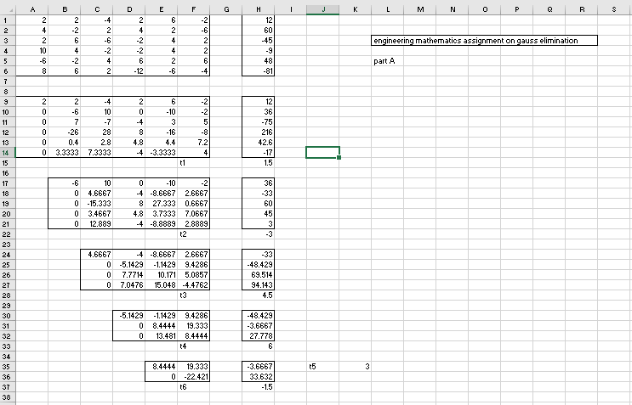

b)
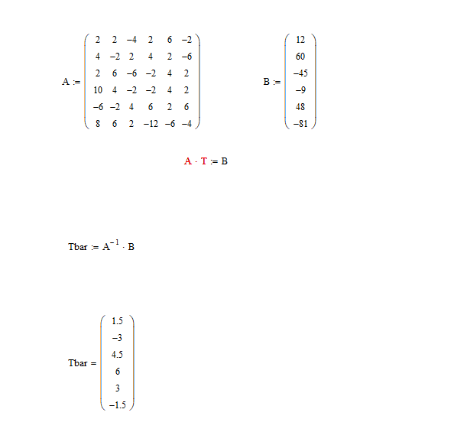

c) 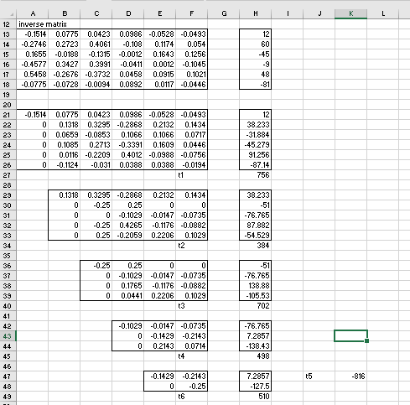
d) 