NAME: EME UBANI EMMANUEL
MATRIC NO.: 17/ENG02/023
DEPARTMENT: COMPUTER ENGINEERING
ENGINEERING MATHS ASSIGNMENT 3
a)
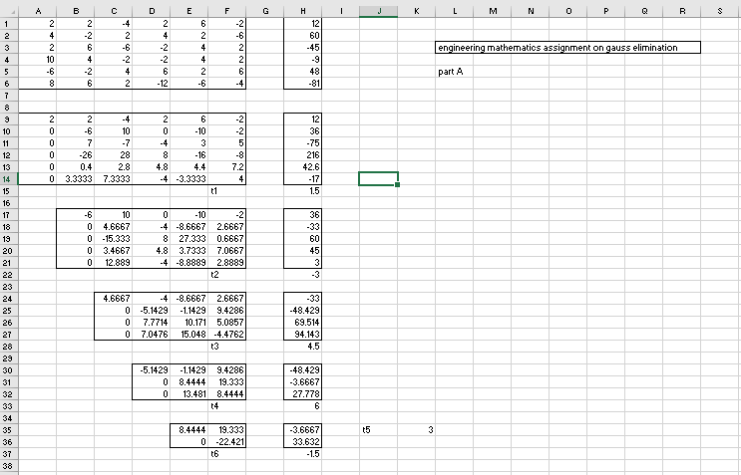

b)
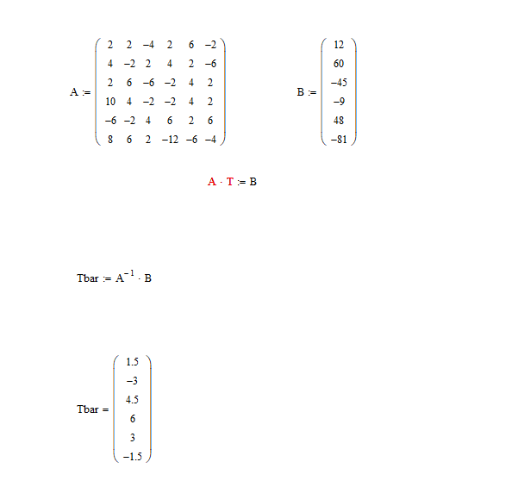

c) 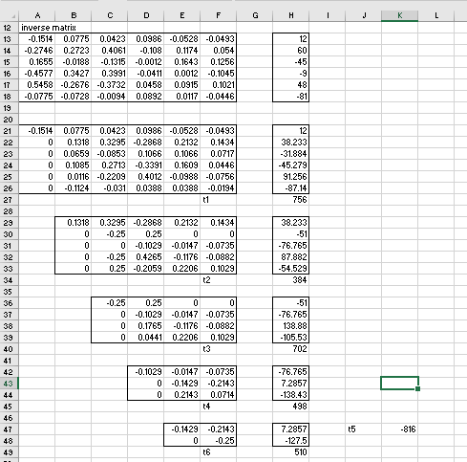
d) 