NAME:OLUTAYO AYODEJI SAMUEL

MATRIC NUMBER : 17/ENG05/034

COURSE: EBG382

Engineering maths assignment 3

a)

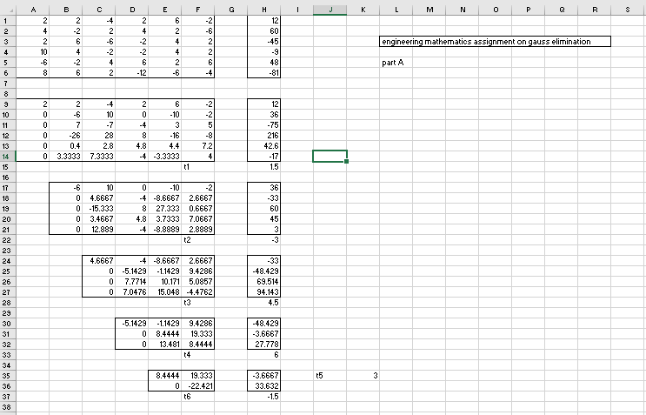

b)

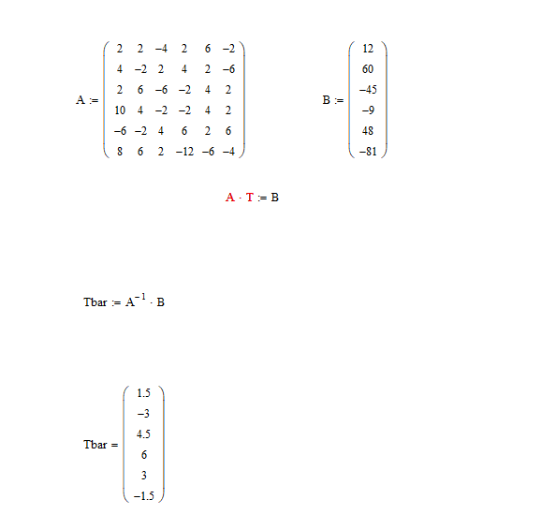

c) 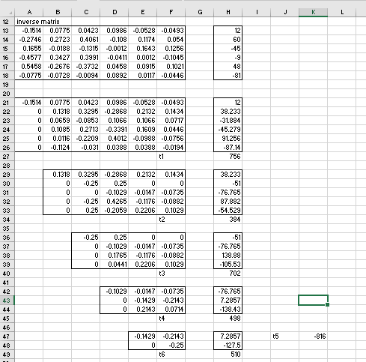

d) 