DEPT.: COMPUTER SCIENCE
NAME: OMOLADE BRIGHT
MATRIC NO.: 19/SCI01/078
NUMBER 1 AND 2
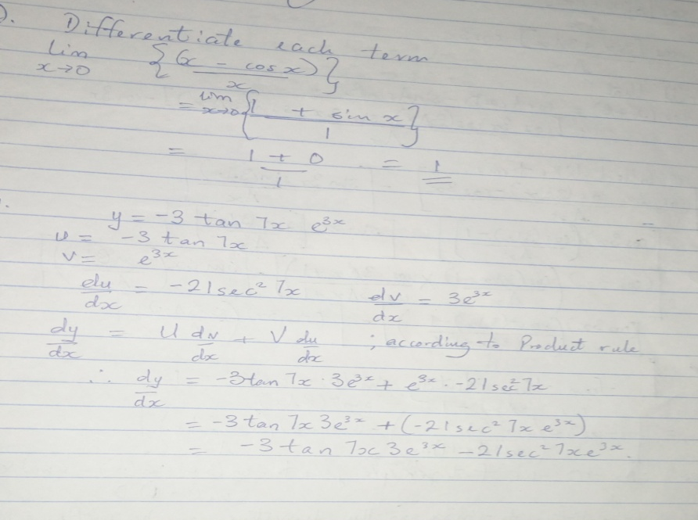
NUMBER 3
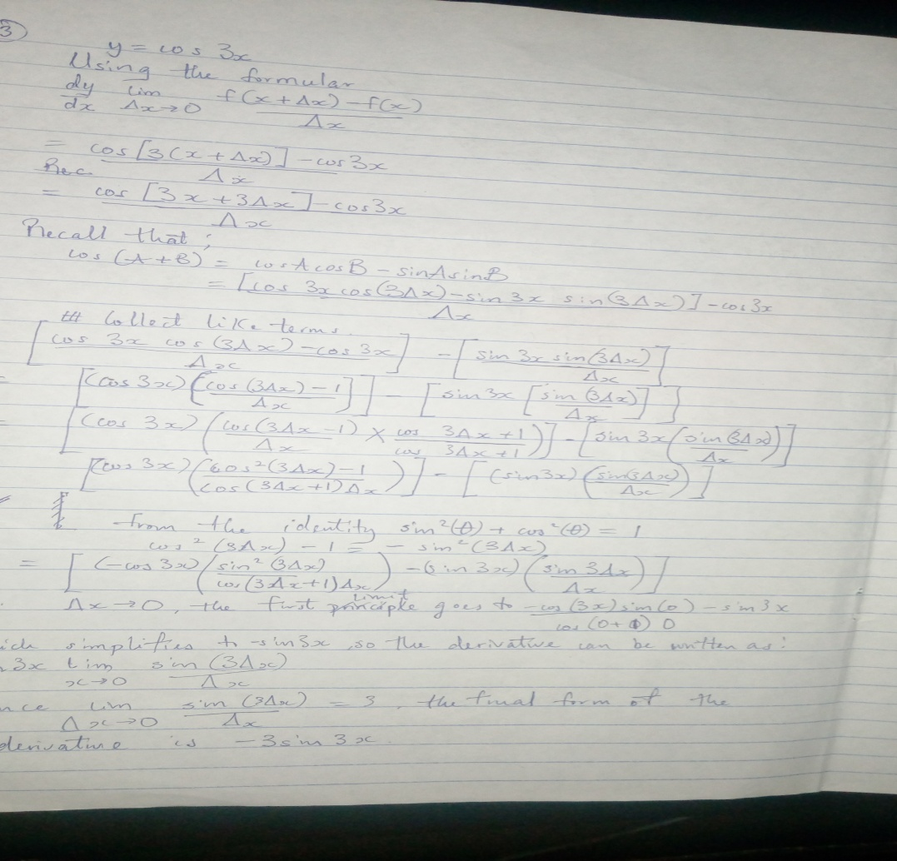

NUMBER 4, 5, 6 AND 7
