NAME:OLABODE TOBY PELUMI

MATRIC NO:18/ENG04/082

DEPT:ELECT ELECT

Engineering maths assignment 3

a)

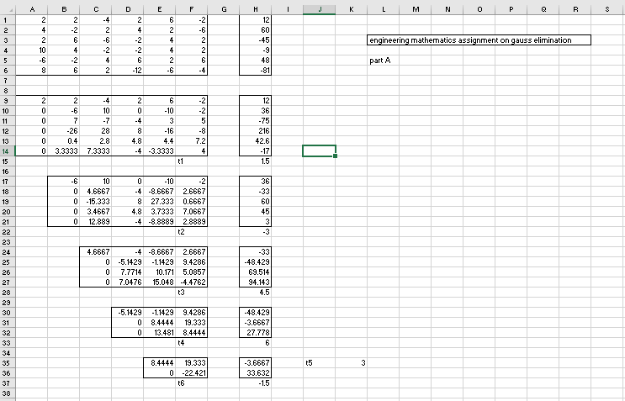

b)

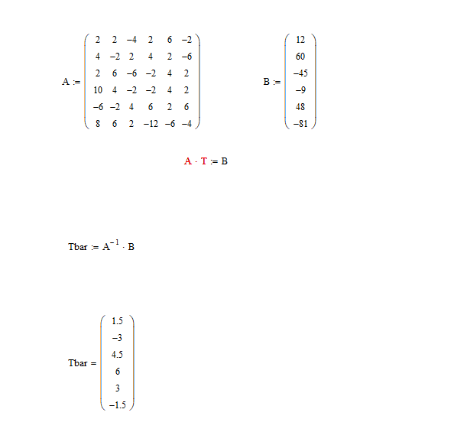

c) 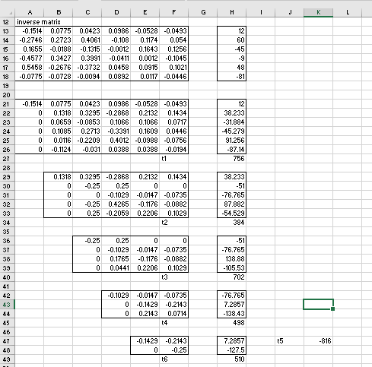

d) 