OBERHIRHI FAVOUR OGHENENYORE
MATHS ASSIGNMENT 3
17/ENG01/019
CHEMICAL ENGINEERING

Engineering maths assignment 3
a)
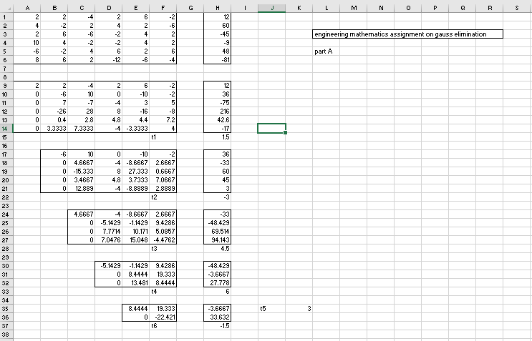

b)
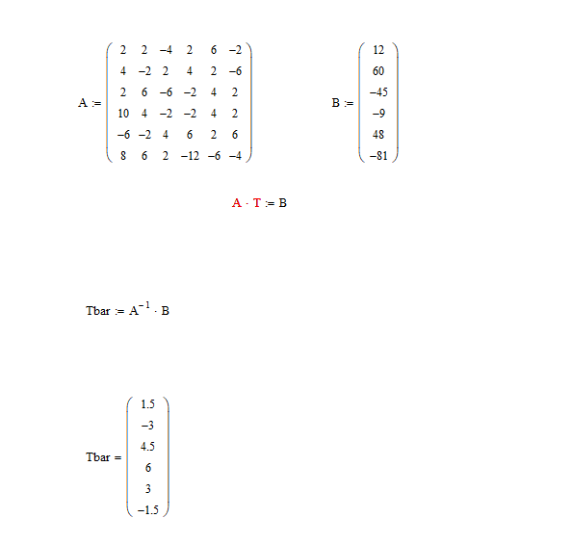

c) 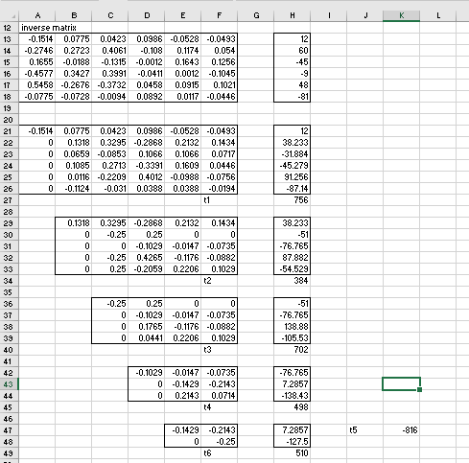
d) 