**17/ENG02/019**

**COMPUTER ENGINEERING**

**ENGINEERING MATHEMATICS IV**

**ASSIGNMENT III**

a) 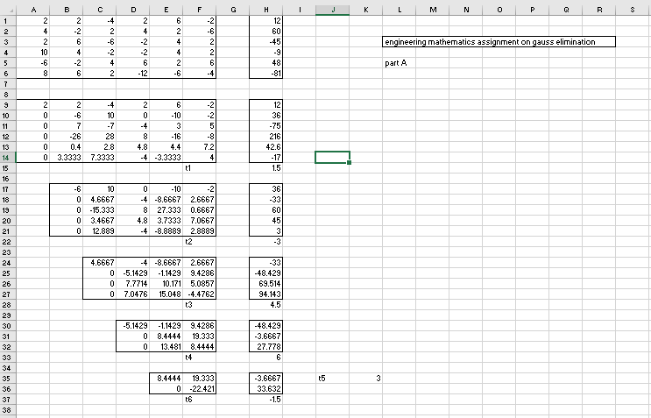

b)

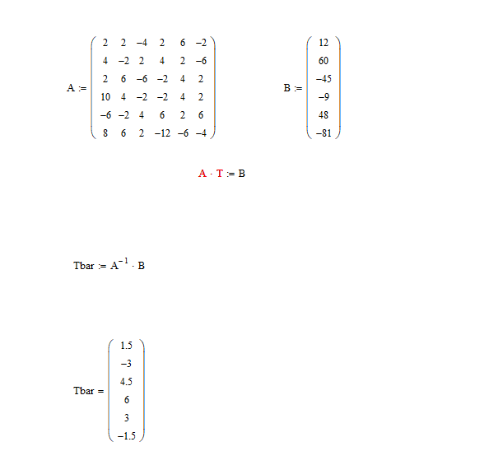

c) 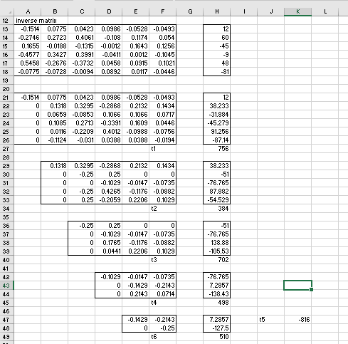

d) 