NAME: IWATT ENOBONG UDO
MATRIC NO: 18/ENG04/080
DEPARTMENT: ELECTRICAL/ELECTRONICS ENGINEERING
ENG 382; ENGINEERING MATHEMATICS ASSIGNMENT

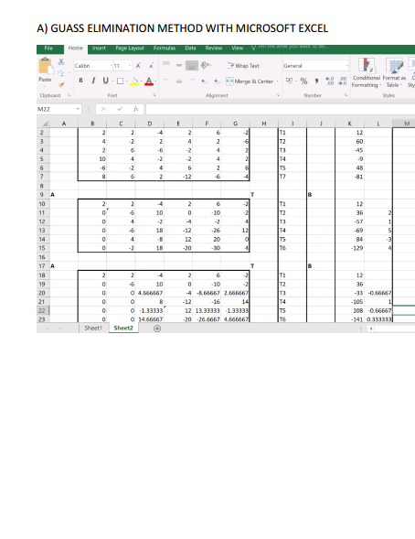
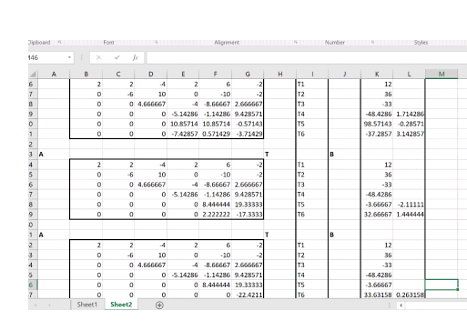

B.). GAUSS ELIMINATION METHOD WITH THE AID OF MATHCAD
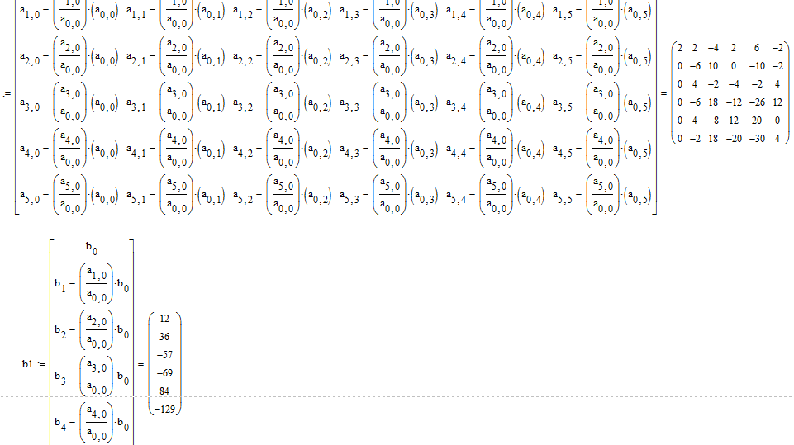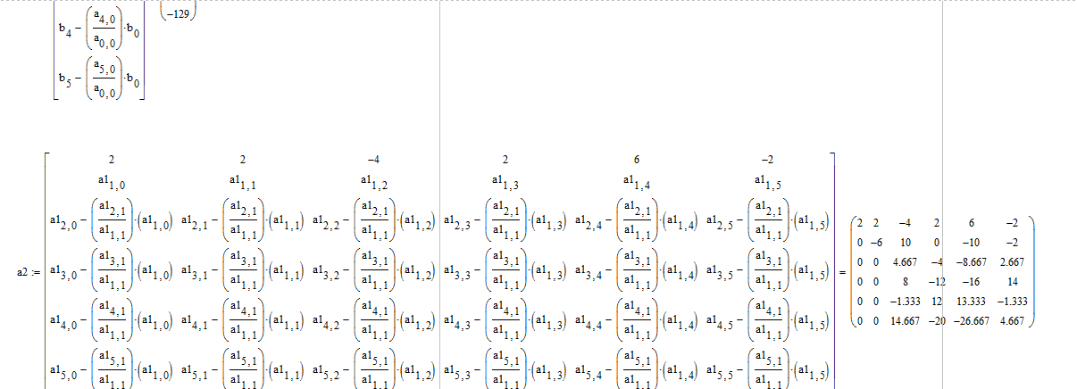

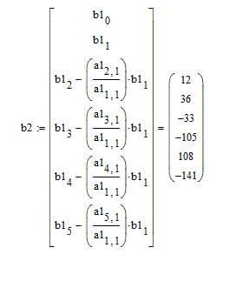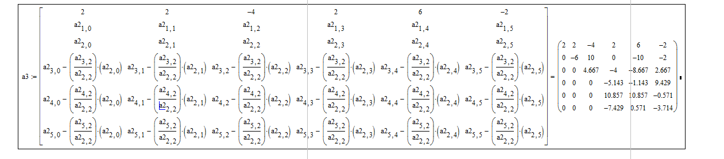

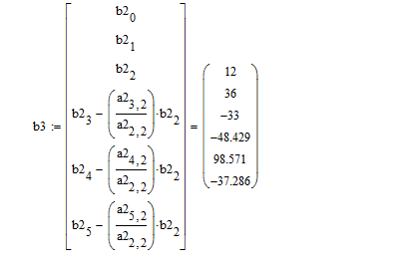

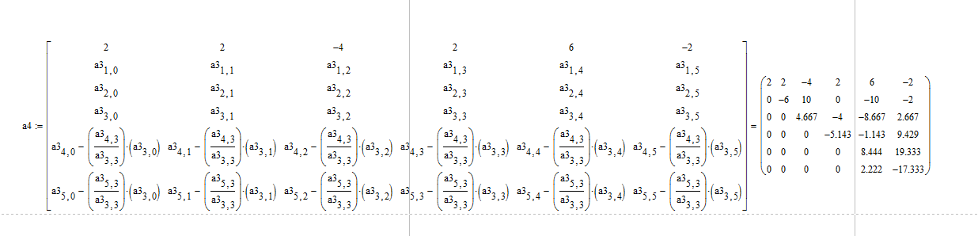

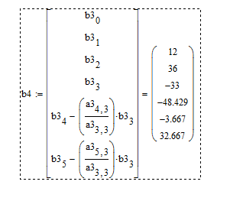

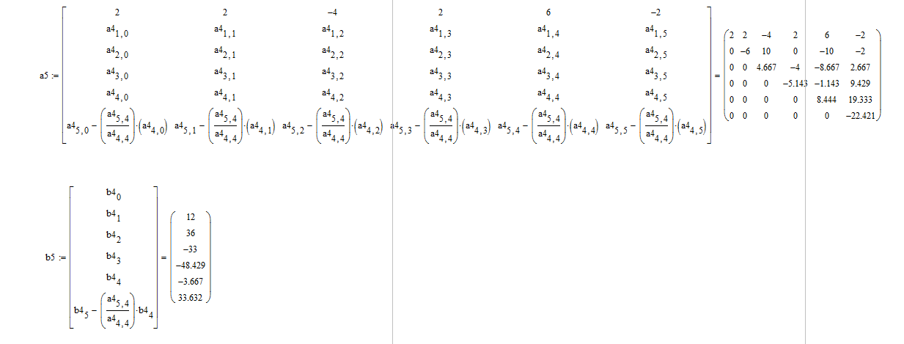

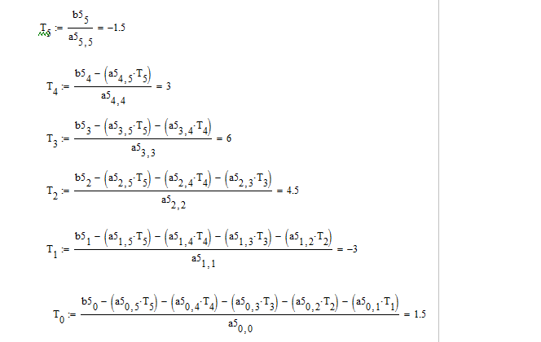

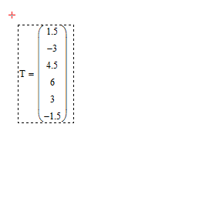
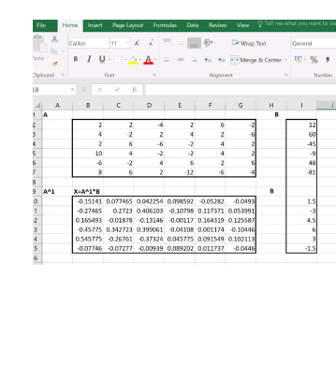
C.). MATRIX INVERSE METHOD WITH THE AID OF EXCEL

D.). MATRIX INVERSE METHOD WITH THE AID OF MATHCAD

