NAME: AGWANIRU ROSEMARY
MATRIC NO:17/ENG01/003
DEPARTMENT: CHEMICAL ENGINEERING
ENG 382 ASSIGNMENT 3

1a. Gauss-Siedel Method using Microsoft Excel
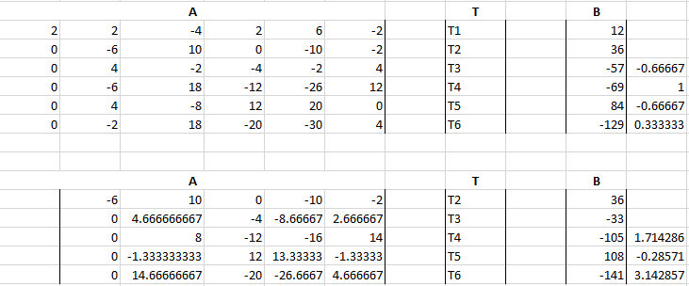
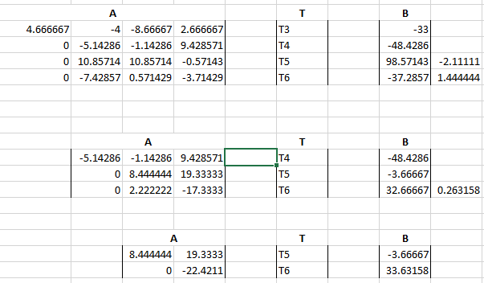

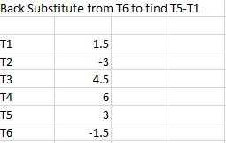

USING MATLAB TO SOLVE GAUSS-SIEDEL METHOD
- Commandwindow
- Clear
- Clc
- A=[2 2 -4 2 6 -2;4 -2 2 4 2 -6;2 6 -6 -2 4 2;10 4 -2 -2 4 2;-6 -2 4 6 2 6;8 6 2 -12 -6 -4]
- B=[12;60;-45;-9;48;-81]
- T=inv(A)*B

SOLUTION From MatLAB
A =
2 2 -4 2 6 -2
4 -2 2 4 2 -6
2 6 -6 -2 4 2
10 4 -2 -2 4 2
-6 -2 4 6 2 6
8 6 2 -12 -6 -4
B = T=
12 1.50000
60 -3.50000
-45 4.0000
-9 6.0000
48 3.0000
-81 -1.50000
3. MATRIX-INCERSE METHOD USING EXCEL
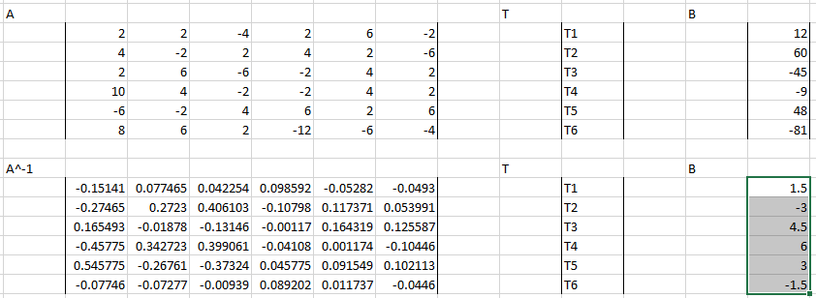
CODE FOR A^-1 CELL= =MINVERSE(C4:H9)
CODE FOR B CELL= =MMULT(C12:H17,N4:N9)

4. MATRIX-INVERSE METHOD USING MATLAB
- commandwindow
- clear
- clc
- A=[2 2 -4 2 6 -2;4 -2 2 4 2 -6;2 6 -6 -2 4 2;10 4 -2 -2 4 2;-6 -2 4 6 2 6;8 6 2 -12 -6 -4]
- B=[12;60;-45;-9;48;-81]
- AI=inv(A)
- T=inv(AI)*B

MATLAB SOLUTION

A =
2 2 -4 2 6 -2
4 -2 2 4 2 -6
2 6 -6 -2 4 2
10 4 -2 -2 4 2
-6 -2 4 6 2 6
8 6 2 -12 -6 -4

B =
12
60
-45
-9
48
-81

AI =
-0.1514 0.0775 0.0423 0.0986 -0.0528 -0.0493
-0.2746 0.2723 0.4061 -0.1080 0.1174 0.0540
0.1655 -0.0188 -0.1315 -0.0012 0.1643 0.1256
-0.4577 0.3427 0.3991 -0.0411 0.0012 -0.1045
0.5458 -0.2676 -0.3732 0.0458 0.0915 0.1021
-0.0775 -0.0728 -0.0094 0.0892 0.0117 -0.0446

T =
756.0000
384.0000
702.0000
498.0000
-816.0000
510.0000

