KAYODE MUINAT ADEBUKOLA
17/SCI14/016
Chemical Engineering
ENG 382 Assignment III

- Gauss elimination method with the aid of Microsoft Excel
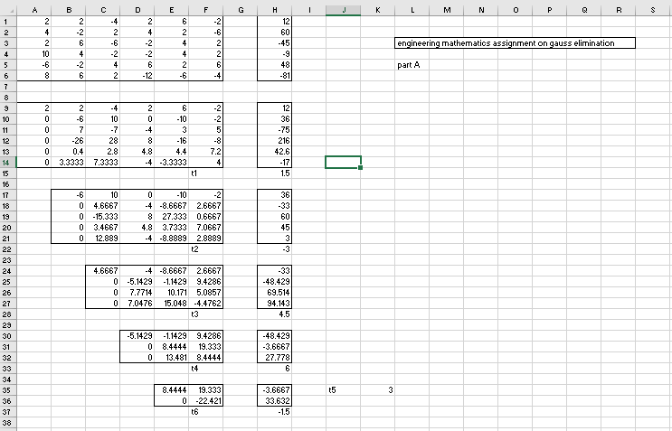

b) Gauss elimination method with the aid of Mathcad
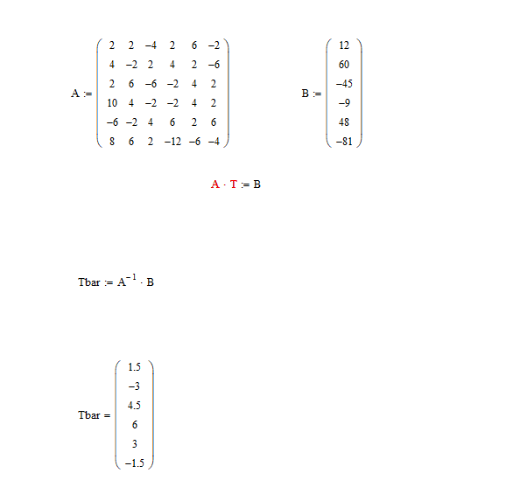

c) Matrix inverse method with the aid of Microsoft Excel
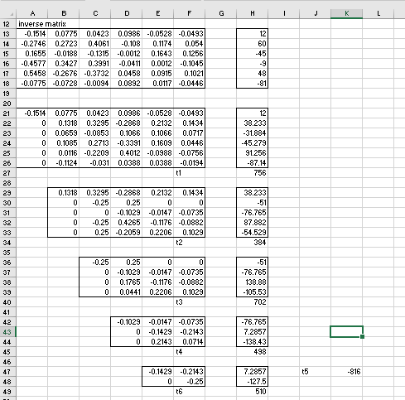

d) Matrix inverse method with the aid of Mathcad
