NAME: TANARAMI WUWUORITSELA ADRIEL
MATRIC NUMBER: 17/ENG05/038
DEPATMENT: MECHATRONICS
ENG 381
Assignment 3
a)
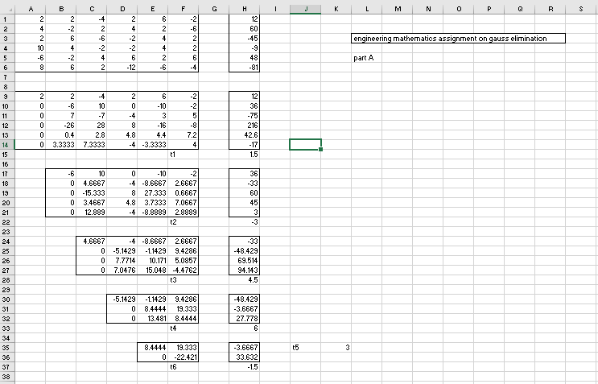

b)
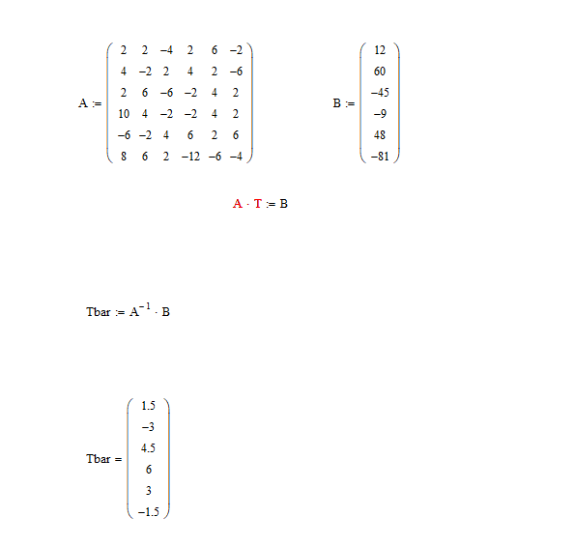

c) 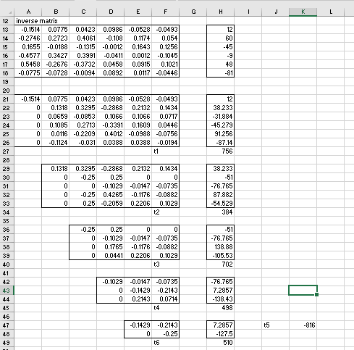
d) 